🧠 VDS AI Tooling

# VDS AI Tooling

The Verizon Design System (VDS) supports hundreds of designers, about two thousand developers, and hundreds of projects and teams across the company.

Effectively managing it at our scale is hard: tracking usage of the system, assessing our design and development community’s needs, not to mention developing design tokens and component libraries that work for all of those teams across several platforms—everything at our scale is hard.

This 86-day initiative has a singular goal: Make the VDS team’s work easier. We’ll accomplish that goal by providing the team with a bespoke suite of tools across three core pillars: Observatory, Foundry, Testbench.

Observatory (seeing stuff)
A big part of design system work is figuring out what downstream product teams are doing and where they’re going, as well as identifying where we can intervene and estimating the impact (positive and negative) with any intervention.

This facet of work can be challenging because, unlike with a website or app, design systems exist across many platforms that design system teams don’t own, which means observability of user behavior with our design system cannot be taken for granted.

It’s a bit easier at smaller companies with simpler org structures, but quite challenging at a company that’s #30 on the Fortune 500 list, employs about ~100,000 people, has multiple design and development departments, and lacks strong centralized DesignOps or DevOps.

Listen, we’re basically playing Battleship, but now we want to cheat and see the other person’s setup, and the Observatory tool suite will help us observe downstream designer and developer behavior.

What of the design system are they using, what are they building that we don’t offer, what are they building that we do offer, what are they struggling with, and what impact will we have if we make any change to the design system.

- Adoption Quality Dashboard will show where VDS is being used across the ecosystem, how much it’s being used, and how well.
- Demand Radar will periodically scan Verizon’s Figma workspace to identify and quantify unmet demand and VDS component drift.
- Breaking Change shows us the impact of any proposed change to the design system, before we ship.

Foundry (building stuff)
The VDS team—over 20 designers and developers—builds several types of digital assets for downstream designers and developers, including styles, variables, and components organized within Figma libraries, as well as design tokens, stylesheets, and components organized in Gitlab code repositories while distributed through Artifactory.

Recently, our team spent over a year building out a new version of the design system, based on Verizon’s rebrand launched 16 months prior.

The Foundry tool suite will accelerate clean and consistent creation of design system assets.

It will automate component specs and translate libraries across platforms, resulting in quality building blocks that are always aligned to VDS standards, faster.

- Component Specs
- Library Translator
- Writing Assistant

Testbench (testing stuff)
Proves every component is production-ready before release. It runs visual regression checks, tests variants across breakpoints, and simulates accessibility in real-world conditions. This safeguards speed-to-market by ensuring quality, parity, and inclusivity at scale.

- Component VQA
- Component Variant Testing

📊 Adoption Quality Dashboard

preAdoption Quality Dashboard
#Observatory
Product Lead: Zukile Temba (Zuki) Ndulo
Engineering Lead: Rishita Gadde
The VDS Adoption Quality Dashboard will be a strategic tool to measure the true health and impact VDS. Currently, we lack visibility into how our system is being used, making it impossible to differentiate between healthy, consistent adoption and low-quality usage that creates tech debt and brand fragmentation. This dashboard moves beyond simple consumption metrics to introduce the concept of Adoption Quality, analogous to the business concept, "Quality of Sale." It's not enough to know that a team is using VDS; we need to know how much and how well they are using it.
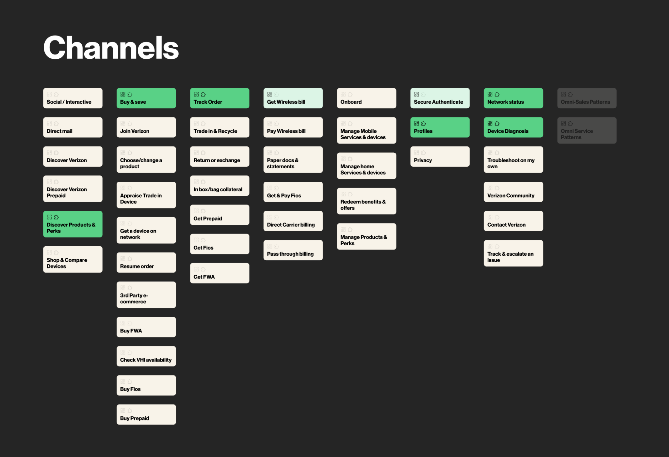
Design explorations by Gaurav Joshi and Premi Jovitta X
The purpose is to provide VDS leadership and the broader design organization with a single source of truth for system health, with all data aligned to the official VCG CX Design Organization Taxonomy. This will enable data-driven decision-making, drive accountability, and ensure we are delivering on the core promise of the design system: creating a more consistent, high-quality user experience across all of Verizon's digital properties.

Problem Statement
We are effectively blind to the true quality of VDS adoption across the organization. Without a system to measure adoption fidelity and cohesion, we cannot identify teams that are creating brand inconsistencies and tech debt by overriding components, nor can we strategically invest our resources to improve the system's effectiveness, ultimately failing to prove the ROI of VDS.

Current State
Our current understanding of VDS adoption is limited to basic, often manual, consumption counts. We might know that a team is a "VDS adopter," but we have no quantitative data on the depth or quality of that usage. We cannot answer critical questions like:
- Are teams using components as designed, or are they overriding them?
- Do the implemented components in production actually match the designs in Figma?
- Which parts of the VCG CX Design Organization are excelling in adoption, and which are lagging?
This lack of insight means we operate on assumptions, making it impossible to manage the design system as a strategic asset.

Outcomes
The primary success metric will be the Adoption Quality Score, a composite metric calculated from:
- Breadth Score: Teams using VDS, even a little.
- Depth Score: The degree to which teams are utilizing VDS.
- Fidelity Score: The percentage of VDS component instances used without overrides or customizations.
- Cohesion Score: The percentage of component instances in production that visually and structurally match their corresponding designs in Figma.
A web-based dashboard that visualizes VDS adoption through the lens of the Adoption Quality Model. The dashboard will provide a comprehensive view of who is using VDS, how much they are using it, and—most importantly—how well they are using it.

Functional Requirements
- Data Integration
  - Ingest component and token usage data from Figma to establish a baseline for design intent.
  - Ingest component and token usage data from GitLab to understand production implementation.
- Adoption Quality Analysis
  - The system must automatically scan code to detect component overrides, restyling, and customizations to calculate a Fidelity Score.
  - The system must perform automated comparisons between Figma assets and production code/screenshots to calculate a Cohesion Score.
  - The system must calculate an overall Adoption Quality Score based on Fidelity and Cohesion.
- Dashboard & Visualization
  - Display the Adoption Quality Score, along with metrics for adoption breadth (who) and depth (how much).
- Dynamic
  - VCG CX Design Organization Taxonomy-centricity; users must be able to drill down into specific areas, such as:
    - Experience Ecosystems
    - Customer Intents (e.g., Buy, Pay, Manage Account)
    - Products (e.g., Digital Sales, Digital Service)
    - Digital and Assisted Touchpoints
- User Interface
  - A clean, intuitive, web-based dashboard accessible to authorized VDS stakeholders and organizational leaders.

Non-Functional
- Accuracy: The detection of overrides (Fidelity) and design-to-dev mismatches (Cohesion) must be highly accurate to be trustworthy.
- Performance: The dashboard must load quickly, even with large datasets. Data ingestion and analysis can run as batch processes.
- Scalability: The system must be able to handle a growing number of Figma files, code repositories, and components.
- Security: Access to the dashboard will be role-based to ensure data is only visible to appropriate personnel.

Global Dependencies
- APIs: Stable and performant APIs for both Figma and GitLab are essential.
- Data Mapping: A robust and maintainable process for mapping thousands of Figma files and GitLab repos to the specific teams and products within the VCG CX Design Organization Taxonomy. This may require a service like Airtable or an internal ownership database.
- Analysis Engine: A sophisticated engine capable of static code analysis and potentially visual regression testing to calculate fidelity and cohesion scores.

Global Risks
- Feasibility Risk (Can we build it?): The riskiest assumption is that we can accurately and scalably automate the measurement of Fidelity and Cohesion. Detecting nuanced code overrides and reliably comparing a Figma design to a live component is a significant technical challenge.
- Viability Risk (Does this work for our business?): The riskiest assumption is that we can achieve the necessary organizational alignment to not only grant broad data access but also to act on the insights provided. The taxonomy mapping is a critical dependency that requires cross-team cooperation.
- Value Risk (Will anyone use it?): If the data is inaccurate or the scores are perceived as punitive rather than helpful, teams will ignore the dashboard. The insights must be presented in a way that empowers teams to improve, rather than punishing them for low scores.

Adoption Quality Model

Adoption Quality Model

Our Adoption Quality Model evaluates VDS adoption across three key dimensions:
- Who’s using it
- How much they’re using it
- How well they’re using it

1. Who is using VDS?
Are teams using VDS, yes or no?
We care both about design and development adoption, as design is often a leading indicator of dev usage.
But, ultimately, we hold ourselves accountable to dev adoption.

2. How much are they using it?
After confirming a team is using VDS, we assess how extensively they use it. Are they utilizing our token packages, and if so, which ones? (e.g., Typography, Spacing, Color.) How many tokens and components from our core library are teams integrating, and which ones? This shifts our perspective from mere presence (yes/no) to depth of adoption, akin to assessing how extensively someone fills their shopping cart—not just if they entered the store.

Also consider:
- Percentage of a page that uses VDS
- How many are they using compared to what they could/should use

3. How well are they using it?
Here, quality of adoption is measured through three distinct categories:

Fidelity
Are teams using components exactly as designed, without overriding, restyling, customizing? Automated code-scans and visual audits ensure compliance; deviations undermine consistency and increase technical debt.

Cohesion
Do the design (Figma) and production (development) assets match precisely? We verify that components in Figma are identical to production implementations, ensuring alignment and minimizing errors during handoffs.

Research
Research

https://www.figma.com/community/widget/1532072013420297079
https://github.com/zeroheight/action-design-system-adoption

Tab 23
Here is a clear, step-by-step list you can give to your lead developer, outlining exactly what data they need to download.
This plan is broken into two main phases:
- Phase 1: Get a "master list" of all official VDS assets.
- Phase 2: Scan all other team files and cross-reference what they are using against that master list.

📝 Plan for Your Lead Developer
Here is the data we need to download from the Figma REST API to track VDS adoption at the file level.

Phase 1: Build the VDS "Master List" (Source of Truth)
First, we need the unique IDs for every official asset in our VDS libraries.
- Get VDS Library File Keys:
  - Identify the file_key (from the Figma file's URL) for all of our VDS library files.
- Download All Published Asset IDs:
  - For each VDS library file_key, make these three API calls:
  - Components: GET /v1/files/:file_key/components
    - What to save: Parse the meta.components array and save all the key values.
  - Styles: GET /v1/files/:file_key/styles
    - What to save: Parse the meta.styles array and save all the style_key values.
  - Variables: GET /v1/files/:file_key/variables
    - What to save: Parse the meta.variables array and save all the id values.
Outcome: You will have three master sets of unique IDs:
- master_vds_component_keys
- master_vds_style_keys
- master_vds_variable_ids

Phase 2: Scan Consumer Files for Usage
Next, we need to scan every file for every team you want to track.
- Get All Consumer File Keys:
  - First, you'll need to get a list of all file_keys for the teams you want to analyze.
  - You can do this by using the GET /v1/teams/:team_id/projects endpoint, and then the GET /v1/projects/:project_id/files endpoint to get all the file_keys within each project.
- Download and Parse Each File's Content:
  - This is the main task. For each consumer file_key, you must make one big API call:
  - API Call: GET /v1/files/:file_key
  - This returns a massive JSON object that represents the entire file. You will need to recursively traverse this entire document tree to find all usage data.
- What to Extract from Each File's JSON:
  - While traversing the file's JSON, look for these specific properties on each node:
  - Component Adoption (Instances):
    - Look for: Nodes where type == "INSTANCE".
    - What to download: For each instance, get its componentId.
    - Result per file: A list of all componentIds used in the file.
  - Style Adoption:
    - Look for: Nodes that have a styles property (e.g., RECTANGLE, TEXT, FRAME).
    - What to download: The styles property is an object. Get the ID values from inside it (e.g., styles.fill, styles.text, styles.effect, styles.stroke).
    - Result per file: A list of all styleIds used in the file.
  - Variable Adoption:
    - Look for: Nodes that have a boundVariables property.
    - What to download: This property contains objects. Get the id from each object.
    - Result per file: A list of all variableIds used in the file.

✅ How This Data Answers Our Questions
Once the developer has this data, they can generate the report for each file.
- For the "Binary (Yes/No)" Question:
  - For a given file, do any of the componentIds it uses exist in our master_vds_component_keys?
  - If yes, vds_component_adoption = true.
  - (Repeat this logic for styles and variables).
- For the "How Much / Which Ones" Question:
  - For a given file, filter its list of used componentIds to only include IDs that are in our master_vds_component_keys.
  - Then, create a count (a frequency map) of those matching IDs.
  - (Repeat this logic for styles and variables).
The final output for a single file (which you can then map to your dashboard teams) will look like this:
JSON
{
"file_key": "abc12345",
"file_name": "New User Onboarding Flow",
"vds_component_usage": {
"vds_component_id_A": 12,
"vds_component_id_B": 5
},
"vds_style_usage": {
"vds_style_id_blue": 22,
"vds_style_id_h1": 8
},
"vds_variable_usage": {
"vds_variable_id_spacing": 40
}
}
This gives you everything you need to know: binary adoption (the objects are not empty) and quantitative adoption (which ones and how many).
Would you like me to elaborate on the API endpoints for listing all the files within your teams?

✊🏽 Demand Radar

Demand Radar
#Observatory
Product Lead: Ashton Coghlan
Engineering Lead: Tobias Tornqvist
Demand & Drift Radar will identify and quantify unmet demand and component drift. Results will feed VDS product decisions. Success will lead to faster roadmaps/knowing what we need to build next, sooner.

Problem Statement
VDS lacks a systematic, data-driven way to identify widespread, unmet component needs and quantify the misuse or "drift" of existing components. This leads to reactive roadmap planning based on anecdotes, proliferation of duplicate components, brand inconsistency, and an inability to measure the ROI of system improvements.

Impact if Unsolved
Without this tool, roadmapping will remain inefficient, duplicate work will continue across teams, and brand cohesion will weaken. VDS will lack the data to justify prioritization, prove its impact, and operate transparently, leading to a diminished ROI for the entire design system program.

Outcomes
- Proactive Roadmap: Replace anecdote with ranked, evidence-backed needs spanning many teams.
- System Integrity: Map and reduce detachment, drift, and shadow variants to improve brand cohesion.
- Faster Migrations: Provide a precise inventory and targeting for Monarch and future brand/theming changes.
- Transparent Governance: Make prioritization explainable, fair, and repeatable.
- Closed Loop: Measure post-change deltas (clusters shrink, drift drops) to prove impact.

Functional JTBDs

Primary
- VDS PMs “Help me prioritize a roadmap that reflects broad, validated demand.”
- VDS Design: “Show me drift hot-spots and concrete examples to consolidate or create better variants.”

Secondary
- ProductOps/Governance: “Give me a data-first starting point for policy, training, and migration plans.”
- Leadership: “Summarize ecosystem health and ROI in plain numbers.”

Tab 22
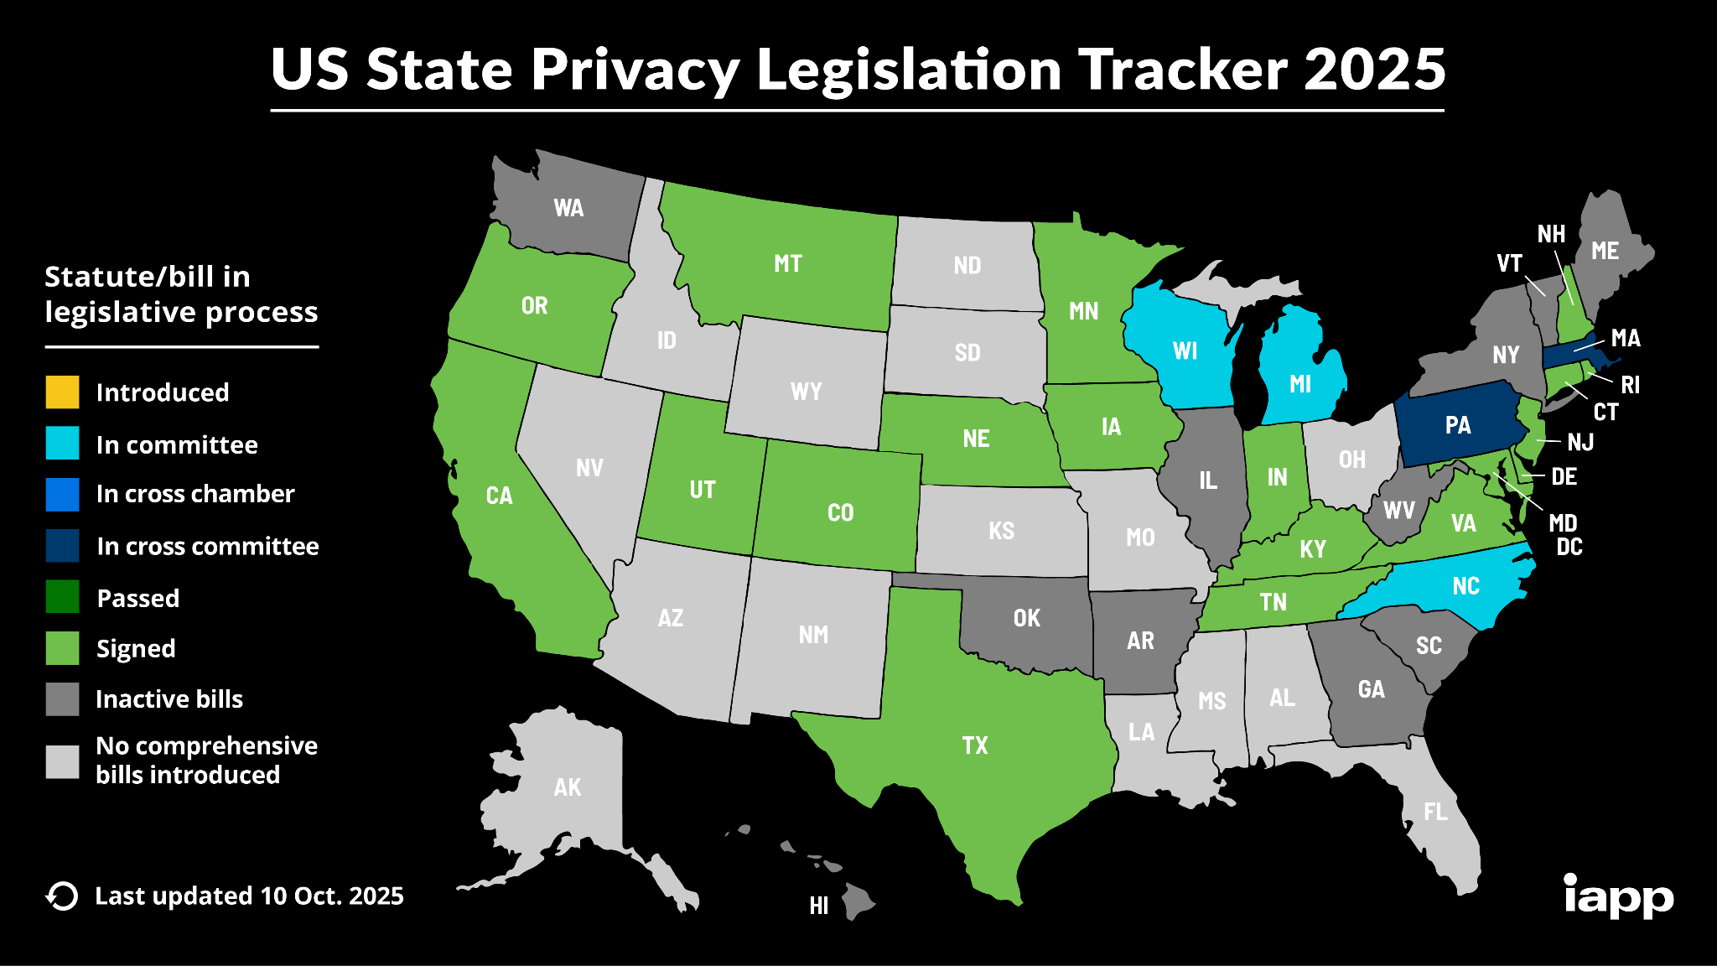

💥 Domino

Domino

(Formerly: Breaking Change)

Product Lead: Ayelet Mintz
Engineering Lead: Harrison Gerstenlauer

Overview
Breaking changes occur when updates to VDS—whether in Figma libraries or developer code—require designers and/or developers to modify their existing projects to maintain compatibility with VDS. This typically necessitates manual updates across numerous files, which, if it becomes a regular occurrence, would lead to upgrade fatigue. Teams can grow wary of adopting new updates due to the anticipated workload, creating a cycle of resistance to change, even if the change brings improvements.
This apprehension has led VDS to adopt infrequent release cycles. Longer release cycles result in larger scopes for each update, which are inherently riskier, and more challenging to manage. Large scopes increase the likelihood of delays, bottlenecks, and quality issues.
Furthermore, the infrequency of releases has allowed us to fall back on manual processes versus automation. Since updates are rare, there's less incentive to automate tasks like communications, documentation, and workflow management. Our reliance on manual efforts is inefficient, hampering our ability to be agile and responsive to both VDS team needs and downstream demands.
Breaking Change Radar is a proactive governance tool designed to make the "blast radius" of any proposed change to VDS visible before we ship. No, it doesn’t magically fix all the breaking changes for all of our users. But it does give us a good idea about how badly we’re about to ruin someone’s day/week/month.

Problem Statement
When the VDS team updates the system, it’s difficult to know which downstream design files, teams, or codebases will be affected. This lack of foresight erodes trust with downstream teams, delays their releases, spurs upgrade fatigue, and risks causing unexpected breaking changes in production.

Outcomes
- VDS leads will be able to release changes with confidence, knowing they have a full picture of the downstream impact.
- The relationship between VDS and its consumers (downstream product teams) will shift from reactive and fraught with friction to proactive and collaborative.
- Build trust that encourages teams to stay on the latest version of VDS, reducing fragmentation and the long-term cost of maintenance.
- VDS will move from large, risky updates to smaller, more frequent and predictable ones.
- Product teams will receive proactive, targeted, and actionable communication about VDS changes that affect them, allowing them to plan accordingly.

Requirements
- The system must detect the severity of a change (e.g., differentiate a minor visual tweak from a breaking API change).
- Assess severity based on dependency count, usage frequency, and component complexity.
- Use historical data to provide "time to fix" estimates for identified impacts.
- The system must achieve >99% accuracy in identifying direct component dependencies in both code and Figma.
- The tool requires broad read-access to Figma files and GitLab repos.
- All access must use secure, audited service accounts and adhere to Verizon's security policies.

Global Risks
Value Risk: The riskiest assumption is that providing an impact report will lead engineers to act on it. If the report is too noisy or contains false positives, users will learn to ignore it.
Feasibility Risk: The riskiest assumption is that we can accurately and performantly build a cross-platform (Figma + code) dependency graph at scale. Statically parsing code for component usage is notoriously difficult, and the dependency map must be version-aware to be accurate. Mapping over 15k Figma files to 80k repos without clear tagging is a massive data integration challenge.
Usability Risk: The riskiest assumption is that an engineer can look at the report and immediately understand the next steps. Presenting the impact on dozens of projects in a digestible way is a critical design challenge.
Viability Risk: The riskiest assumption is that we can get the necessary organizational buy-in for broad data access. If the CI job significantly slows down build processes, it will face immense pressure to be disabled. The tool can surface problems but cannot solve the cross-functional coordination required for complex migrations.

Tab 21

Using AI to Streamline Breaking Changes in a Design System

When it comes to evolving a design system, one of the most delicate tasks is introducing breaking changes. These are changes that can disrupt existing components or workflows and therefore need to be handled with a great deal of care. While it’s essential to treat your design system like a product that grows and improves, it’s equally important to support the teams relying on it so they can adapt smoothly.

The Challenge of Breaking Changes

Before we dive into how AI can help, let’s revisit why breaking changes are tricky. As a design system team, you need to know who is affected by the change, why you’re making it, and how to guide teams through the transition. Traditionally, this involves a lot of manual documentation and communication. But AI can take this to another level.

Here’s a hypothetical example: Let’s say we decided to deprecate the legacy ButtonPrimary component and replace it with a new Button system that standardizes variants (primary, secondary, tertiary) via a variant prop. However, this introduces a breaking change because ButtonPrimary is removed entirely in the latest version. Any downstream team still referencing ButtonPrimary in their Figma files or consuming it in React codebases encountered broken layouts, missing styles, and TypeScript errors during CI/CD. Without a proper migration path, this change disrupted several in-flight features across Retail, Home, and Protect teams, requiring urgent hotfixes and rework

Leveraging AI for Migration Support

So, how does AI fit into this? Essentially, AI can help you build custom tools that act as intelligent migration assistants. For example, you can develop AI-powered scripts that analyze the existing design or codebase and automatically suggest the necessary changes. Instead of your teams having to manually compare old and new components, the AI can highlight those changes and even generate code snippets or design tokens that align with the updated system.

You can also create interactive AI assistants or bots. Imagine a bot integrated into your team’s Slack that can walk developers and designers through the migration process. They can ask the bot questions, get specific instructions tailored to their context, and even receive automated suggestions on how to refactor their files.

The Benefits of an AI-Assisted Approach

The biggest advantage here is that AI reduces the manual burden on both the design system team and the downstream teams. It makes the process of handling breaking changes much more scalable and less stressful. Instead of relying on extensive documentation alone, you’re giving your teams a kind of AI-powered guide that’s available whenever they need it.

In conclusion, using AI to assist with migration when you introduce breaking changes is a powerful way to keep your design system evolving like a product while still ensuring that your teams have the support they need. It’s all about making the transition as seamless as possible, and AI can be a fantastic partner in that process.

🗺️ Specify

Specify
#Foundry
Product Lead: Ashton Coghlan
Engineering Lead: Enrique Chong

tldr: our interpretation of the Figma Specs plugin.

Overview
Specify is a core tool within the VDS Foundry suite designed to eliminate the manual, error-prone, and time-consuming process of creating and maintaining component specifications. This project will build Specify, an intelligent Figma plugin that automates the creation of VDS component documentation, inspired by and adapted from the concepts in the EightShapes Specs plugin.
Its purpose is to transform the laborious task of manual specification into a fast, consistent, and reliable automated workflow. By parsing a component's structure and properties directly within Figma, it will generate high-quality specs that can be used for design reviews, developer handoffs, and archival as the official system of record.

Problem Statement
Creating and maintaining specifications for VDS components is a manual, labor-intensive task, often leading to outdated or inconsistent documentation that slows down release cycles, increases QA churn, and erodes trust between design and engineering.

Current State
A VDS designer must painstakingly measure every element, document every token, capture every state, and write out every interaction rule. This process can take hours or even days. The output is often a static document or a set of annotations in Figma that quickly becomes outdated the moment the component is tweaked.

Outcomes

Business
- Streamline Design-to-Development Handoff: Significantly reduce the time and friction involved in preparing and consuming component specs, directly improving speed-to-market.
- Improve Product Quality: Reduce the number of implementation defects caused by ambiguous or outdated specifications.
- Optimize Resource Allocation: Free up countless hours of designer and developer time currently spent on the manual labor of creating and interpreting specs.

User
The primary users are VDS Designers responsible for creating and publishing official component specs. The secondary users are Engineers (both within VDS and on product teams) and the Component VQA tool that consumes the specs.
Here are the desired user outcomes:
- VDS designers and engineers will have a single, reliable, and always-current source of truth for every component's properties and behaviors.
- The process of creating documentation will become nearly instantaneous, removing a major source of toil for designers.
- Engineers will receive unambiguous, machine-generated specs they can trust, reducing the need for clarification and rework.

Product
The immediate outcome is a dramatic reduction in the lead time required to get a component from design-complete to development-ready, ensuring that engineers always have access to an accurate, unambiguous, and up-to-date source of truth.

Tracking Outcomes
The success of this tool will be measured by a primary North Star Metric: Time on Task. We will measure the median time from when a component is marked "design complete" to when its specification is approved and published.

Requirements

Functional
- The plugin must be able to select a main component in Figma and traverse its entire structure, including all variants and nested instances.
- It must extract all relevant properties: dimensions, spacing (auto-layout), color/typography/effect tokens, and variant properties.
- It must generate a new, cleanly organized page in the Figma file containing the specification.
- The generated spec must include visual annotations for each component variant.
- The spec must include a structured table detailing all component properties, their types, and the VDS tokens they use.
- It must be able to export the generated specification in a developer-friendly format, such as Markdown.

Non-Functional
- Performance / Speed: Spec generation for a complex component (e.g., with 50+ variants) must complete in under 20 seconds.
- Accuracy: The extraction of token names, measurements, and property values must be 100% accurate.
- Security & Compliance: The plugin must operate entirely within Figma's secure sandbox and not transmit any design data to external servers.
- Maintainability: The templates used to generate the specs must be easily configurable by the VDS team without requiring a new plugin release.

Out-of-Scope
- This tool will not write narrative, "why"-based documentation (e.g., usage guidelines, best practices). It documents the "what" and "how" of a component's construction, not its strategic intent.
- It will not validate the design against VDS rules; it only documents the existing state of the component.
- It will not generate code snippets in its first version.
- It will not have a web-based UI; it is a Figma-only plugin.

Global Dependencies
- Tools / Frameworks: Figma Plugin API.
- Integration Points: The primary integration is with the Figma canvas itself. A secondary integration is with the VDS documentation site, where the Markdown exports will be published.
- Teams: Success relies on a well-structured and tokenized source component built by VDS Designers. Garbage in, garbage out.

Global Risks
Value Risk (Will anyone use it?): The riskiest assumption is that an auto-generated spec will be sufficient for engineers. Over-reliance on automation could lead to a false sense of completeness if the output is just a "data dump" of properties rather than a curated, usable document.
Feasibility Risk (Can we build it?): The riskiest assumption is that the Figma Plugin API provides all the necessary hooks to reliably extract the semantic intent behind a design (e.g., interaction behaviors). Reverse-engineering this logic could be highly complex.
Usability Risk (Can users figure it out?): The riskiest assumption is that a "one-click" model is always desirable. We must also solve for how the tool handles updates and versioning of specs.
Viability Risk (Does this work for our business?): The riskiest assumption is that standardizing specs via automation aligns with how all teams work. If the tool requires components to be built in a very rigid way to be "parsable," it may create more work for designers upfront, negating the time saved.
Estimated Timeline:
Prototype / POC: Set up a baseline Figma application with Doc access
Phase 1: Plugin Cleanup, Data Extraction & Integration
Phase 2: Specification Generation Engine
Phase 3: Performance, Export & Quality Assurance
Phase 4: Finalization & Documentation

Note: Enrique Chong will be away December 22nd - 27th for the holidays.

Is there value in chatting with some designers about the current pain points, along with a recent spec sheet?

Resources
- Component Specs
  - VDS component specs
  - On component specs (Nathan’s Medium article)
  - Specs plugin (Medium article)
  - Specs plugin (Figma)
- Additional Resources
  - VDS engineering docs (Confluence)
  - VDS documentation website
  - VDS library
  - VDS storybook
  - Guide to Publishing on Figma
- Figma Documentation
  - Figma Plugin Example
  - Figma Plugin Guide
  - Create private Figma Plugin

To Do’s
- Figma file where we can get component design inputs for the Specify tool
- UXR - VDS engineers who consume specs
- Enrique Laptop setup. Need elevated access to finalize my local machine settings (specifically, git settings from the Xcode CLI tools)

💬 Lingo

Lingo
#Foundry
Product Lead: Ashton Coghlan
Engineering Lead: Kevin Muldoon

Overview
Lingo is an AI-powered tooling initiative designed to automate the conversion of VDS's canonical React components into other key frameworks like Angular and Vue. The purpose is to create an automated, reliable pipeline for translating VDS React components into high-quality, idiomatic components for other modern JavaScript frameworks. By leveraging Abstract Syntax Trees (ASTs) and Large Language Models (LLMs) trained on our codebase, we can drastically reduce the manual effort required to support a multi-framework ecosystem.

Problem Statement
Front-end developers on non-React teams are forced to manually rebuild VDS components, which is inefficient, error-prone, and results in inconsistent user experiences, ultimately hindering VDS adoption and slowing product delivery.

Current State
VDS officially supports React. For development teams building with other frameworks (e.g., Angular), the workflow is manual and painful. Developers must rebuild components from scratch, manually translating JSX, props, state management, and styling. This redundant effort can more than double the time it takes to implement business logic, and the resulting custom component is "detached" from VDS, missing critical updates and leading to long-term maintenance debt.

Outcomes

Business
- Increase Developer Velocity & Speed-to-Market: Drastically reduce the time spent on redundant component-building, allowing teams to ship features faster.
- Improve Quality & Consistency: Ensure a consistent, on-brand, and accessible user experience across all digital properties, regardless of the underlying tech stack.
- Increase VDS Adoption: Directly contribute to the 5% adoption growth target by removing a primary blocker for non-React teams.
- Enable Strategic Initiatives: Unblock teams from using modern architectures (e.g., Next.js, Angular with SSR) needed to build next-generation experiences.

User
- Developers can focus on building features, not rebuilding UI components that already exist.
- Developers will have confidence that VDS provides a reliable, accessible, and performant solution that works for their tech stack.
- Developers can quickly find and implement the components they need without having to build costly workarounds or custom solutions.
The primary users are Front-End Developers at Verizon working with non-React frameworks. Secondary users include Product Designers, QA Engineers, and the VDS Team.

Product
The primary outcome will be the successful delivery and adoption of a CLI tool that translates VDS components with high fidelity. This will unblock teams, reduce friction, and make VDS the true single source of truth for UI, regardless of tech stack.

Tracking Outcomes
Success will be measured by:
- The number of non-React teams successfully using translated VDS components in production.
- A measurable reduction in UI bugs and inconsistencies reported from pilot teams.
- Positive qualitative feedback from developers on time saved and improved workflow.

Requirements

Functional
- The system must ingest a specified VDS React component from its source.
- The system must output a functionally equivalent component for a specified target framework (starting with Angular).
- The output must include the component logic, template, styles, and any necessary configuration.
- The translated component must correctly handle props/inputs, events/outputs, and slots/content projection.
- The system should be accessible via a command-line interface (CLI).

Non-Functional
- Accuracy: Translated components must maintain >95% visual and functional fidelity with the source React component.
- Performance: The translation process for a single component should complete in under 60 seconds. The generated code must be performant.
- Maintainability: The generated code must be clean, well-structured, and idiomatic to the target framework.
- Scalability: The architecture should allow for adding new target frameworks in the future with minimal rework.

Out-of-Scope
- A GUI for translation: The initial version will be a CLI tool only.
- Support for all frameworks: The pilot will focus on translating to Angular only.
- Complex Application Logic: This tool is for translating presentational UI components, not entire applications with complex state management or business logic.
- Automated Upgrades: The tool will generate components, but it will not automatically update them in consumer codebases.

Options
1. Nothing (Manual Porting).
- Dependencies: None.
- Risks: Development velocity will remain sluggish for non-React teams. We will continue to see a fragmented and inconsistent brand experience, failing to meet VDS adoption goals and perpetuating a cycle of wasted effort.
2. Build a Custom AI-Powered Tool.
- Description: Develop a bespoke translator using LLMs and ASTs tailored specifically for VDS components to ensure high-quality, idiomatic output.
- Pilot: Start with the Button Component. It is a foundational component with clear inputs and outputs, making success easy to validate. Avoid the Data Table Component for the pilot due to its complexity.

Global Dependencies
- Tools / Frameworks: Access to a powerful LLM API for code translation, Abstract Syntax Tree (AST) parsing libraries (e.g., Babel).
- Integration Points: VDS component source code repository (GitLab), NPM for distributing the CLI tool.
- Teams: Collaboration with the VDS Core Engineering team and at least one pilot team using Angular.

Global Risks
- Value Risk (Will anyone use it?): The riskiest assumption is that developers will trust AI-generated code enough to use it in production. The quality must be demonstrably better than their manual process.
- Feasibility Risk (Can we build it?): The riskiest assumption is that modern LLMs, combined with AST analysis, can accurately translate React's specific patterns (Hooks, Context, JSX) into idiomatic equivalents.
- Usability Risk (Can users figure it out?): The riskiest assumption is that a CLI-based workflow is simple enough for all front-end developers. We need clear documentation and error handling.
- Viability Risk (Does this work for our business?): The riskiest assumption is that the long-term cost of building and maintaining this tool is lower than the cumulative cost of developer inefficiency and brand inconsistency.

Change to Lingo

Project Name Change Documentation

From "Library Translator" to "Lingo"
Date: October 2025
Project: VDS AI Tooling Initiative - Foundry Pillar
Status: Official Name Change
Team: The Component Cult (VCG CXO, India)

Executive Summary
The VDS AI Tooling project originally called "Library Translator" in the project briefs has been officially renamed to "Lingo". This change reflects an evolution in implementation approach while maintaining all original project goals and success metrics.

Original Name: Library Translator
Source: Project Briefs (living document) - Foundry Pillar
Original Description:
"The VDS Library Translator is an AI-powered tooling initiative designed to automate the conversion of VDS's canonical React components into other key frameworks like Angular and Vue."
Original Brief Intent:
- Translate from React → other platforms (Angular, Vue, Swift, Compose, Web Components)
- Reduce manual porting effort
- Create idiomatic code per platform
- Support multi-framework ecosystem

Implementation Shift
During initial architecture planning, the implementation approach evolved:
Original Concept | Revised Approach
React as source → Translation to other platforms | Figma REST API as source → Generation for all platforms simultaneously
Key Change:
Rather than React being the source that gets translated, Figma definitions became the source, with React used as a reference example of "what good output looks like" for the LLM.
This shift made "Library Translator" less accurate—we're not translating libraries, we're generating platform-specific implementations from a single design source.

New Name: Lingo

Naming Exploration Process
The following names were evaluated before selecting Lingo:
- Babel Fish - Descriptive but overused
- Rosetta Stone - Descriptive but overused
- Prism - Strong metaphor but color-focused, conflicts with existing Prismcolor.io
- Polyglot - Accurate but difficult to pronounce
- Lingua - Sophisticated but pronunciation unclear (LING-gwah)

Why Lingo Won
1. Immediate Recognition
Association with Duolingo creates instant understanding of "language learning/translation"
2. Approachability
Casual tone reduces intimidation factor while remaining professional
3. Pronounceable
Two syllables, impossible to mispronounce (LING-go)
4. Memorable
Simple, distinct, conversational
5. Cultural Fit
Matches VDS team personality (see: "The Component Cult")
6. Natural Usage
"Did you run it through Lingo?" flows naturally in conversation

The Duolingo Association
Rather than being a liability, the Duolingo connection is a feature:
- ✓ Positive brand equity in education/translation space
- ✓ Different domain (human languages vs code platforms) prevents confusion
- ✓ Mental model: "Teaches components to speak different platform languages"

Official Branding
Product Name: Lingo
Full Description: Lingo - Multi-platform component generation from Figma
Tagline: "Figma to code, fluently"
Package Name: @vds/lingo
Command Structure: lingo generate --platform=react

What Stays The Same
Despite the name change, the core project goals remain identical to the original Library Translator brief:

Success Metrics (From Original Brief)
- Time reduction: Manual porting → automated generation
- Quality: >95% visual/functional fidelity to source
- Adoption: Number of non-React teams using generated components
- Maintainability: Generated code is clean, idiomatic, and sustainable

Technical Scope
- Platforms: React, Angular, Vue, Swift, Compose, Web Components
- Inputs: Design specifications, design tokens, reference implementations
- Output: Production-ready, platform-specific component code
- Timeline: 80-day sprint with milestone demos
- Team: The Component Cult (VCG CXO, India)

Integration Points
Upstream Dependencies:
- Figma REST API
- Style Dictionary (design tokens)
- VDS Component Library
Downstream Consumers:
- Component VQA
- Platform teams
- VDS documentation

Phased Development Plan
Phase 1: Core concept validation (Button, React)
Phase 2: Platform diversity (Button across Angular, Vue, Swift)
Phase 3: Component complexity (Input, Card, Modal)
Phase 4: Integration & polish (CLI/Plugin/API + VQA workflow)

Documentation Updates Required
All references to "Library Translator" in the following documents should be updated to "Lingo":
- Project Briefs (living document) - Foundry section
- VDS AI Tooling overview deck
- Internal Confluence/Wiki pages
- Jira epics and stories
- Slack channel names/descriptions
- GitLab repository names
- Package.json files
- README files

Communication Guidelines

Internal Messaging
"We've renamed the Library Translator project to Lingo to better reflect our Figma-first approach and make the tool more approachable. All functionality and goals remain the same—only the name has changed."

External Messaging
"Lingo is VDS's tool for generating platform-specific components from Figma designs. Think of it as teaching your components to speak every platform's language fluently."

Questions or Concerns
Contact: [Project Lead Name]
Slack: #lingo or #vds-ai-tooling
Documentation: [Link to project docs]

This document serves as the official record of the project name change from Library Translator to Lingo. All future references should use "Lingo" as the canonical project name.
Document Version: 1.0
Last Updated: October 2025

📝 Ghostwriter

Oddbody
#Oddbody
Product Lead: Anna Jolliffe
Engineering Lead: Steve Mason

Overview
High-quality, cohesive content is critical for a clear user experience and a strong brand identity. To ensure their copy is correct, designers and content strategists manually reference multiple, disparate sources of documentation. This includes VDS guidelines, brand editorial style guides, component-specific UX copy guidelines, the AP Stylebook, and more. This process is time-consuming, inefficient, and susceptible to human error.
We’re building a custom Figma plug-in to provide real-time writing assistance for text properties within design components. It will enforce content guidelines, correct common style mistakes, and improve the overall quality and consistency of UX copy.
If left unsolved, the reliance on manual checks will continue to result in:
- Slower Delivery: Designers and content creators will continue to spend significant time searching for guidelines instead of focusing on creative and strategic work, creating a bottleneck in the design process.
- More VDS resourcing required: When designers and content strategists accidentally miss a standard laid out in the system, they rely on support from the VDS team, both during the development and the review process, requiring more time and resourcing of us.
- Inconsistent User Experience: Inconsistent terminology, tone, and formatting across different products and features will confuse users and erode brand trust.
- Increased Rework: Mistakes caught late in the development cycle (or after release) lead to costly and time-consuming bug fixes and design revisions.
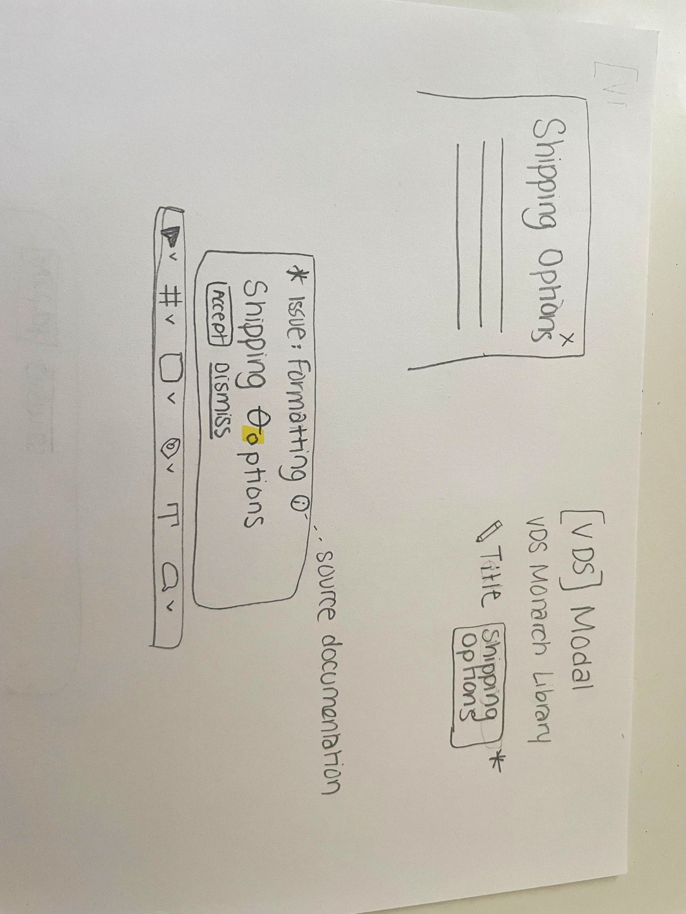

Outcomes

Business Outcomes
- Increase speed to market by reducing the time spent on manual copy checks and revisions.
- Improve brand consistency by programmatically enforcing editorial and style guidelines across all digital products.
- Reduce operational costs associated with fixing content-related errors post-launch.
- Lighten the load of the VDS support team

User Outcomes
Users (designers, content strategists) will feel confident that their work aligns with all relevant guidelines without having to leave their primary tool, Figma. They can focus on the core problem they are trying to solve for customers, trusting the tool to handle the mechanical aspects of content quality. This empowers them to work faster and more creatively.

Product Outcome
Users will integrate the AI writing assistant into their daily Figma workflow. The tool will become the primary method for validating and improving text content, leading to a measurable increase in content quality and a decrease in content-related defects.

Requirements

Functional Requirements
- The tool must be a plug-in that operates within the Figma environment.
- It must check for adherence to:
  - VDS content guidelines (e.g., principles, voice & tone, grammar, terminology, spelling, text patterns)
  - Component-specific UX copy guidelines
  - Parent Brand Elements (Voice and Editorial Styling)
  - Editorial Style Guide
  - AP Stylebook rules (e.g., grammar, punctuation, spelling) and associated dictionary, Merriam Webster
- It must flag content for potential issues related to clarity, tone, and readability.
- It must suggest corrections and allow the user to accept or dismiss them with a single click.
- It must provide links to the relevant documentation for flagged issues, helping to educate the user.

Non-Functional Requirements
- Performance: Suggestions and corrections must appear in near real-time to avoid disrupting the user's workflow.
- Accuracy: The AI model must have a high degree of precision to ensure suggestions are relevant and helpful, minimizing false positives.
- Security & Compliance: The tool must handle all text content securely, ensuring no sensitive or proprietary information is exposed to unauthorized parties.
- Usability: The interface must be intuitive and seamlessly integrated into the existing Figma UI.

Out-of-Scope
- This tool is not a generative AI for creating net-new content from a prompt. It is an assistance and validation tool.
- The tool will not check for the factual accuracy of the content.
- Initial versions will not support languages other than English.

Dependencies
- Tools / Frameworks: Figma Plug-in API, Large Language Model (LLM) APIs.
- Integration Points: Access to a comprehensive, up-to-date, and machine-readable repository of all content guidelines:
- Teams: Collaboration with VDS and Content Strategy teams to ensure the AI is trained on the correct and most current guidelines.

Risks

Value
(Will they use it? Does it solve a real problem?)
- Will designers and content strategists trust the AI's suggestions over their own judgment, especially on nuanced topics like tone?
- Is the time saved from manual look-ups significant enough for users to adopt the tool consistently?
- Does the tool provide clear, educational feedback, or will users find it to be a "black box" that encourages blind acceptance of changes?

Feasibility
(Can we build it with the time, skills, and technology we have?)
- Can an LLM be reliably trained or fine-tuned to understand and apply our specific, and sometimes conflicting, style guides?
- Can we achieve the near real-time performance required for a seamless Figma experience, given potential API latencies?
- How will we create and maintain the comprehensive knowledge base required to train the AI, and keep it updated as guidelines evolve?

Usability
(Can users figure out how to use it?)
- How should suggestions and errors be presented in the Figma UI so they are helpful and actionable, not intrusive or distracting?
- What is the ideal workflow for reviewing, accepting, and dismissing suggestions?
- How do we prevent "alert fatigue" if a large number of issues are flagged at once?

Viability
(Does this solution work for our business?)
- What is the cost of using external LLM APIs at scale, and is the ROI (in terms of time saved and quality improved) justifiable?
- How do we ensure the tool's usage complies with data security and privacy policies, especially if users are working on projects with sensitive information?
- Who owns the governance of the AI's rule set? How is accountability for the AI's suggestions managed?

Resources
Editorial_Style_Guide_2024_1_11.xlsx

🎓 Building An Expert

Building an Expert

After skimming source documents and style guides, I find it likely that nobody is an expert - there is so much info here, it looks nearly impossible to check everything. The necessity for an assistant is very apparent.

✦ Try the Gemini Gem prototype here

Source Documents

- VDS Content Guide
https://beta.designsystem.verizon.com/content/overview

VDS Component-Specific Docs (for Components with Copy)
https://beta.designsystem.verizon.com/components/component-status
- Filter through these and create a subset of copy-editable components
- Provides context of text purpose & possibly some formatting rules (UI text, microcopy, case & punctuation)
- Purpose helps with determining intention around the copy
- Seeking real examples (Do’s & Don’ts) for each copy component for training context
  - Where do these come from? Is there a way to automatically flow these back into the system?

Brand Central Guidelines - Voice
- Brand Strategy & Watchouts section
- ❤️Principles & Tactics - Probably the most important and literal ruleset for brand voice

Brand Central - Editorial Styling (punctuation, casing, formatting rules)
- This is where a lot of the org-specific “mechanical”/linting stuff will come from
- Acts as top-priority rules over AP Style or other guidelines

Verizon.com Editorial Style Guide - This is COMPREHENSIVE

VZA Guidelines - All of this
https://www.figma.com/design/S3z4fC6KvVmpCfaJmPxQXB/VZA-guidelines-and-style-guide?node-id=373-39332&t=aZrp5iHVx70s1FUm-0

….more coming…

AP Stylebook
This resource requires licenses - there’s a book that must be purchased, an “online tool” that doesn’t seem to have any developer access

AI Considerations

The custom LM backend will be built on the Verizon Vegas platform.

The type of setup we will likely be building is a Retrieval-Augmented Generation (RAG) agent. This LM will have the ability to look up information from source documents we have for additional context and further processing.

An intermediate API will handle user requests and communication with the LM Agent on the Vegas API. Previously, the Signal app was configured with a custom API and user auth, but it is not clear yet whether that can be utilized for this project. There’s a possibility of having to create a separate API server instance for the purpose of the single plugin, which needs a new code repo, dev test setup, and deployment pipeline.

Vegas has an API license time limitation of 4 weeks to get the project up and running and prove business value for continued use (need more info). Development, testing, and demoing should be planned around this.

Input & Output Formatting

✦ This was generated using the custom Gem.

Here is a breakdown of how to optimize the input and output for a future-facing, hybrid AI application.

Recommended Input Format & Context
To enable the AI agent to make highly specific and accurate editorial and compliance checks, the input JSON must provide more than just the text. It needs to include crucial contextual metadata. This metadata allows the engine to apply rules that are conditional on factors like component type, page location, and target audience.
Proposed Input JSON Schema:
JSON

{
"content_id": "callout-card-12345",
"component_type": "Secondary Callout Card",
"page_context": {
"page_name": "iPhone 17 Product Page",
"placement": "Hero",
"audience": "B2C"
},
"text_fields": [
{
"field_name": "title_line_1",
"text": "iPhone 17, on us"
},
{
"field_name": "title_line_2",
"text": "No trade-in required"
},
{
"field_name": "cta_button",
"text": "Buy"
},
{
"field_name": "footnote",
"text": "When you switch. Even on our lowest-priced plans."
}
],
"associated_media": {
"has_device_image": true,
"device_name": "iPhone 17"
}
}


Why this format works:
- content_id: Provides a unique identifier for tracking and history.
- component_type: Allows the engine to apply component-specific rules, such as character limits or specific CTA conventions.
- page_context: Crucial for applying rules that vary by audience (B2C vs. B2B) or placement (e.g., brand mark rules in headlines vs. body copy).
- text_fields: A standardized array ensures each piece of text is clearly labeled. This is vital for pinpointing where issues occur and for applying field-specific rules (e.g., CTA capitalization).
- associated_media: This is a critical piece of context. The VDS and Brand guides have specific rules regarding brand marks for devices when a product image is present. Knowing this helps the engine make the correct determination.

Recommended Output Format & Structure
The output should be designed to be easily parsed and displayed by a Figma plugin, serving as a real-time, actionable checklist for the user. It should go beyond a simple pass/fail by providing structured, machine-readable data that the plugin can use to build a rich user interface.
Proposed Output JSON Schema:
JSON

{
"compliance_status": "non-compliant",
"issues_found": [
{
"issue_type": "Capitalization/Punctuation",
"field": "title_line_1",
"original_text": "iPhone 17, on us",
"suggested_correction": "iPhone 17 on us",
"guideline": "VDS: Writing Guidelines > Punctuation, Brand: Capitalization decision tree",
"rule_description": "Avoid using commas unless necessary for clarity. The phrase is a simple offer, not a list."
},
{
"issue_type": "Brand Mark/Trademarks",
"field": "title_line_1",
"original_text": "iPhone 17",
"suggested_correction": "iPhone 17™",
"guideline": "Brand: Device Brand Marks",
"rule_description": "Run the brand mark (™) with the first reference to the branded term. Since the title is the first reference and there is no device image shown, the trademark symbol is required."
},
{
"issue_type": "Tone & Voice",
"field": "title_line_2",
"original_text": "No trade-in required",
"suggested_correction": "No trade-in needed",
"guideline": "Brand: Brand Voice > Watchouts",
"rule_description": "The word 'required' can sound prescriptive. 'Needed' is more aligned with the brand's 'simple and clear' and 'accessible' attributes."
}
],
"summary_report": {
"pass_fail_flag": "Fail",
"total_issues": 3,
"related_resources": [
{
"title": "Brand Central: Capitalization",
"url": "https://brandcentral.verizonwireless.com/guidelines/details/parent-brand-elements/editorial-styling/capitalization-decision-tree"
},
{
"title": "Editorial Style Guide: Device Brand Marks",
"url": "file://Editorial_Style_Guide_2025_05_01.xlsx - Device Brand Marks.csv"
}
]
}
}


Why this format works for your application:
- compliance_status: A top-level flag for quick visual feedback (e.g., a red/green dot).
- issues_found array: This is the core of the validation. Each object is an actionable item for the user.
  - field: Allows the plugin to highlight or associate the issue with the specific text box in Figma.
  - suggested_correction: Provides the exact text to replace the non-compliant version. The plugin could even implement a one-click "apply fix" button.
  - guideline & rule_description: Provides the justification and educates the user, which is a key goal of this tool.
- summary_report: Provides a quick overview for the user and can drive the plugin's UI.
  - pass_fail_flag: A simple, boolean-like value.
  - related_resources: This is a key value-add. The plugin can render these as clickable links, directing the user to the exact source documentation for deeper learning.
This structured output allows for a rich and interactive user experience within the Figma plugin, enabling features like in-line corrections, issue highlighting, and direct access to the source material.

Editorial Issue Taxonomy (WIP)
✦ This was generated using the custom Gem.
Note: The AP Stylebook is missing as a resource for this structure - I need a pdf
Anna Jolliffe

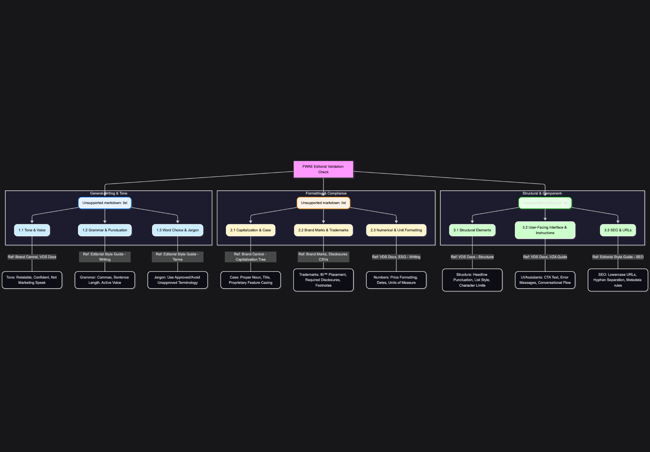

This table outlines the structured issue types and their corresponding documentation references, designed for programmatic validation and clear user feedback in the Figma plugin.
Category | Sub-Category | Issue Type Code | Description | Primary Document References
1. General Writing & Tone | 1.1 Tone & Voice | 1.1.01 | Checks for adherence to brand voice principles ("Relatable realness," "Encouraging conviction"). Flags language that is too formal, distant, or "marketing speak." | Brand Central Voice & Editorial Docs.pdf (Principles, Watchouts), VDS Docs (beta).pdf (Voice & tone), ESG - Writing Guidelines.csv
1. General Writing & Tone | 1.2 Grammar & Punctuation | 1.2.01 | Validates basic grammatical rules, including sentence structure, active voice, and the correct use of punctuation marks (commas, dashes, ellipses). | ESG - Writing Guidelines.csv (commas, ellipsis), Brand Central Voice & Editorial Docs.pdf (Punctuation), VZA Content Style Guide.pdf
1. General Writing & Tone | 1.3 Word Choice & Jargon | 1.3.01 | Flags the use of unapproved terms, jargon, or overly technical language, suggesting alternatives from the official term sheet. | ESG - Terms.csv (Primary Dictionary), Brand Central Voice & Editorial Docs.pdf (Jargon & slang), VZA Content Style Guide.pdf (Dictionary)
2. Formatting & Compliance | 2.1 Capitalization & Case | 2.1.01 | Ensures correct casing (Sentence, Title, Proprietary) based on the content field type (e.g., product names, headlines, features). | Brand Central Voice & Editorial Docs.pdf (Capitalization decision tree), ESG - Writing Guidelines.csv (capitalization), VZA Content Style Guide.pdf
2. Formatting & Compliance | 2.2 Brand Marks & Trademarks | 2.2.01 | Verifies correct use and placement of trademark symbols (®, ™, ℠) and that required disclosures are included for branded terms/devices. | ESG - Device Brand Marks.csv, ESG - Other Brand Marks.csv, ESG - Disclosures.csv (Mandatory Disclosure Text)
2. Formatting & Compliance | 2.3 Numerical & Unit Formatting | 2.3.01 | Checks for proper formatting of numbers, currency (prices), percentages, dates, times, and units of measurement. | Brand Central Voice & Editorial Docs.pdf (Numbers and units), ESG - Writing Guidelines.csv (money, numbers), VDS Docs (beta).pdf (Prices)
3. Structural & Component-Specific | 3.1 Structural Elements | 3.1.01 | Validates content against component-specific constraints, such as character limits for titles/subtitles, list styling, and headline punctuation. | VDS Docs (beta).pdf (Structural text elements), ESG - Writing Guidelines.csv (lists)
3. Structural & Component-Specific | 3.2 User-Facing Interface & Instructions | 3.2.01 | Checks copy for UI elements (CTAs, error messages, form labels, instructional text) to ensure clarity, consistency, and a helpful, task-focused tone. | VDS Docs (beta).pdf (Error message), VZA Content Style Guide.pdf (Domains), ESG - Writing Guidelines.csv (UI elements)
3. Structural & Component-Specific | 3.3 SEO & URLs | 3.3.01 | Ensures content intended for SEO (URLs, page titles) adheres to guidelines (e.g., lowercase, hyphens, proper naming conventions). | ESG - SEO URLs.csv (Primary Source for URLs), ESG - Writing Guidelines.csv (SEO / Site Search)

🌩️ Brainstorm

More Ideas & Use Cases

Generate proofs
Creative Exploration & Iteration

Selecting any text, generate alternative proofs that tweak aspects the original text while maintaining the intent. For example, a CTA button “Sign up now”, generates 2 alternatives “Get started” and “Sign me up”.

Scroll through the copy proofs to see them in the design, or clone the whole group of elements to commit 3 adjacent design proofs in the document.

Mark proofs for A/B Testing. View data related to tests.

Full maturation - surface data from previous tests on related copy, use the information to suggest some sort of strength metric (eg; BLAM factor)

“Writing Mode” Hybrid AI Chat interface
Experimental UX

In Writing Mode, the AI Chat minimizes into a thinking bubble. Any time you start editing text (on the page or as a text property), the element becomes highlighted, indicating AI focus, and a widget appears next to the text element providing inline feedback.

Execute Bulk Instructions on Copy
Advanced Workflow Utility

Chat with the AI Assistant to identify & select different groups of copy on the file, and perform actions on them like validation, bulk-approve changes from the chat window, tweak the tone, or get a summary of intent.

Ask Steve about the easter egg feature

🔬 UX Research

AI Assistant Interfaces

Based on the Verizon principle of “Relatable: Create Familiar Interactions”, the Writing Assistant tool is an AI Assistant - so it makes sense to look into modern AI Interfaces, especially chat, for inspiration and functional overlap – so the interface feels familiar and intuitive.

Exploration: What parts of the modern/standard AI Chat interface apply to this tool?

AI Assistant Interface Modalities

1. Conversational Interfaces
This modality uses natural language to mimic human conversation.
- Characteristics: Relies on text or voice as the primary mode of interaction.
- Examples: Standalone apps like ChatGPT, or chatbots on websites for customer service (e.g., a Domino's Pizza bot).
- Key UX Principles: Conversation design, a clear and consistent AI persona, effective error handling, and the ability to use multimodal inputs (e.g., text, voice, and visual elements like quick replies).

2. Embedded & Contextual Interfaces
This AI functionality is integrated within a larger product or system and appears contextually.
- Characteristics: The AI is a feature layer, not a separate app. It can be proactive (initiating interaction) or reactive (responding to user actions).
- Examples:
  - Proactive nudges: A banking app suggesting you pay a bill.
  - Inline suggestions: Gmail's Smart Compose, offering real-time text completion.
- Key UX Principles: Seamless integration, ensuring the AI's presence feels natural and unobtrusive. The AI should be predictive without being intrusive, and the user should always have control to accept or dismiss suggestions.

3. Proactive Interfaces
These interfaces anticipate user needs and initiate interaction without being prompted.
- Characteristics: The AI leverages contextual data (e.g., location, time, behavior) to provide timely and relevant information. The AI initiates the interaction, rather than waiting for the user to.
- Examples: A navigation app suggesting your commute home based on the time of day, or an e-commerce site offering a discount code at checkout.
- Key UX Principles: Transparency, where the AI explains why it's making a suggestion, user control to override or dismiss actions, and non-intrusiveness to avoid overwhelming the user.

4. Generative Interfaces
This modality uses AI to create new content from a user's prompt.
- Characteristics: The user provides a high-level command (e.g., "Write a blog post about UX design trends"), and the AI generates a complete output.
- Examples:
  - Text/Code Generation: An AI that drafts a marketing email or writes code snippets.
  - Visual Generation: An AI that creates images, diagrams, or UI mockups from a description.
- Key UX Principles: Prompting as an interaction element, allowing for easy refinement and iteration, and "Human-in-the-Loop" control, ensuring the user can edit, mix, and match the AI's output.

Key UI/UX Design Trends for Chat Interfaces
The visual and interactive elements are just as important as the underlying technology.
- Transparency and Trust: To manage user expectations, it's a best practice to clearly disclose that the user is interacting with an AI. This can be done with a clear welcome message, an "AI" label next to the chatbot's name or avatar, and clear legal disclosures.
- Structured and Guided Interactions: While free-form conversation is powerful, users often benefit from guidance. Design patterns include:
  - Prompt Scaffolding: Providing suggested prompts or "quick replies" to help users get started.
  - Progressive Disclosure: Offering a small number of clear choices or buttons to guide the user through a specific flow.
  - Interactive Visuals: Using elements like buttons, cards, or carousels to present information in an organized way, rather than a wall of text.
- Dynamic Feedback: The interface should provide real-time visual feedback to the user. This includes:
  - Typing/Thinking Indicators: An animation that shows the bot is processing the request. This reduces perceived latency and manages expectations.
  - Dynamic Content: Responses that include interactive elements, links, or images that load as the AI generates them.
- Personalization and Context-Awareness: The interface should adapt to the user's needs, history, and context. This goes beyond just personalization and can include the interface adapting based on the user's device (desktop vs. mobile) or even their emotional state (using sentiment analysis).
- Micro-interactions and Animations: Subtle animations and hover effects provide user feedback and make the experience feel more polished and engaging. Examples include a subtle pulse on a button or a smooth transition when new content loads.

Oddbody Integration & Overlap

Oddbody Docs
Guardrails & UX Principles
- Preserve flow
- Low false positives
- Always reversible fixes
- Guidance over enforcement
- Supportive, human tone
- Progressive disclosure
- Transparent data handling: opt-in for context, no “surveillance.”

Core Capabilities (Moment-of-Need)
- Detect & Nudge: Identify outdated components, misapplied tokens, risky motion, copy overflow, and misaligned priorities.
- One-Click Fix: Apply automated corrections—token swaps, spacing, motion presets, accessibility fixes.
- Explain & Teach: Every nudge comes with rationale, linked guidance, and customer or product context.
- Ask VDS Anything: In-canvas conversational support for specs, guidelines, and best practices.

👯 Component VQA

Component VQA
#Testbench
Product Lead: Natasha Khoso
Engineering Lead: Gabriel Dib

Component VQA NotebookLM

“[VQA] is necessary… it needs to be part of the workflow, but it’s nobody’s favorite part of their job.”

“The time taken is really in clicks. It’s just a million clicks to get stuff done. Make a change, pull it down, take a screenshot, pull it up, go to another window, change the dynamic type setting, go back, make an edit, screenshot… that kind of stuff takes the most time. So if there’s a way to automate out all those clicks, that’s hours and hours of time saved. It’ll save hours off each round of VQA.”

“[VQA] is a very manual process, and because it’s a manual process, there’s a lot of room for error.”

“VQA needs to happen, because we’ve had some major issues [with components] that would have looked psychotic if they’d gone into production. But nobody likes doing it. It’s not the kind of work that anybody got into design to specifically do.”

Overview

What is VQA?
Visual Quality Assurance (VQA) is the process of visually verifying that a coded UI component exactly matches its original design specifications.

Why do we do VQA?
We do VQA to ensure the visual quality of components before they are released, preventing visual bugs and inconsistencies.

How do we do VQA today?
The VQA process of components is a time-consuming, manual process. It involves designers and developers comparing rendered components to Figma designs and visually inspecting pixel-level differences. VQA relies on human judgement to identify inconsistencies.

The VQA process is done for both web and mobile components. Each of these has a separate workflow.

Web VQA

Inconsistencies found?
yes
no
Failed VQA:
Record bug in Jira ticket
Passed VQA:
Ready to be merged
Component ready for VQA
First VQA done in Storybook by inspecting the DOM of the component
Second VQA done in Test App by visually inspecting the component
Inconsistencies found?
yes
no
Failed VQA:
Report bug in Jira ticket
Passed VQA:
Ready for next phase
High level process diagram for web VQA

Storybook is a frontend platform to build UI components, and is used for web VQA. In Storybook, the rendered component and its properties can be accessed.

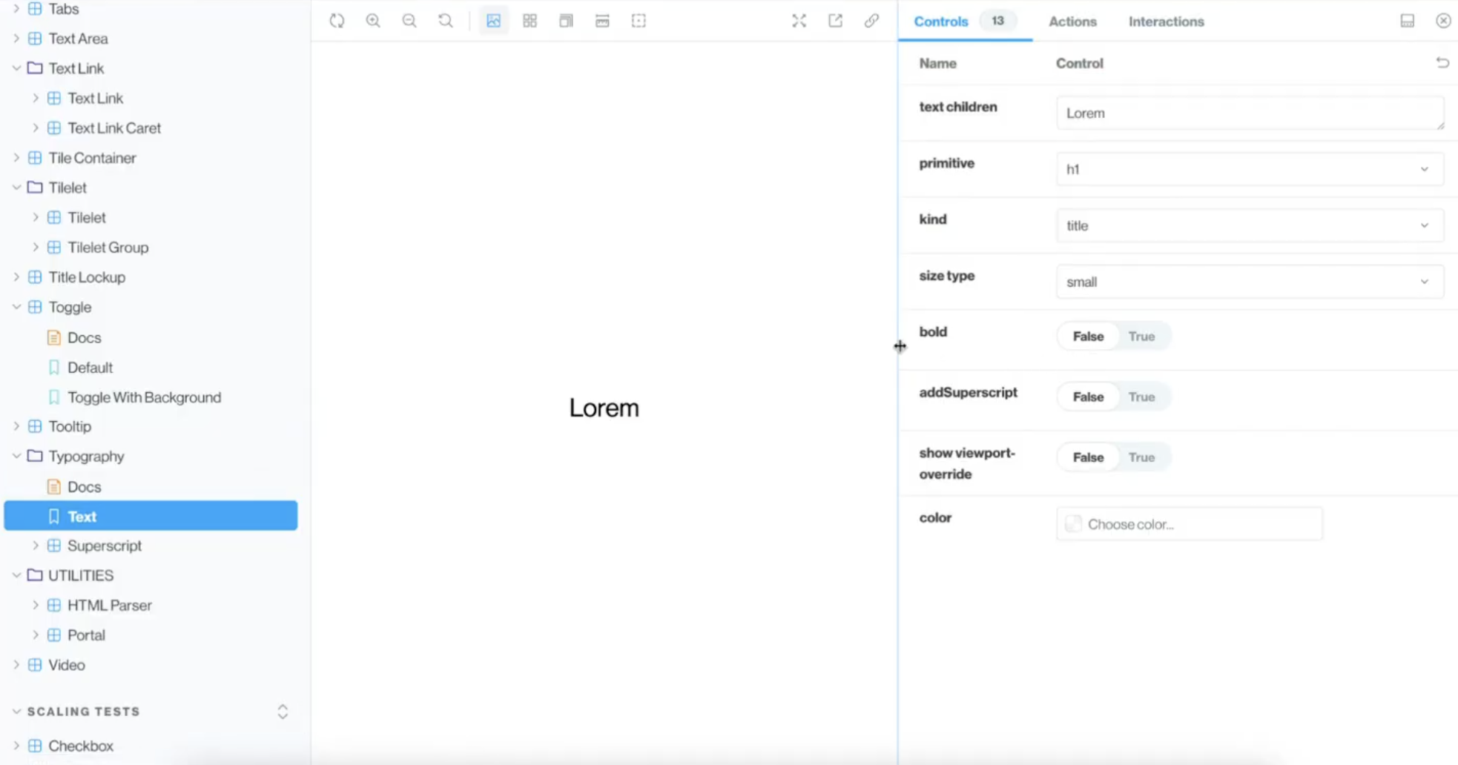
Text component in Storybook and its properties

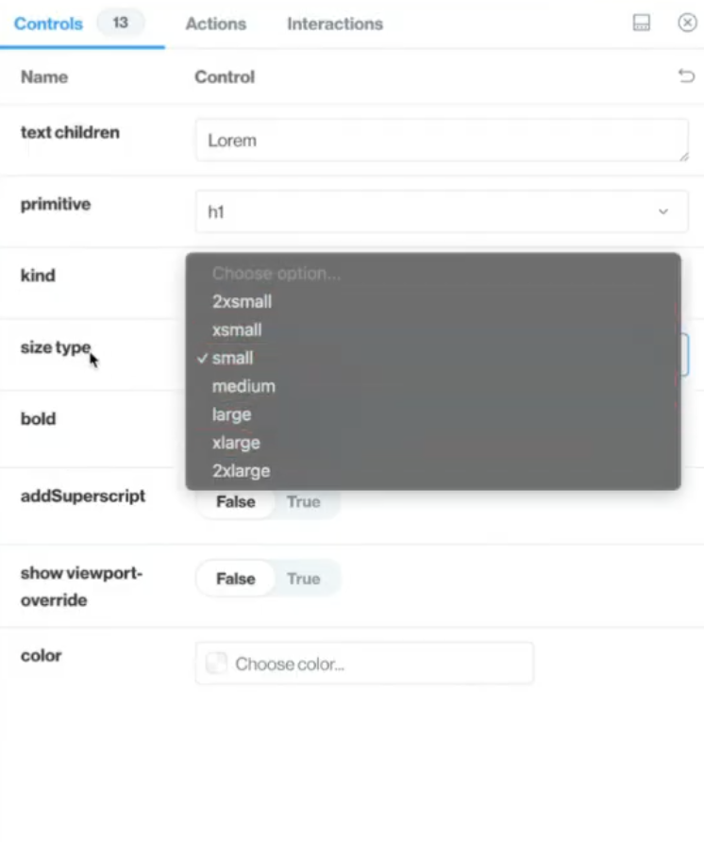
Values for the ‘size type’ property of Text component

To perform VQA in Storybook, the Document Object Model (DOM) of the component is inspected. This allows the user to see the structure of the component and verify that the intended design tokens are being applied.

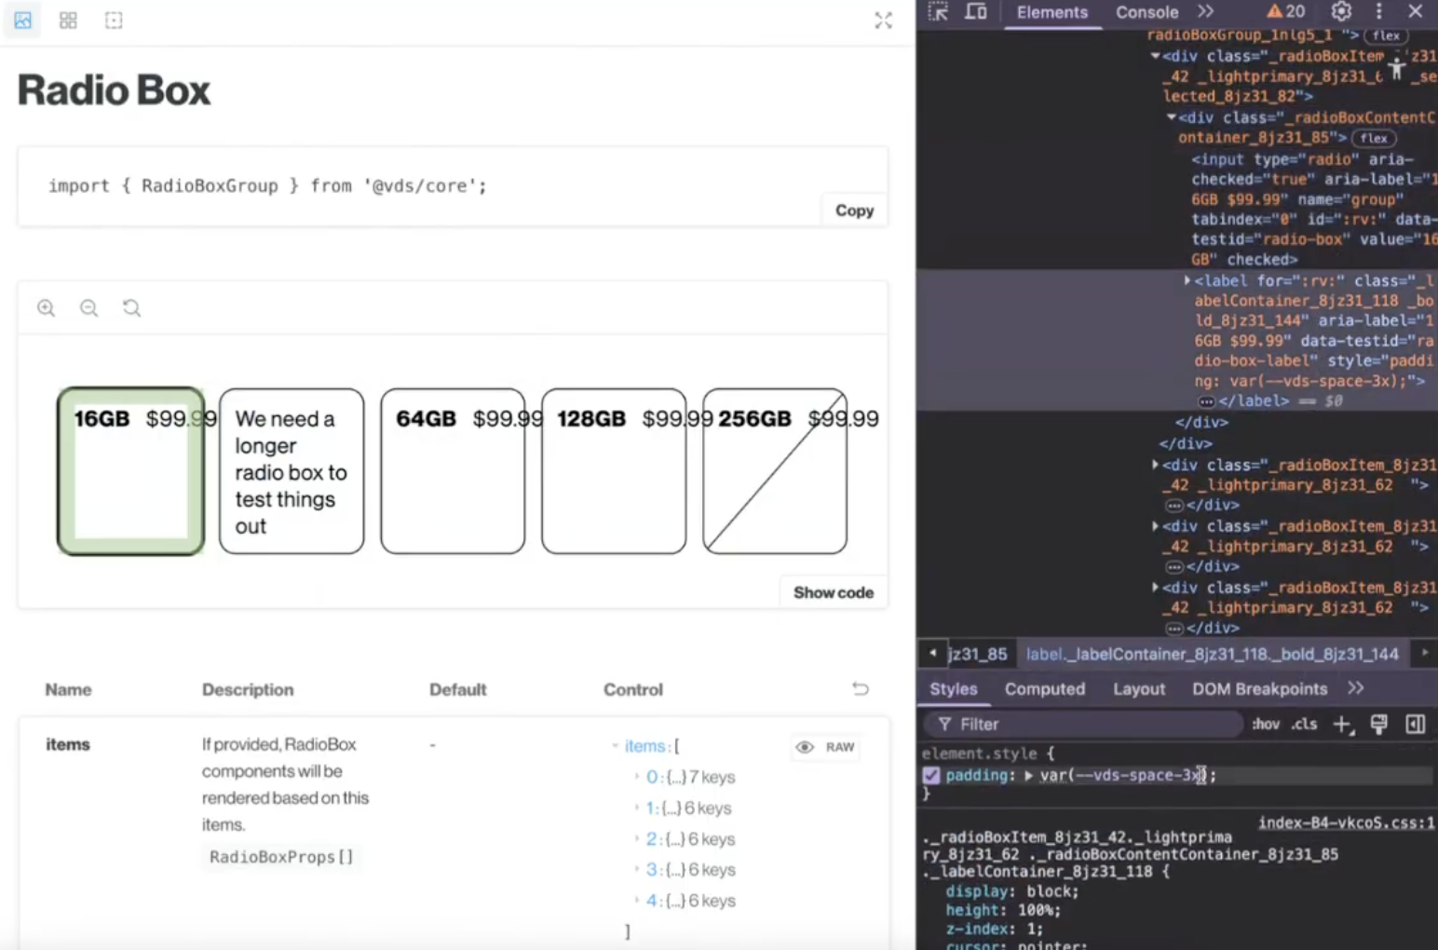
Inspecting the Radio Box component to see if the correct padding is being applied

This structure is compared to the design spec for the component. A design spec provides all the relevant information on the functionality, behavior, and appearance of a component. In a design spec, there is a section called ‘Change History’ outlining the changes made to the component.

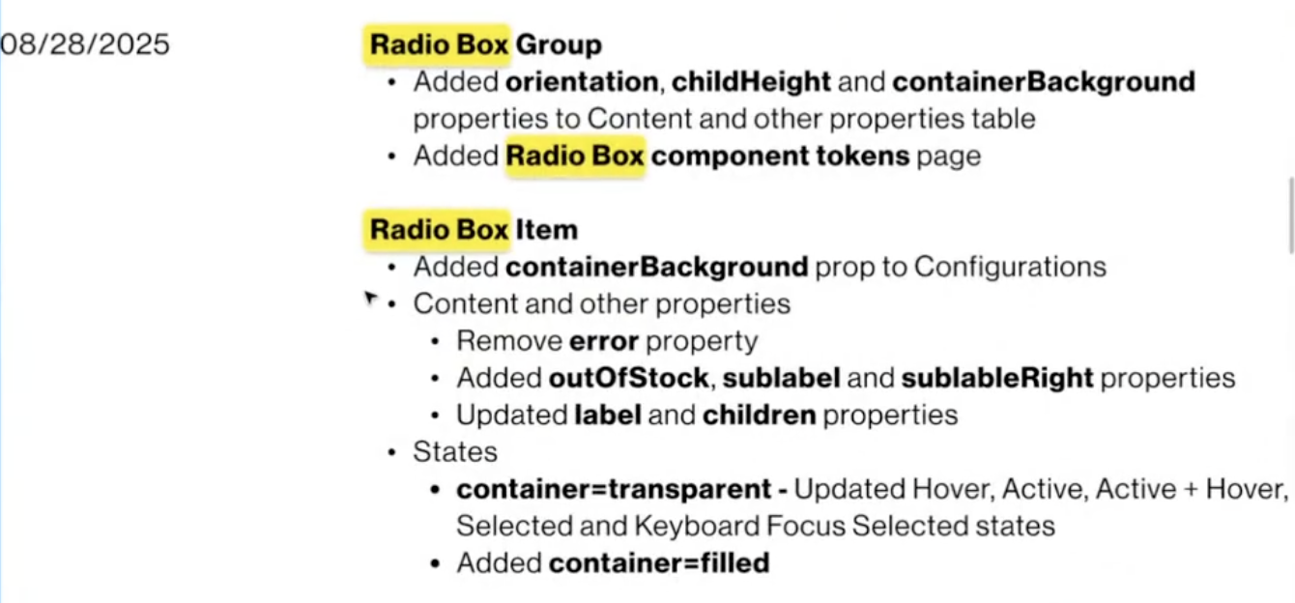
Part of the Change History outlined in design spec

If the component’s structure exactly matches the design specs, the component will pass VQA. If it does not, it will fail VQA. In both cases, this information will be added to the Jira ticket.

In Test App, which is a mock version of the Verizon website, components are visually checked to see that they appear as expected. The DOM is also inspected to confirm that the structure of the component is correct. Like in Storybook, the component either passes or fails VQA. This is documented in the Jira ticket.

The amount of time spent on VQA varies based on the complexity of the component. Di estimated that web VQA is 30% of her total workload. On the engineering side, Wasim estimates that VQA for a web component takes under 2 hours on average. For a simpler component like Toggle, it would take an hour for VQA whereas more complex ones like Carousel could take 3-4 hours. These time estimates include the time he spends reviewing the code.

Mobile VQA

Build for iOS released to TestFlight
Screenshots taken of different visual states of the component
Screenshots resized in Figma
Manually compare the Figma design to the screenshot to spot visual differences
Inconsistencies found?
yes
no
Failed VQA:
Report bug and update ticket
Passed VQA:
Ready to be merged
Build for Android released to BrowserStack
Component ready for VQA

High level process diagram for mobile VQA

- For Android, the coded component is accessed on a selected Android device in BrowserStack. For iOS, the component is accessed on an iOS concession device.
- The component is configured by changing some of its properties using the properties panel.
- A screenshot is taken of the component in its configured state.
- The screenshot is uploaded to Figma to preserve its original resolution.
- The screenshot is manually resized to match the dimensions of a corresponding frame in Figma that has a component configured with the exact same properties.
- The screenshot is overlaid on the design frame with 50% opacity, making misalignments visible.
- The Jira ticket is updated with whether the component passes or fails VQA. If there are any inconsistencies, these are also documented in the ticket.

Below is an example of a Jira ticket that shows the exchange between developers and designers for the Badge Indicator component on iOS.

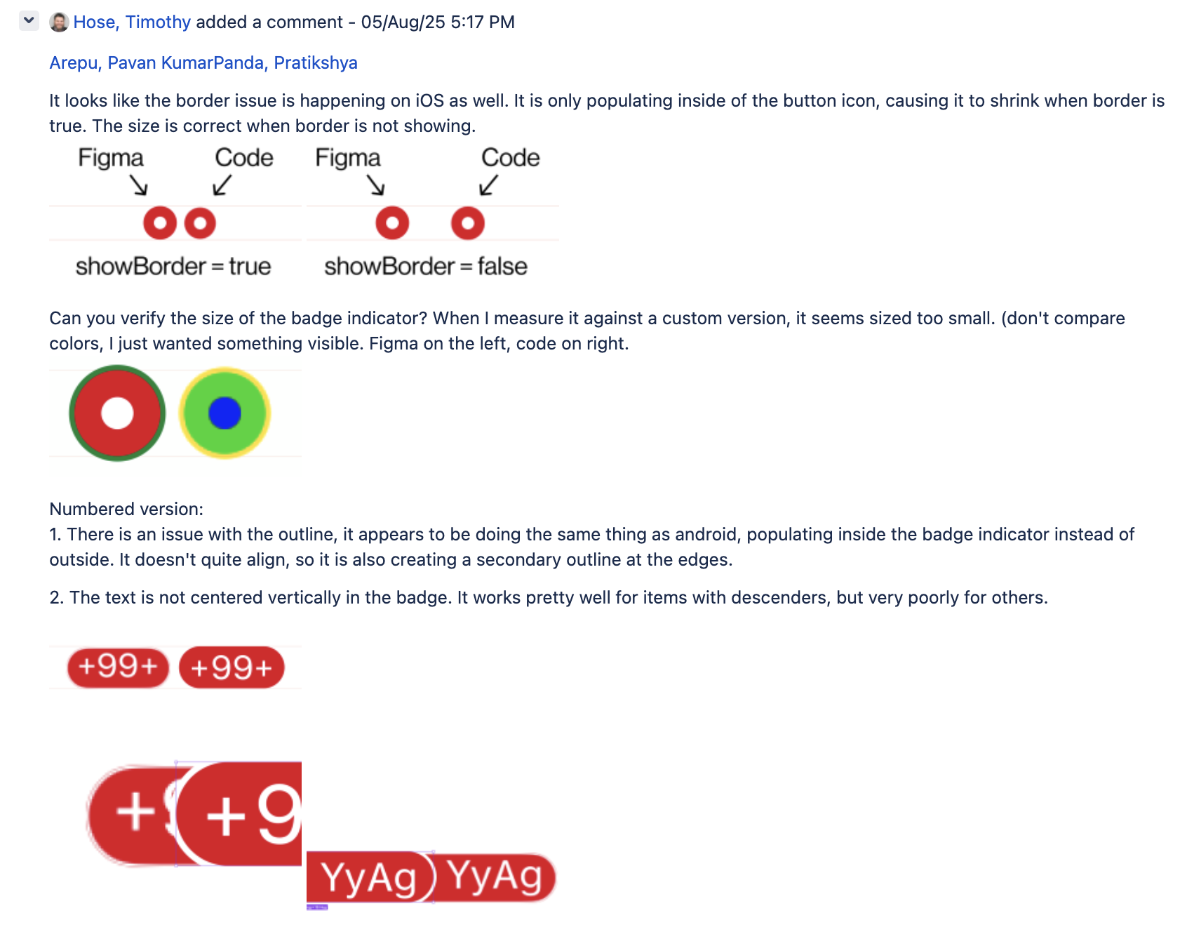
Detailed explanation of issues with Badge Indicator component given by designer

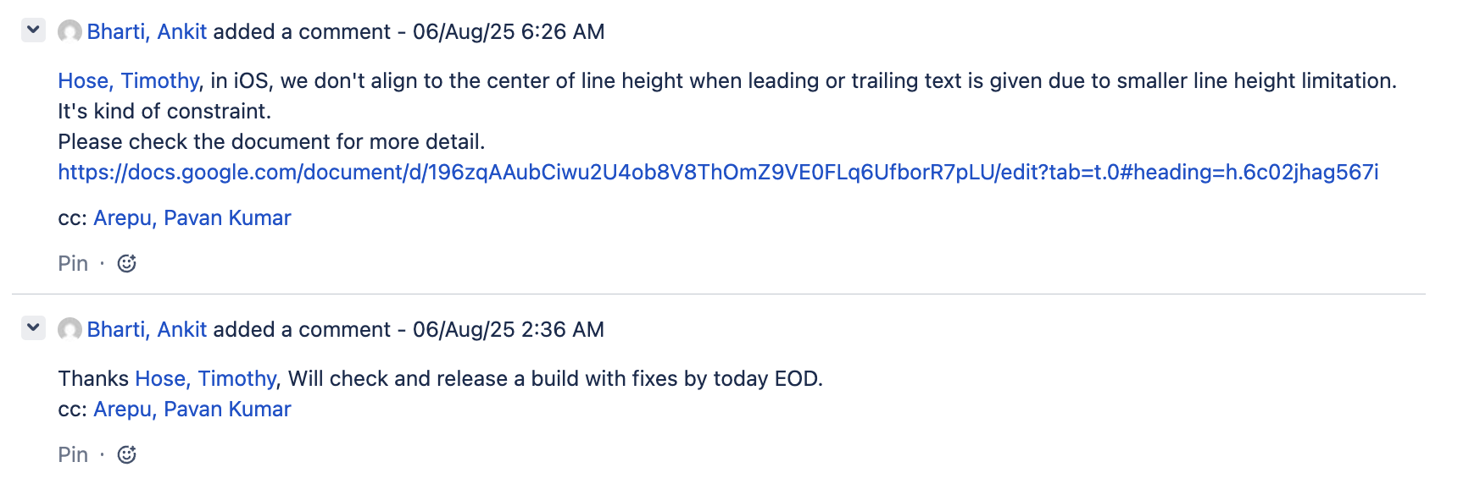
Developer addresses the reported issues and will release new build with fixes

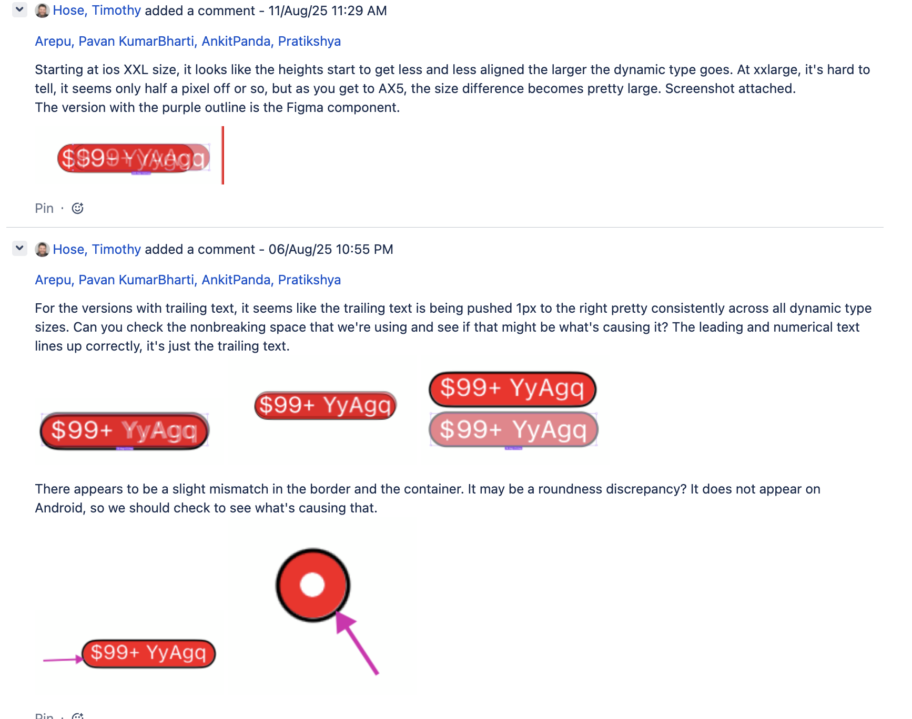
More issues with the component identified by the designer

Jira ticket for Android Button VQA

Components might go through several rounds of VQA before they are visually verified and ready for release. For example, a mobile component like Typography required 14 rounds of VQA, while Button went through VQA 7 times, followed by additional dynamic testing. For both web and mobile components, this process is done at least twice: once by developers and once by designers.

The amount of time spent on mobile VQA varies based on the complexity of the component. Tim estimated that mobile VQA is 60-80% of his workload.

Problem Statement
The current VQA process is a manual and tedious task that takes up valuable time from designers.

Impact if Unsolved
If left unaddressed, the VQA process will remain manual, limiting its scalability. The manual nature of the process will continue being a bottleneck, hindering the team’s ability to quickly release new components to meet the demands of downstream design teams.

JTBD
Jobs-to-be-done Theory (JTBD)

Functional: By automating the VQA process, users can work more efficiently. They can dedicate more time to:
- Discovery work for new components
- Addressing backlog requests for components to support

Emotional: The tool performs VQA instead of the user, while still leaving the final review to the user. As a result, the user feels confident about the quality of the component and that no bugs have been missed.

Users will spend less time manually performing VQA, and will instead integrate the tool in their workflows.

Tracking Progress
The following outcomes will be tracked on a weekly basis to measure progress:

- Time on task: how many minutes are spent on VQA for a component
- Quality: percentage of accuracy of the identified bugs
- Risks: the number of risks mitigated

Users
The main users of this tool will be designers who want to ensure that the coded component exactly matches the original design. Developers who build the component will also use the tool, allowing them to proactively check for visual regressions as they write code, before it is sent to a designer for review.

Requirements

Functional Requirements
Mobile VQA
- Renders components on a set of virtual Android and iOS devices using an integration like BrowserStack.
- Programmatically configures a mobile component’s properties to apply specific values.
- Captures high-resolution screenshots of the component in various configurations and uploads them to Figma.
- Performs a pixel-by-pixel comparison between the screenshot and the Figma design to identify visual inconsistencies.
Web VQA (likely lower priority, TBD)
- Programmatically accesses and renders components from Storybook based on specific configurations and properties.
- Accesses and interprets the design specification and identifies the required design tokens.
- Automatically inspects the DOM and compares the tokens being used to those outlined in the spec.

Non-Functional Requirements
- Performance / Speed
  - Completes VQA for a simple component in less than X amount of time (figure out this number).
  - Completes VQA for a complex component in less than X amount of time (figure out this number). .
- Accuracy and Reliability
  - Achieves >95% (placeholder number) precision and recall, meaning that test cases are both comprehensive and valid.
- Security & Compliance
  - Leverages the VEGAS platform to ensure all GenAI operations are secure and compliant with Verizon’s standards.
**maybe change the phrasing here
- Scalability
  - Allows for the code and infrastructure to be easily maintained and updated if changes are made to APIs or design system architecture.

Out-of-Scope
- Accessibility audits: While visual consistency is related to accessibility, the tool will not perform automated accessibility checks such as color contrasts.
- Component functionality: The tool will not verify a component’s functionality, and will only be doing a visual check of the component.
- End-to-end testing: The tool will focus only on component VQA, and will not extend to full-page layouts or user flows.

Dependencies
- Integration Points: APIs for Figma, GitLab, BrowserStack (if being used) and VEGAS platform.
- Data: Access to VDS design specifications and component libraries.

VEGAS
VEGAS (Verizon Enterprise GenAI Services platform) is an experimentation and prototyping sandbox to build use cases that leverage GenAI. It acts as a drag-and-drop canvas for users to easily build and customize GenAI use cases. VEGAS hosts reusable code and API endpoints which minimizes rework by standardizing use case delivery. Implementation teams can build and stitch together use cases, and the output is an API that they can embed into other applications to reference the solution they built.

Why VEGAS?
- A centralized platform helps accelerate GenAI application development by enabling the quick exploration, building, deployment, monitoring and maintenance of use cases.
- It leverages the latest LLM Ops standards to ensure solutions are high-quality, scalable, secure, and responsible. The VEGAS team manages access to the latest technology in a safe and secure way, allowing users to focus on building without worrying about underlying infrastructure or governance.

Options (of possible solutions)
- Manual VQA
This is the current process used to check for visual consistency (as outlined in Background) that relies on human effort for testing.
  - Value: A time-consuming and tedious process that keeps designers and developers tied up in mundane tasks rather than focusing on high-impact work.
  - Usability: The process is repetitive and error-prone, leading to bugs and user frustration.
  - Feasibility: While it is currently being used, it is not a feasible long term solution. As the number of components grows, it becomes difficult to manually check for visual inconsistencies.
  - Viability: It creates a bottleneck in the development pipeline and delays the release of components.
- Browserstack (Mobile)
  - Value: It does not directly address the problem and would need to be integrated with a custom solution.
  - Usability: The manual steps of having to select devices and take screenshots are time-consuming (too many clicks!!)
  - Feasibility: Already built.
  - Viability: Not cost effective if being used in addition to a custom solution.
- Percy
  - Value: Makes the VQA process faster by reducing manual work. Supports both web and mobile apps.
  - Usability: Changes are highlighted in a meaningful way and feedback can be left on the file.
  - Feasibility: Already built.
  - Viability: Can help reduce time and money spent on VQA so users can focus on other work.
- Chromatic
  - Value: Reduces manual work because it was specifically built to perform visual regression testing. It provides an automated web VQA process but does not support mobile VQA.
  - Usability: Has a centralized, collaborative dashboard to streamline VQA work. Changes are flagged to be reviewed, and can be approved or denied by a team member.
  - Feasibility: Already built.
  - Viability: It is hosted on an external cloud-based platform so would need to be vetted by legal and security teams.
- Playwright
  - Value: Is built to perform visual regression testing and can do pixel-level comparisons.
  - Usability: Not the most intuitive tool as it is generally run in the terminal on a local device.
  - Feasibility: Already built.
  - Viability: A basic tool that does not have the scalability and collaborative features required for a larger enterprise.
- Custom Tool

Pilot Components
- [ component name ] - [ explain why this is a good and/or bad choice ]

AI Evals
First define what a correct/valid detection is.

Initial evaluations:
Create a dataset of X (decide this number, and decide which components) components representing a range of complexities.

(***These should probably be new components or components that haven’t been through VQA yet, because if we use ones that have already been tested they won’t have bugs anymore?
OR
We use older versions of components that had visual bugs because we know exactly what bug there was - and then some that we know do not have any bugs) I feel like this one makes more sense

Metrics:
- Precision: of all the visual bugs flagged by the tool, what percentage were actually valid and correct?
- Recall: of all the genuine visual bugs that exist in the dataset, what percentage did the tool successfully detect?
- Speed: how long does it take for the tool to generate a VQA report?
- Consistency: how consistent are the results for the same component across different platforms?

Run, review, and retrain (as needed).

User evaluations:
Have users incorporate the tool into their workflow - they should use the tool to conduct VQA the way they normally would (once we decide what parts to focus on, will make this more specific).

Metrics:
- Time on task: how long does it take for the user to do VQA with the tool versus without it?
- Error rate:
  - Wrong detections: how many AI-flagged issues were incorrect?
  - Missing detections: How many bugs did the tool fail to detect that a user was able to find?
- Qualitative feedback on:
  - Usability
    - Does the tool fit into the designer’s workflow?
      - Are there any points of friction?
    - How easy it is to:
      - Use the tool
      - Understand the output given by the tool
  - Accuracy
    - Types of errors the tool is making

Prioritization (WIP)

Steps in the Process | Mobile | Web
Open the component in BrowserStack and display it on a selected device | Yes | No
Change some properties of the component (e.g. change values, turn toggles on/off) | Yes | No
Take screenshots of the component | Yes | No
Upload to Figma | Yes | No
Resize the screenshot in Figma | Yes | No
Overlay the screenshot and component in Figma and spot inconsistencies | Yes | No
Update Jira ticket with whether VQA has been passed or not | Yes | Yes
Inspect the element in Storybook and check if the correct tokens are being used | No | Yes
Visually inspect the component on the Test App | No | Yes

Product Risks
The Four Big Risks - Marty Cagan (The Godfather of Product Management)

Value Risk
(Will anyone use it? Does it solve the right problem?)

- Users might not find the tool to be useful if..
  - They have to fix all of its outputs.
  - They don’t trust it, because..
    - The tool isn’t consistently accurate.
    - It doesn’t instantly tell them what’s wrong. (might move to usability risk)
    - They don’t know how the tool is making decisions.
- It might not be efficient if..
  - It would be faster for users to do the task manually.
  - Users spend the same amount of time on VQA (reviewing, fixing bugs) even if they’re not the ones performing the tasks.
- The output lacks quality if..
  - It is not able to detect as many bugs as a human.
  - The differences it detects are not meaningful or relevant (false alarms).

Feasibility Risk
(Can we build it with the time, skills, and technology we have?)

- The custom tool might not integrate seamlessly with the software/platforms we need to use (e.g. Figma).
- If changes are made to external APIs that we rely on, it might break our workflow.

Usability Risk
(Can users figure out how to use it? Will they use it correctly?)

- Users might not be able to understand the output of the tool if..
  - It is too technical or complex for the target users.
  - There is no visual feedback to explain what the output means.
  - It does not make it clear what action the user should take based on the result.

Viability Risk
(Does the solution work for the business — legal, cost, compliance, stakeholders?)

- The tool might not be sustainable and cost-effective in the long term if..
  - It requires manual maintenance to keep running.
  - The cost of external tools being utilized becomes too high.
  - It takes a lot of time and effort to train team members.
  - The cost to update and improve the tool is too high.
- The tool might not remain relevant as the design system evolves if..
  - It cannot be updated to match changes in the design system’s architecture.
  - It does not support new types of components or design tokens.

Appendix

BrowserStack

(***probably imp info but move this somewhere else)
The VDS team is currently on the following BrowserStack plans:
- For web testing: Live Team Plan ($300/month, 10 users)
- For app Testing: App Live Team Plan ($300/month, 10 users)

These plans give users access to thousands of iOS and Android device units for manual, live testing. Some examples of the manual steps include selecting devices and taking screenshots.

BrowserStack has other plans/features that can be considered:
- Team Pro Plan
This plan costs $499/month for 10 users. The plan has two key features that would be useful when considering automating the VQA process.
  - Multi-device testing: This allows for a component to be tested on multiple devices simultaneously, with screens placed side-by-side for easy comparison.
  - Dynamic type testing on iOS devices: This feature is only available on the Pro plan. Having access to it could eliminate the need to use a separate concession device for screenshots.
- Automate Plans
The current plans are designed for manual testing, but BrowserStack also has Automate plans that have features that make automation easier.
  - Screenshot API: can be used to automate the process of generating, saving, and sharing screenshots of the site on multiple devices and browsers However, this feature is only available for web testing plans so it doesn't address our specific problem of manually screenshotting for mobile testing.

Example: BrowserStack API has been used to build a custom QA tool by the company Exemplifi. They created an automated QA pipeline by combining BrowserStack’s Screenshot API and a machine learning image recognition tool called AWS Rekognition. The process involved automatically capturing screenshots across a wide range of browsers and devices. These screenshots were then processed and sliced in Python to identify individual UI elements. They were used to train the Rekognition model, which allowed them to visually validate core elements of their website.

Limitations: The AWS Rekognition tool is not the most suitable for our purposes because its function is fundamentally different from what we are looking for. The tool is able to identify whether an element is present or missing, but does not do a pixel-by-pixel comparison, therefore it does not ensure exact alignment. This means it can classify whether an element is a button or not, but may not flag a change in its exact color or a one-pixel shift in its position.

Percy

Percy is a visual testing tool to automate catching visual bugs, enabling users to review UI changes. It can be integrated into existing testing suites and is used for both web and native applications. It captures screenshots of a build and compares them to a baseline image. The changes are highlighted as shown in the image below:

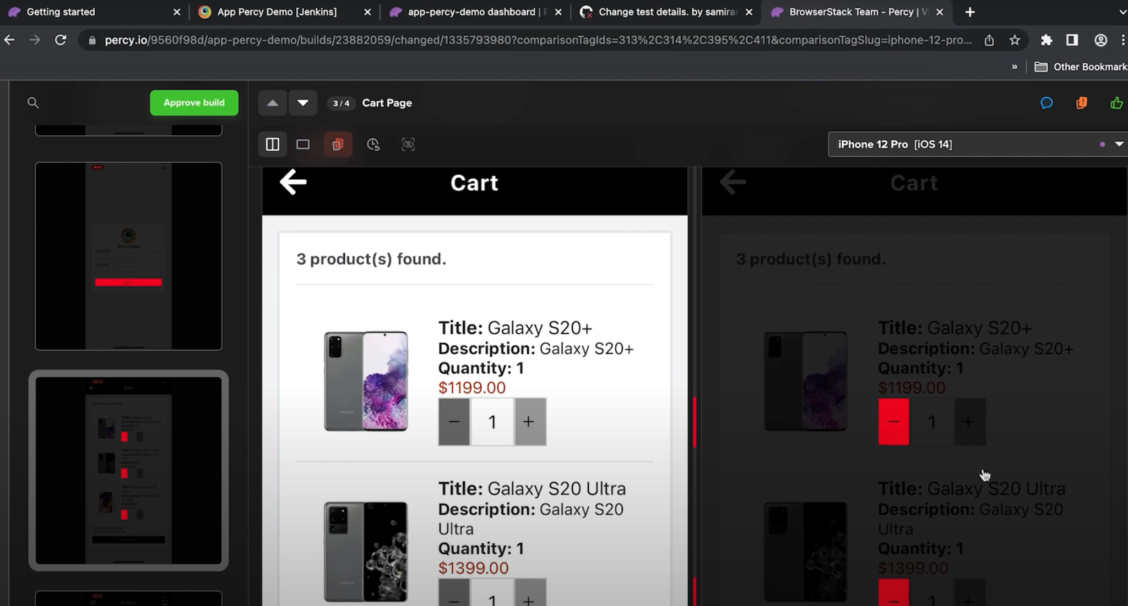
Differences between images highlighted in red

Comments and feedback can be left on files where the changes are highlighted. There is a feature called ‘ignore region’ that allows users to block off a certain area of an image to be excluded from future comparisons. The level of sensitivity of detection can also be modified which helps ignore noise while still identifying meaningful changes.
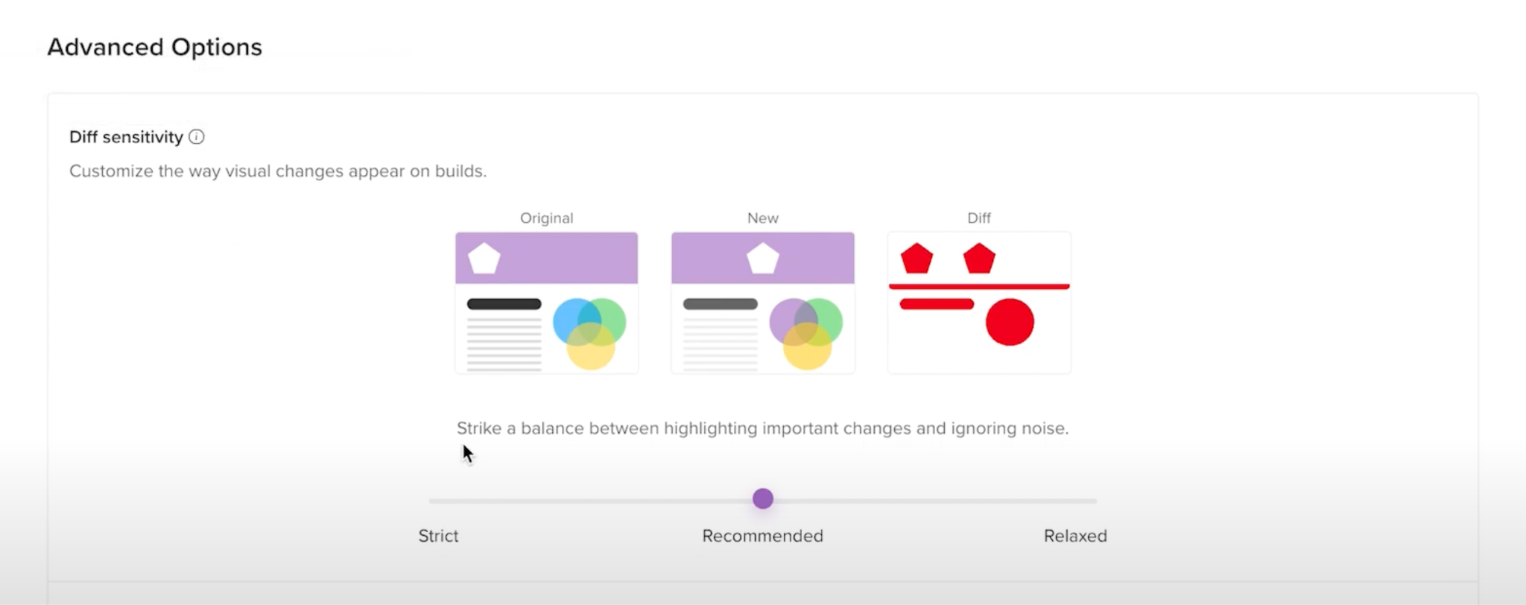
Can set different levels of sensitivity to changes

Percy can be integrated into existing CI/CD pipelines, automating visual tests on every pull request. For mobile testing, it works in conjunction with Appium, which drives the test scripts used to capture screenshots. Tests can also be debugged using BrowserStack’s App Automate feature.

Percy documentation: https://www.browserstack.com/docs/app-percy

Chromatic
Chromatic is a tool that has been specifically built to perform automated visual regression testing on UI components. It automatically turns existing component tests (written in Storybook, Playwright, or Cypress) into visual regression tests. It takes snapshots of a component's styling, real code, and assets in a standardized browser to ensure consistent results. This approach helps reduce flaky tests (false positives or negatives).

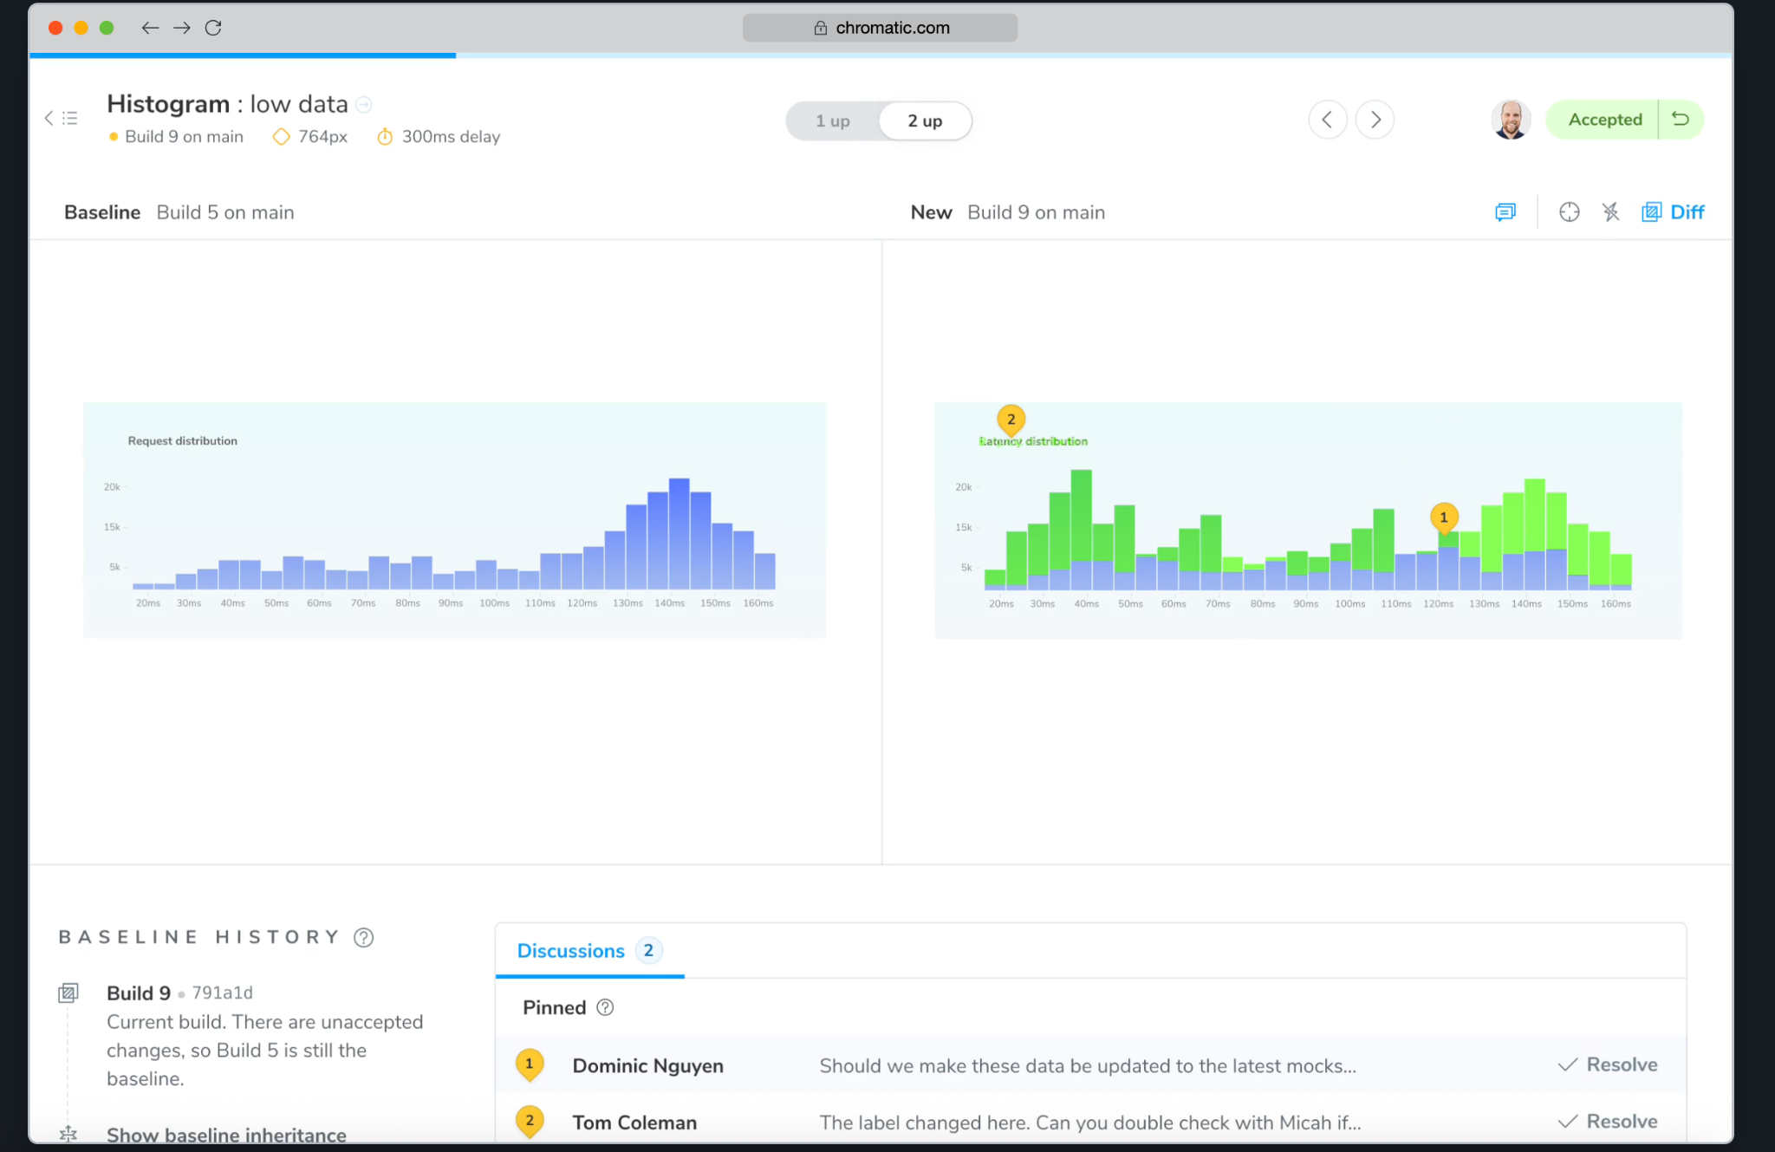
Chromatic’s dashboard where changes are flagged and reviewed

It provides a central dashboard (pictured below) for a streamlined QA workflow. When a change is detected, it is flagged for review. Users can inspect the component and either accept or reject the changes directly from the dashboard. There is also a collaborative space for different members of the team to leave comments. It has integrations for tools like Git and Slack.

Limitations: Chromatic does not support QA for native mobile UI components. While it can text web components across different screen sizes and viewports, it does not allow for iOS or Android component visual testing.

Playwright

Playwright is an open source tool for web testing that automates interactions in a browser. It has built-in visual testing capabilities, allowing it to capture and compare screenshots when run. It takes screenshots of a full web page or a specified element and compares this new screenshot to a pre-approved baseline image. If a pixel-level difference is identified, the test fails and Playwright highlights the changes. It can run visual tests across browsers and different screen sizes.

Limitations: It does not have a centralized dashboard that shows the differences between the screenshots. It does not support QA for native mobile UI components. While it can text web components across different screen sizes and viewports, it does not allow for iOS or Android component visual testing.

Other info

MCP Servers

Using MCP, AI applications can connect to:
- Data sources (e.g. local files, databases)
- Tools (e.g. search engines, calculators)
- Workflows (e.g. specialized prompts)

This allows them to access information and perform tasks.

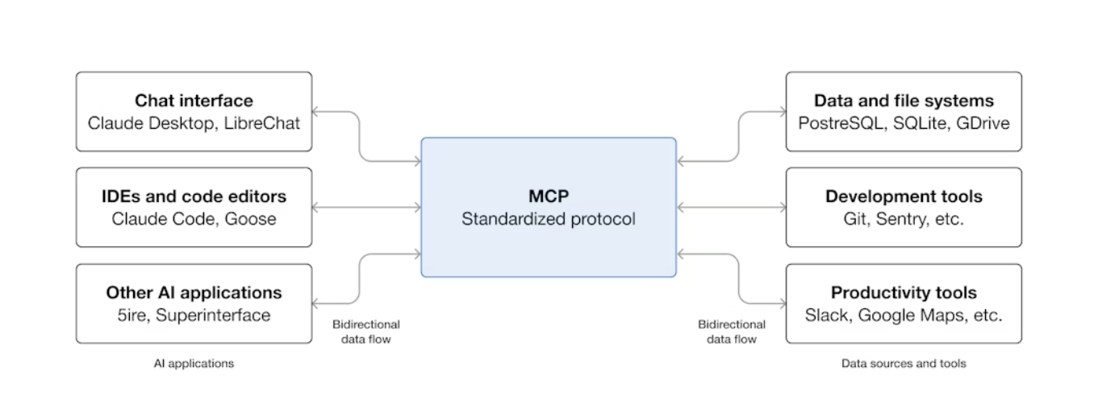
How MCP connect AI applications to external systems

Figma MCP Server
**subject to change

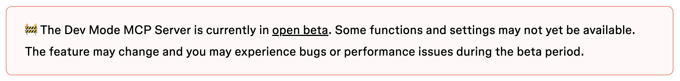

Cross Browser Testing

Cross browser testing is a process that ensures the visual integrity and intended appearance of a component across different browsers and operating systems. This is important because each browser uses a different rendering engine, which can lead to subtle differences in how components are displayed. The purpose is to catch visual inconsistencies, layout shifts, or bugs that may only appear on a specific browser.

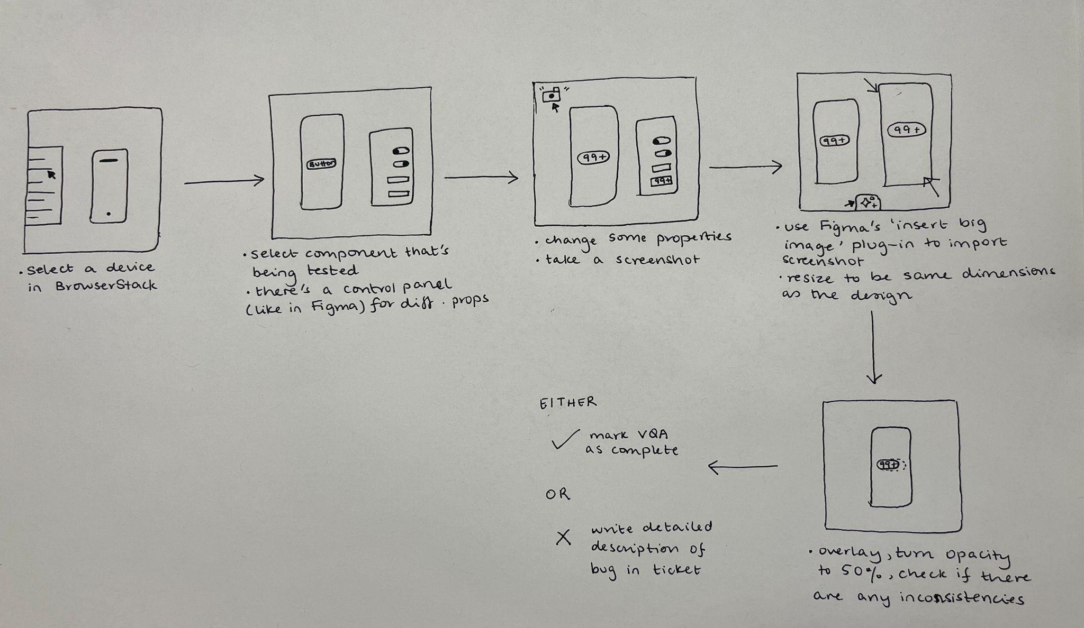
VQA workflow using BrowserStack

🧌 Component Variant Testing

Generating Variant Tests
Product Lead: Natasha Khoso
Engineering Lead: Daniel Henderson-Ede
Designers who work on this currently: Kshitij Tembe, Tarun O
Component Variant Testing NotebookLM
Copy of Figma files with test cases

Project Description:
A Figma plugin that takes in a component and generates all possible combinations of variant properties of the component. This is a need of the VDS team as the number of possible variant combinations can grow exponentially, leading to bugs that only appear when a specific combination of properties is used.

Outcomes:
The tool performs the exhaustive test case generation work, allowing the user's role to shift their time to that of reviewing outputs and decision making.

Functional requirements:
- Generate all possible combinations of variant properties of a component by automating the process and layout outlined in the Ways of Working documentation

Non-Functional requirements:
- Should generate all test cases much faster (at least 10x faster) than the manual creation time
- Should be able to create test cases for any component

Data flow
https://gitlab.verizon.com/cx-platforms/vds/vds-experimental/kaleidoscope#architecture

How are you building it
The Figma plugin is React (v19) bundled into a single file using esbuild. Typescript is used for type-safety across the main and ui threads. The interface uses VDS core and tokens 2.0.0.

Dependencies
https://gitlab.verizon.com/cx-platforms/vds/vds-experimental/kaleidoscope#dependencies--network-requests

Current Status
- Completed:
  - Base, min width, and max width sets for a given component
  - Implementing different themes/surfaces
  - Functional plugin that can take any VDS component and create test cases
- In-progress
  - Final UI designs
  - Resolving open bugs
  - Iterating on user feedback

“If we could automate the creation [of test cases] entirely, that would really save us time from doing this mundane task… instead of spending those hours making them I would rather spend those hours testing [them].”

“If we’re creating 3000 test cases and spending 5 hours [on it], and if doing that can be automated, that’s a big win for us.”

“If we can automate this process of creation of test cases, we would not have to maintain the test cases over a period of time. Currently, we create test cases for every release. We duplicate them, update the library, do a swap. Every time, if we can actually just generate the test cases and save an actual copy of things and we know that variables are still intact, our components are still intact, and there is zero margin of error, our work will really get a boost in all of these aspects.”

Overview
By programmatically testing every component variant combination, VDS can deliver high quality components more efficiently.

What’s a component?
Components are UI elements that can be reused across designs. In Figma, a component can be quickly identified by a purple diamond icon appearing on the layer in the Layers panel or directly on the canvas when selected.

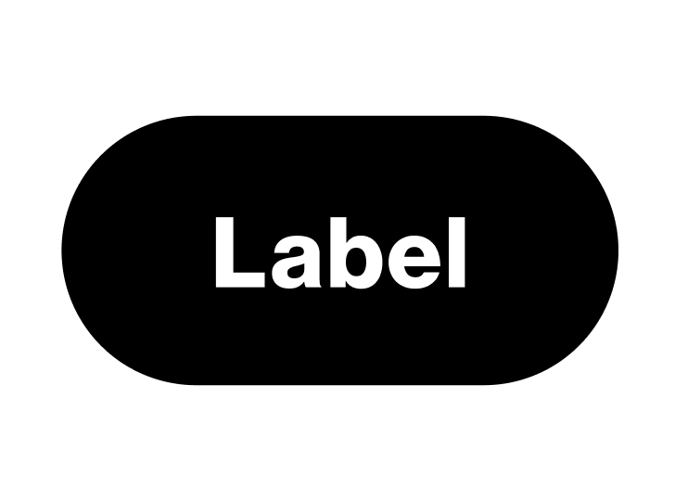
VDS Button component

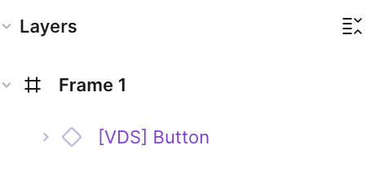
How to identify a component in Figma

Why do we build components?
We build components to improve efficiency and maintain consistency across our designs. By having reusable components, designers do not have to create the same elements every time, ensuring that every version looks and behaves the same.

What’s a component variant?
Component variants are predefined versions of a single component that reflect different states, styles, or properties (e.g. size, color). In Figma, these variants are grouped into a component set.

They are not
- Composite component: A component made up of two or more components.
- Configured component: A single instance of a component with specific variant properties selected (e.g. an ‘inactive’, ‘large’ button).
- Customized component: An instance of a component where a user has manually made a change that breaks from its predefined properties.

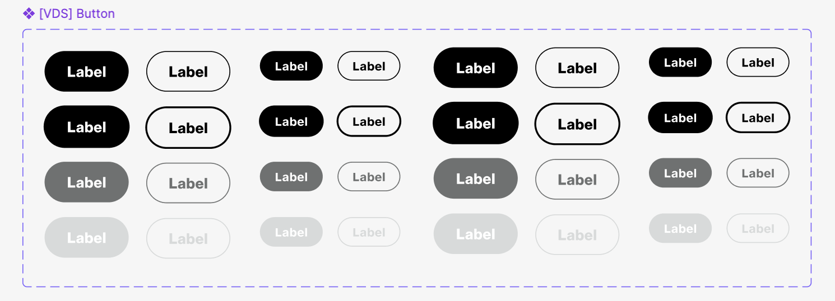
Variants of Button component

How do we build component variants?
The current process of creating variants involves designers defining behaviors and constraints as they build out the variants. One example of this is the Tooltip component, which has a variant in the color red. For accessibility reasons, this variant cannot be placed on a dark background. Therefore, safeguards have been put in place to throw an error message when designers on downstream teams attempt to use the variant in this manner.

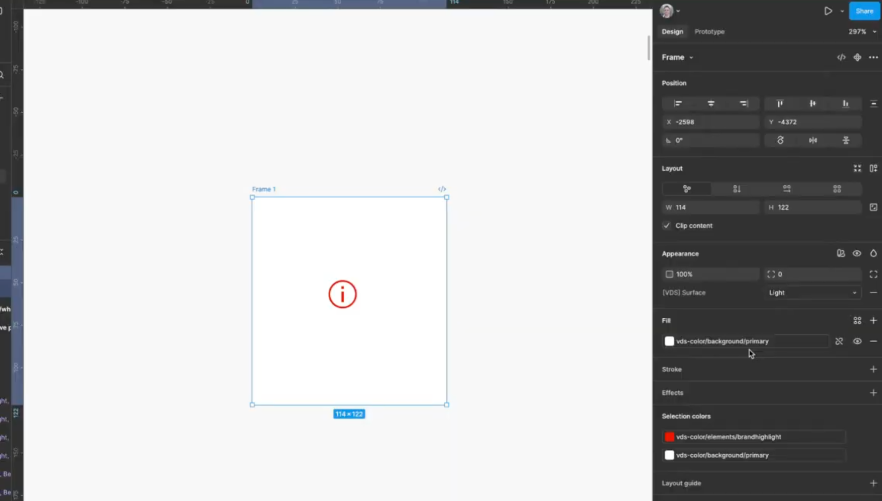
Tooltip variant used on a light background

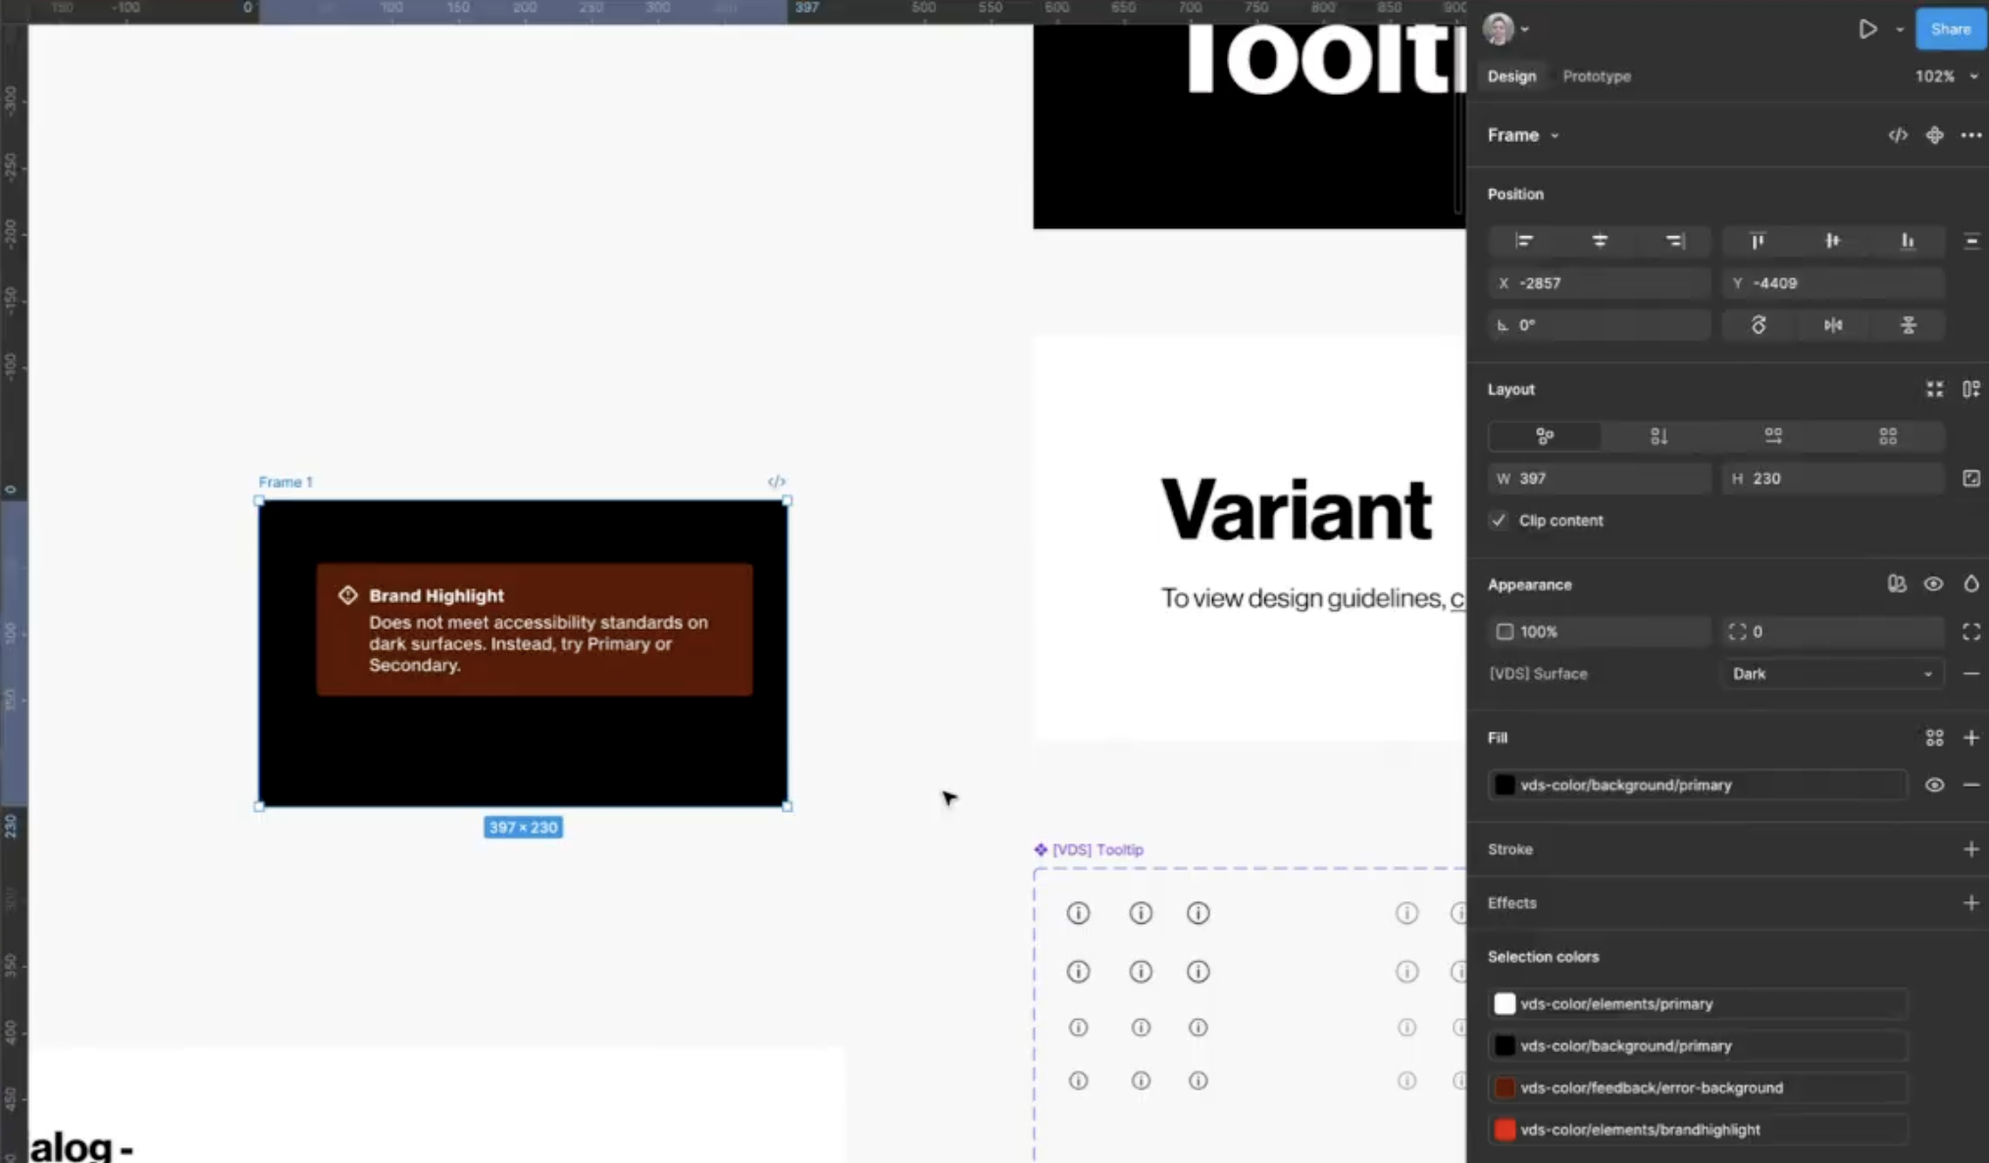
Error message after using Tooltip variant on a dark background


Example of Tooltip variant’s behavior in different contexts

Why do we build component variants?
Component variants are built to manage the variety of a single UI element in a structured way. Instead of creating separate components for every state or style, variants of a component group these variations into a single component set. This makes the design system easier to organize and maintain.

Why do we need to “test” component variants?
While a component’s individual properties might work correctly, the number of possible combinations of properties in variants can lead to bugs. Testing components ensures that the component behaves as expected across all contexts, preventing issues that might only appear when a specific combination of properties is used.

How do we test them today?
Variants are tested in a realistic environment that simulates how they will be used. This testing involves checking for behaviors like text overflow and responsiveness across different viewports and widths.

Here’s our current testing process:
- Add the component to the ‘Variant Display’ template in Figma
- List all of the component props based on the number of options for each prop (in descending order).
  - Exclude other nested VDS components.
- Add the first prop to the default state of the component and duplicate based on the number of options for that prop.
- Update the placeholder text with text that is slightly longer than the ideal scenario.
- Add the next prop and repeat the process until all the props are added.
- Duplicate the base set to create minimum width and maximum width sets.
- Create more sets for all the different viewports.
- Manually check test case responsiveness to different contexts.
- Bugs
  - If there are bugs, the designer will directly resolve any issues in the variant.
  - If there are no bugs, no changes need to be made.

The component variant testing process is a manual, time-consuming workflow. It involves creating a wide range of test cases, which are different combinations of a component based on its properties. It takes a lot of time to build and subsequently test every possible combination in terms of its behavior and responsiveness in different contexts. For a given component, the time spent on testing variants depends on its complexity.

[ Add image - probably Text Link ]

A simple component like Text Link takes about 30 minutes to make test cases and an additional 30 minutes to test it.
[ Add image - probably Tilelet ]

A more complex component like Tilelet typically takes 4 to 6 hours to build test cases and testing would take around 2 hours.

Updating Existing Test Cases
Currently, test cases are maintained in a testing file over a period of time to avoid having to create them from scratch. When components need to be updated, these test cases are duplicated and the library is swapped, which can lead to issues with the design files, such as variables not getting swapped on non-component elements.

Why This is Important
The process ensures that components exhibit the correct behavior in different contexts. As components grow more complex, the number of combinations grows exponentially, making it important to catch edge cases and bugs that may arise when specific combinations of props are used.

Problem Statement
The current variant testing process is tedious and manual, taking up time from designers.

Impact if Unsolved
If left unsolved, the variant testing process will remain manual. It would eventually lead to:
- Slower delivery, since the manual nature of the process will continue being a bottleneck, hindering the VDS team’s ability to release new components to meet the demands of downstream design teams.
- Brittle components, since it is difficult to ensure complete testing coverage due to the manual nature of testing.

Users
The users of this tool would be designers who are verifying that the component behaves correctly across every possible state and combination. While the tool performs the testing, it does not remove the user from the process. Instead, they decide if the output is as expected.

Outcomes

JTBDs
Jobs-to-be-done Theory (JTBD)

Functional: By automating the variant testing process, users can work more efficiently. They can dedicate more time to:
- Building more components.
- Building components that are more robust or scalable.

Emotional: The tool performs the exhaustive testing instead of the user, while still leaving the final review to the user. As a result, the user feels confident about the quality of the component and that no test cases have been missed.

Users will spend less time manually creating and testing variants, and will instead integrate the testing tool in their workflows. Their role will shift to more of a reviewer and decision maker, choosing whether the tool’s outputs are accurate or not.

Tracking Progress
The following outcomes will be tracked on a weekly basis to measure progress:
- Time on task: how many minutes are spent on creating test cases.
- Quality: percentage of accuracy of generated test cases.
- Risks: the number of risks mitigated.

Requirements

Functional Requirements
- Test Case Generation (if this is the main part of the process we are focusing on)
  - Accepts a Figma component set as an input.
  - Must identify all the properties and their values within a Figma component set.
  - Creates a new Figma file or frame for the test cases.
  - Generates every possible combination of the component’s properties, creating a component instance for each combination.
  - Names and organizes the test cases in a clear and consistent format.
  - Generates test cases for different viewport sizes.
  - Populates test cases with sample content that stresses the component’s design (e.g. long text strings to test for string overflow).
  - Supports the ability to exclude nested components.
- Workflow
  - Allows the user to specify which component set to generate test cases for.
  - Integrates into the existing Figma workflow, including the test case template.
  - Allows designers to manually review and edit test cases.

Non-Functional Requirements
- Performance / Speed
  - Generates test cases for a simple component in less than X amount of time (decide what this is).
  - Generates test cases for a complex component in less than X amount of time (decide what this is).
- Accuracy and Reliability
  - Achieves >95% (placeholder number) precision and recall, meaning that test cases are both comprehensive and valid.
  - Handles edge cases (e.g. components with a large number of properties or values) without crashing.
- Security & Compliance
  - Leverages the VEGAS platform to ensure all GenAI operations are secure and compliant with Verizon’s standards.
- Scalability
  - Allows for the code and infrastructure to be easily maintained and updated if changes are made to Figma API or design system architecture.

Out-of-Scope
- It will not simulate user interactions (e.g. clicks and hovers).
- It will not handle long-term versioning, archiving, or maintenance of test cases.

Dependencies
- Integration Points: APIs for Figma and VEGAS platform.
- Data: Access to VDS design specifications, component libraries, and documentation/templates for variants.

VEGAS
VEGAS (Verizon Enterprise GenAI Services platform) is an experimentation and prototyping sandbox to build use cases that leverage GenAI. It acts as a drag-and-drop canvas for users to easily build and customize GenAI use cases. VEGAS hosts reusable code and API endpoints which minimizes rework by standardizing use case delivery. Implementation teams can build and stitch together use cases, and the output is an API that they can embed into other applications to reference the solution they built.

Why VEGAS?
- A centralized platform helps accelerate GenAI application development by enabling the quick exploration, building, deployment, monitoring and maintenance of use cases.
- It leverages the latest LLM Ops standards to ensure solutions are high-quality, scalable, secure, and responsible. The VEGAS team manages access to the latest technology in a safe and secure way, allowing users to focus on building without worrying about underlying infrastructure or governance.

Options
- Status quo: Manually building test cases
  - Value: A time-consuming and tedious process that keeps designers tied up in mundane work.
  - Usability: The process is repetitive and leads to user frustration.
  - Feasibility: While it is currently being done, it is not a feasible long term solution. It becomes difficult to efficiently create test cases that provide adequate test coverage.
  - Viability: Low operational efficiency.
- Custom AI tool

Pilot Components
- Text Link - simple
- Tilelet - complex

Analytics & Data Points
Time it takes (available)
- Comparing versions
Time saved (?)
- Communicating value
- Estimated human time - time it takes
Number of times it’s run on a specific component
- Are they trying to compare or do initial tests
- Could communicate robustness of component
Date last ran per component
- Has this component been tested recently with updates?
Number of times the plugin is opened
- Are people using it?
User details
- Who is using it
Number or errors
- Bug tracking
What kind of errors
- Bug tracking

AI Evals
First define what correct/valid test cases are (these would probably be a rubric).
Things to consider:
- Technical feasibility
- Adherence to standard practices
- Completeness

Initial evaluations:
Create a dataset of X (decide this number, and decide which components) components representing a range of complexities. Each of the components should have a pre-existing, comprehensive set of test cases that have been manually verified.

Metrics:
- Precision: of all the test cases that were generated, what percentage were actually valid and correct?
- Recall: of all the correct test cases that should have been generated, what percentage did the tool actually find?
- Speed: how long does it take for the tool to generate the test cases?
- Format: does the output match the format used by the team?

Run, review, and retrain (as needed).

User evaluations:
Have users incorporate the tool into their workflow - they should use the tool to generate the test cases and then do variant testing how they normally would.

Metrics:
- Time on task: how long does it take for the user to do variant testing with the tool versus without it? (would we ask them to make test cases from scratch?)
- Error rate:
  - Deletion rate: the percentage of test cases the user deletes entirely.
  - Manual correction rate: the percentage of test cases that require any manual editing.
- Qualitative feedback on:
  - Usability
    - Does the tool fit into the designer’s workflow?
      - Are there any points of friction?
    - How easy it is to:
      - Use the tool
      - Understand the output given by the tool
  - Accuracy
    - Types of errors the tool is making
    - Types of cases the tool is missing

Product Risks
The Four Big Risks - Marty Cagan (The Godfather of Product Management)

Value Risks
(Will anyone use it? Does it solve the right problem?)

- Users might not find the tool to be useful if..
  - They have to fix its outputs.
  - They don’t trust it because..
    - The tool isn’t consistently accurate.
    - It doesn’t instantly tell them what’s wrong.
    - They don’t know how the tool is making decisions.
- It might not be efficient if..
  - It would be faster for users to do the task manually.
  - Users spend the same amount of time on variant testing even if they’re not the ones actually building the test cases.
- The output lacks quality if..
  - It is not able to generate test cases in the format we want.
  - It does not provide extensive test coverage.

Feasibility Risk
(Can we build it with the time, skills, and technology we have?)

- The custom tool might not integrate seamlessly with the software/platforms we need to use (e.g. Figma).
  - Regular developers may not have access to tools such as the Dev Mode MCP Server for Figma.
- If changes are made to external APIs that we rely on, it might break our workflow.

Usability Risk
(Can users figure out how to use it? Will they use it correctly?)

- Users might not be able to understand the output of the tool if..
  - It doesn’t adhere to internal standards and established workflows.
  - It does not make it clear what action the user should take based on the result.

Viability Risk
(Does the solution work for the business — legal, cost, compliance, stakeholders?)
- The tool might not be sustainable and cost-effective in the long term if..
  - It requires manual maintenance to keep running.
  - The cost of external tools being utilized becomes too high.
  - It takes a lot of time and effort to train team members on using the tool.
  - The cost to update and improve the tool is too high.
- The tool might not remain relevant as the design system evolves if..
  - It cannot be updated to match changes in the design system’s architecture.
  - It does not support new types of components or design tokens.

Performance Testing Figma

Rectangles
To inform decision making, we tested the node insert performance of Figma by generating {n} rectangles and measuring the time it took to finish.

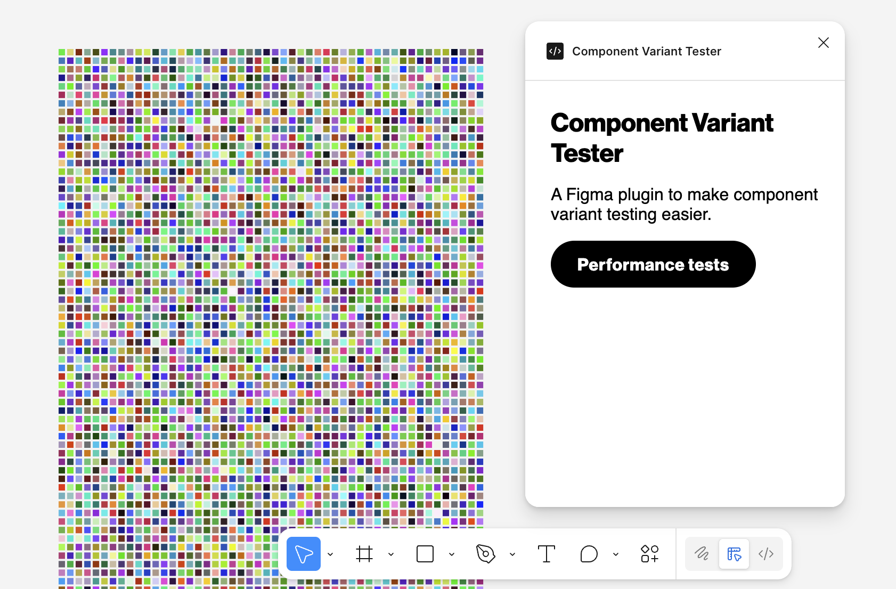

Results:

Count | Time (s)
1 | 0.017
10 | 0.027
100 | 0.084
1,000 | 0.663
10,000 | 6.431

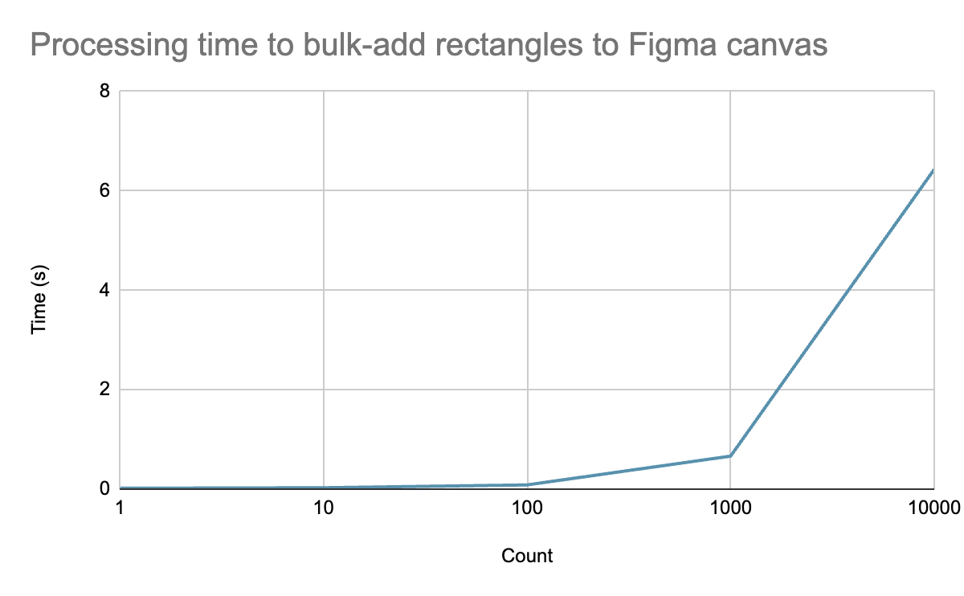

VDS Monarch Calendar

The same tests were ran again, this time with the VDS Monarch Calendar.
Component key: 83cee2f5b06e94ae62e92ebc6db997843b337e81

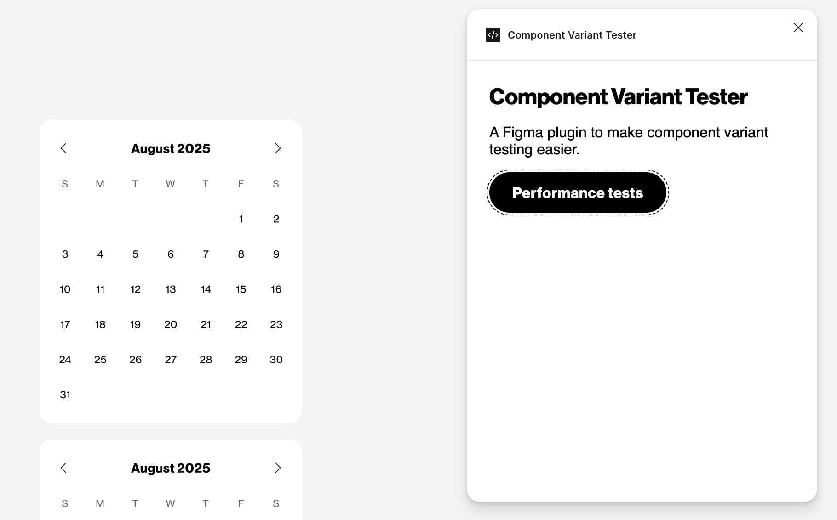

Count | Calendar Time (s) | Rectangle Time (s)
1 | 0.244 | 0.017
10 | 1.302 | 0.027
100 | 11.186 | 0.084
1,000 | 128.999 (2 mins) | 0.663
10,000 | EST: 22 mins | 6.431

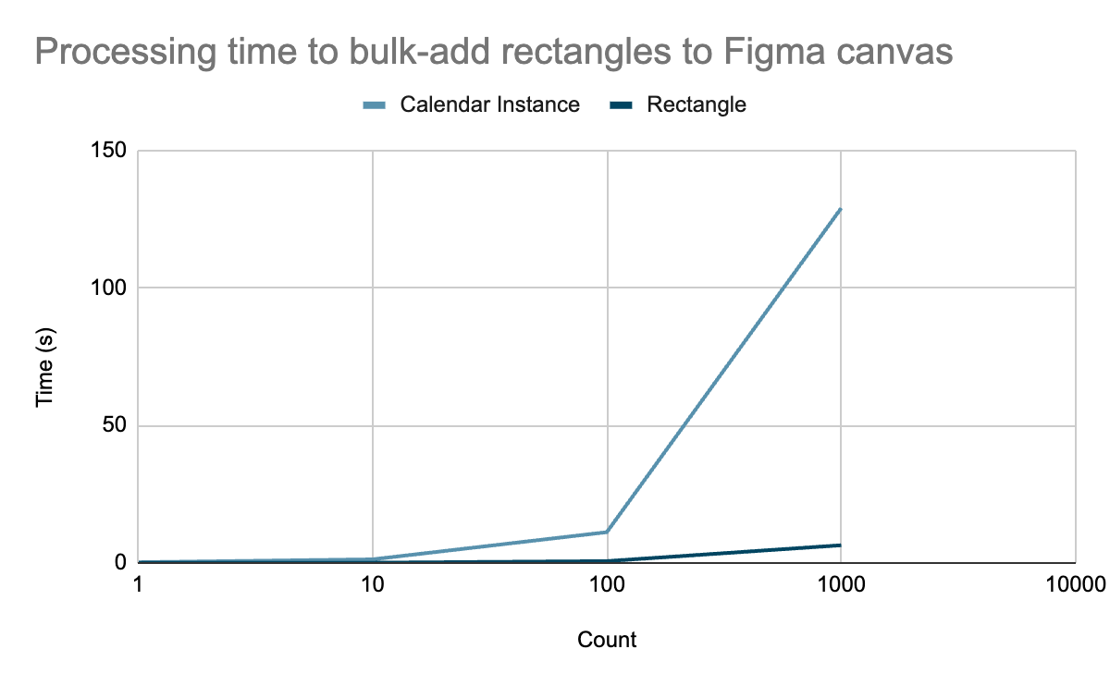

Appendix

Figma Make

Figma Make is an AI driven tool where a user enters a prompt with their ideas or existing Figma design files. The output is functional prototypes, web apps, and interactive UI. Through conversation, users can ideate, iterate, and improve the prototypes and web apps.

Some of the features it includes are:
- Users can attach existing Figma designs and components to their prompts
- Users can point to specific parts of the preview that they want to improve as they converse with the AI
- Team members can collaborate within the same conversation
- Share previews of the functional prototype or web app with others

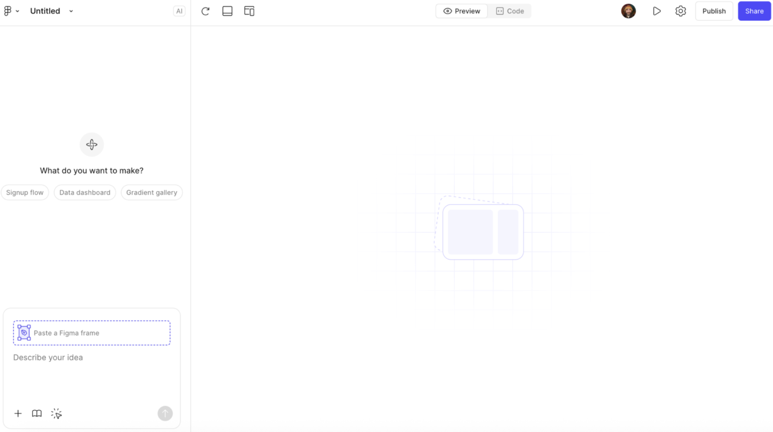
Figma Make interface for prompting

Considerations:
- Figma Make is currently blocked by the Verizon IT
- Figma Design tools are not directly integrated into Figma Make. Instead, users can use the edit tool to select elements of the preview and edit by prompting. Alternatively, some properties (like font style and text padding) can be directly manipulated.
- While components and design files can be uploaded for prompts, there is currently no option to integrate the tool with existing design systems, as mentioned in this thread.

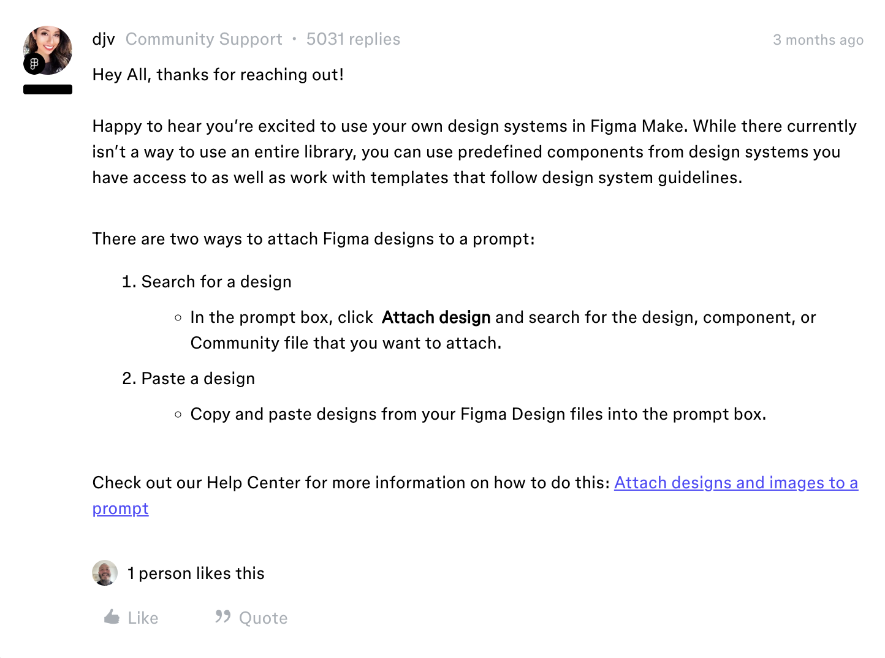
Figma Forum comment about not being able to integrate existing libraries with Figma Make

Variant Creation and Usage (Figma Standard Practices)

Variants group and organize similar components into a single container to simplify the component library.

Properties and values can be added as needed, and customized to suit the design system:
- Variant properties: the variable aspects of the component (e.g. the properties of a button component could be size, state, or color).
- Values: the different options available for each property (e.g. the state property could have the values default, hover, pressed, and disabled).

There are several methods of creating variants.

Method 1
Renaming components:
Figma uses the slash naming system to organize components in the assets tab and instance menu. Each / creates another level of hierarchy. This naming convention can be used to convert components into variants. To accurately be converted, the following structure should be used:

componentName/property1value/property2value/property3value

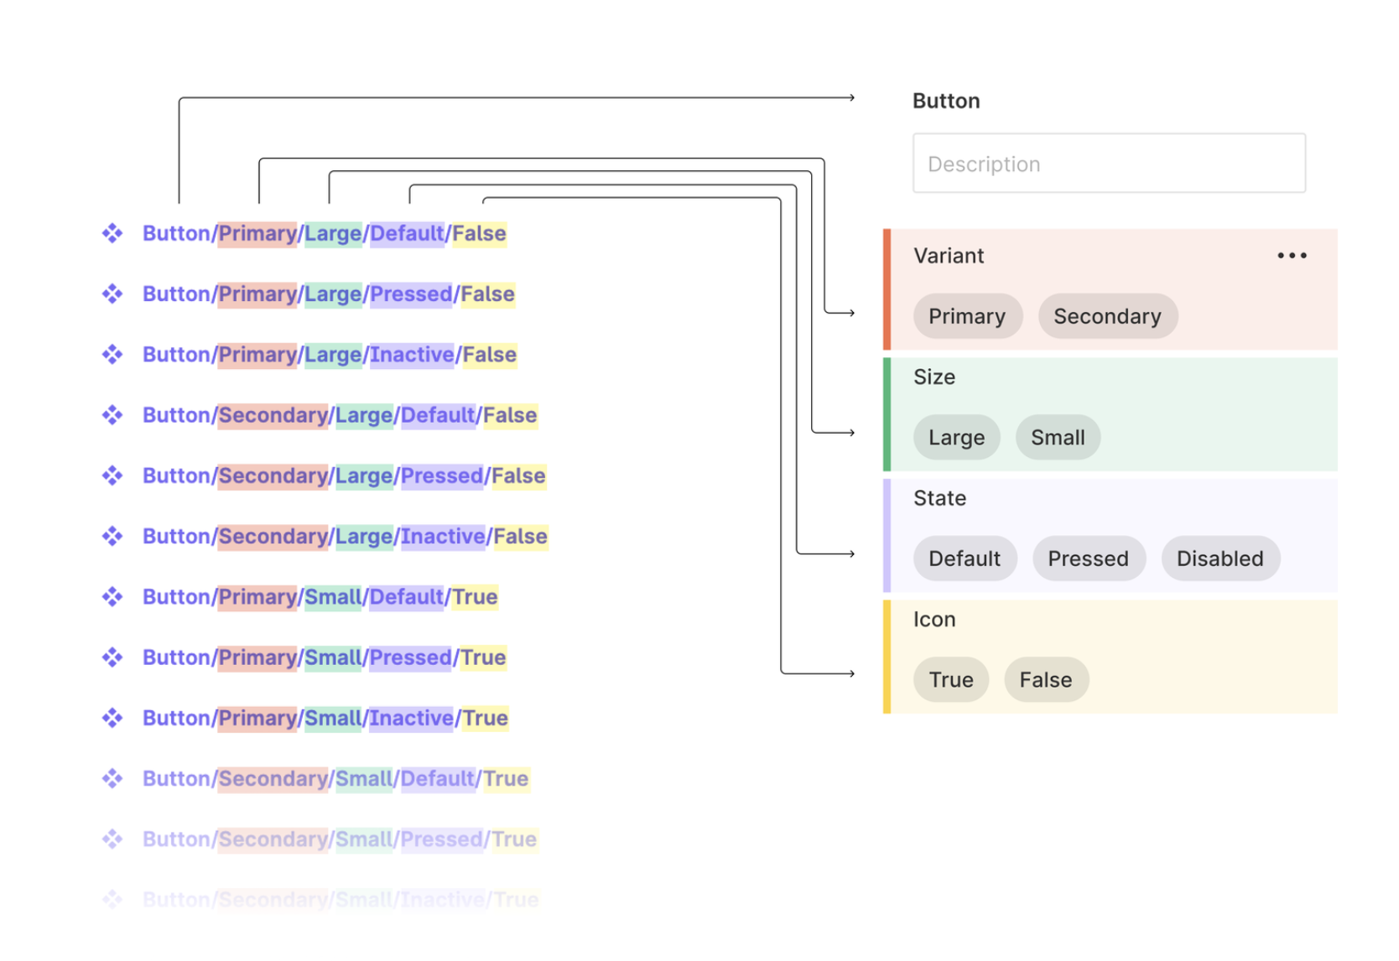
How component names are converted to variant values

Combine as variants:
- Select the components you want to combine
- Select ‘combine as variants’
- All components will be added to a single component set

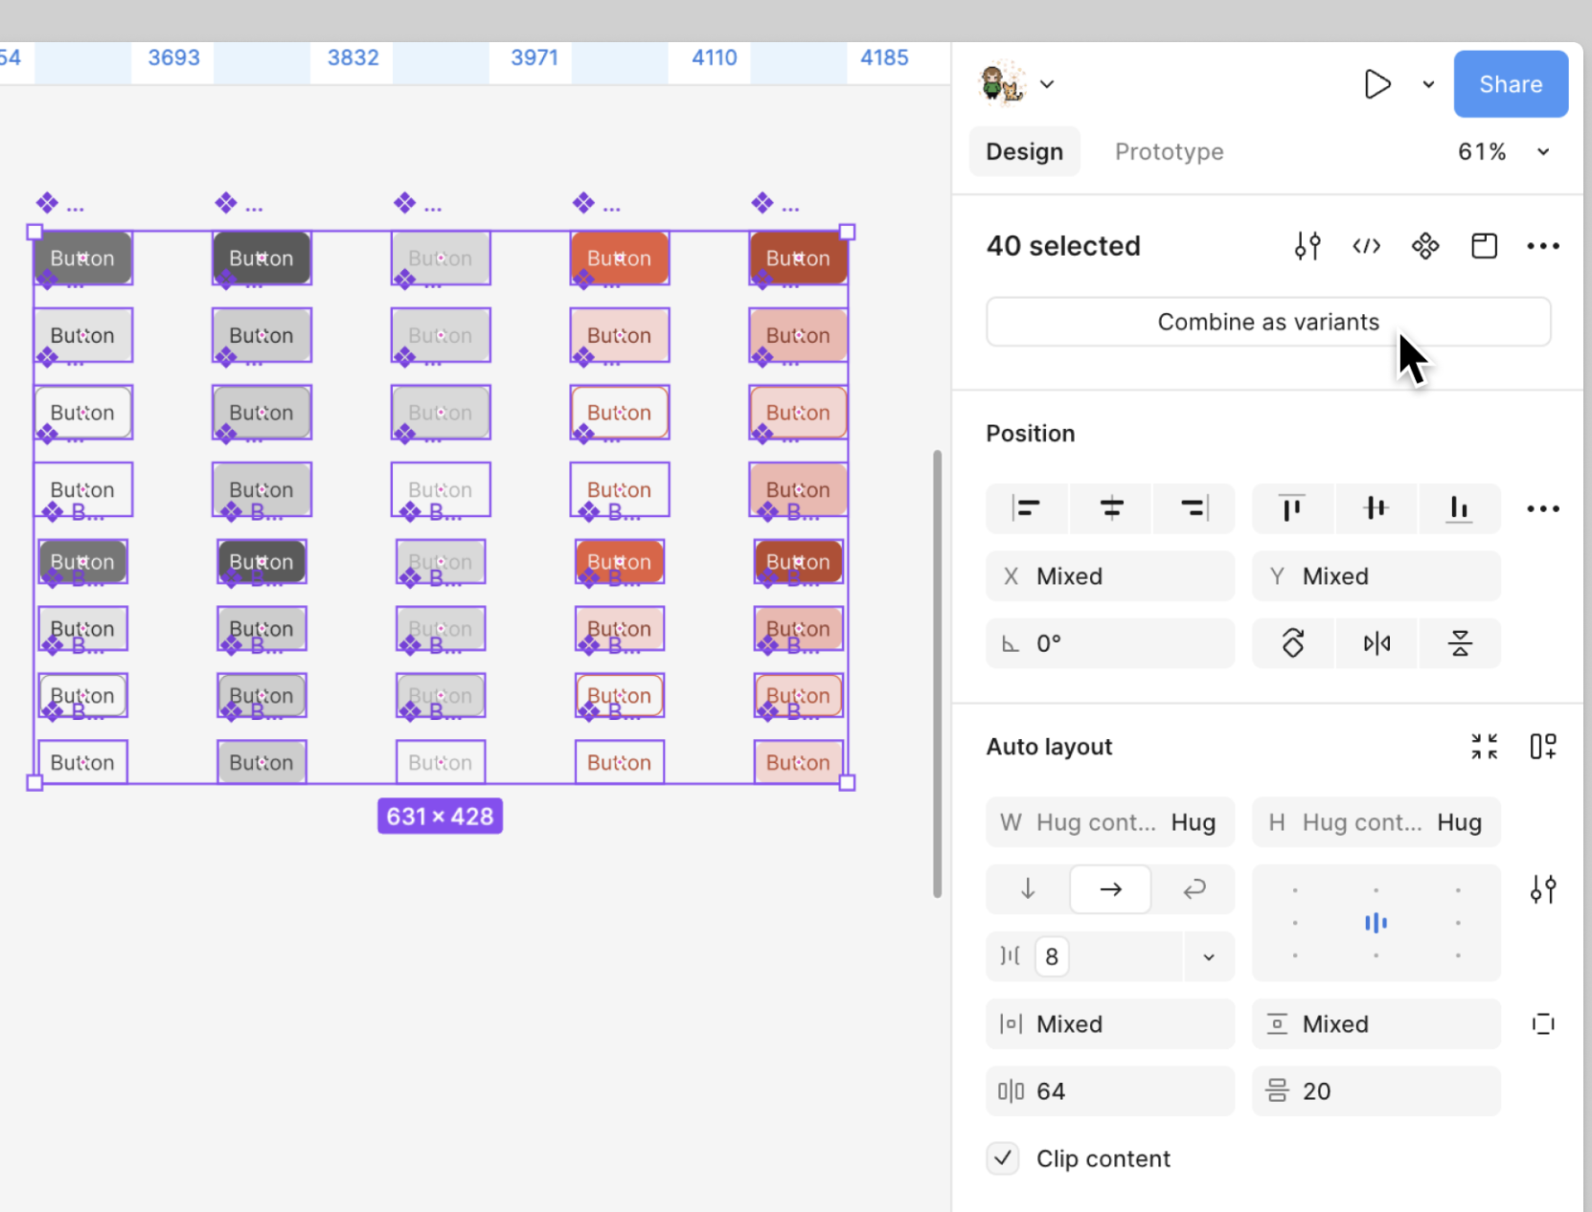
Components added to a single component set

Give properties descriptive names:
Figma will create generic properties and add any attributes to the component's name as values. It will name the first property Variant, and then number then sequentially (e.g. Property 2, Property 3, etc). These properties need to be renamed to be more descriptive:
- Select the component set
- Find the Properties section in the sidebar
- Edit the name of the property
- Repeat for naming the other properties

Method 2
Organize components on canvas:
If a component has lots of variants, they can be organized in rows, columns or grids. Text layers can be added to the canvas to annotate relevant properties and values.

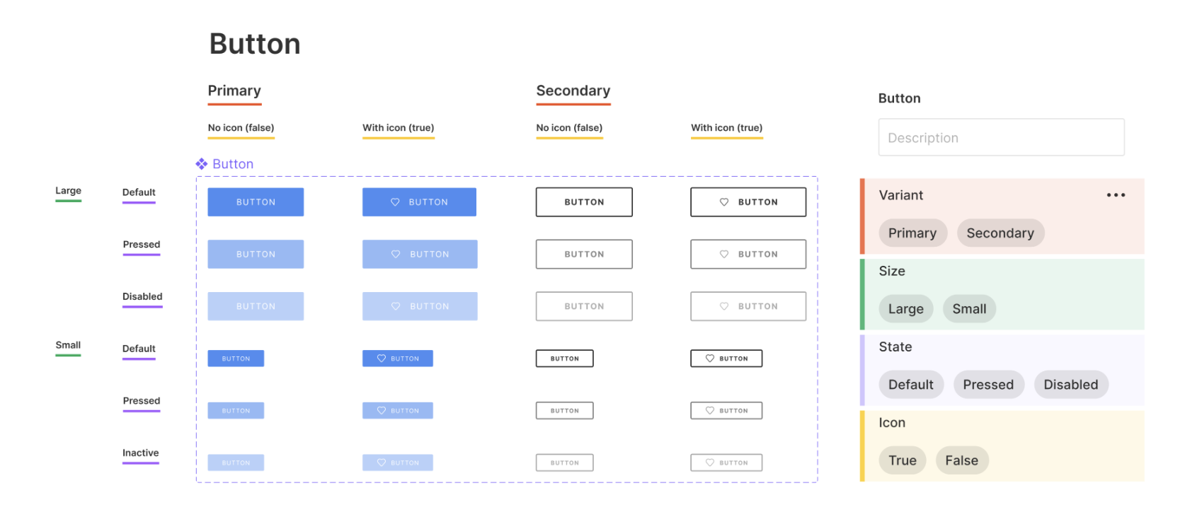
Variants arranged in a grid

Combine as variants:
- Select the components you want to combine
- Select ‘combine as variants’
- All components will be added to a single component set


Components added to a single component set

Give properties descriptive names:
Figma will create generic properties and add any attributes to the component's name as values. It will name the first property Variant, and then number then sequentially (e.g. Property 2, Property 3, etc). These properties need to be renamed to be more descriptive:
- Select the component set.
- Find the Properties section in the sidebar.
- Edit the name of the property.
- Repeat for naming the other properties.

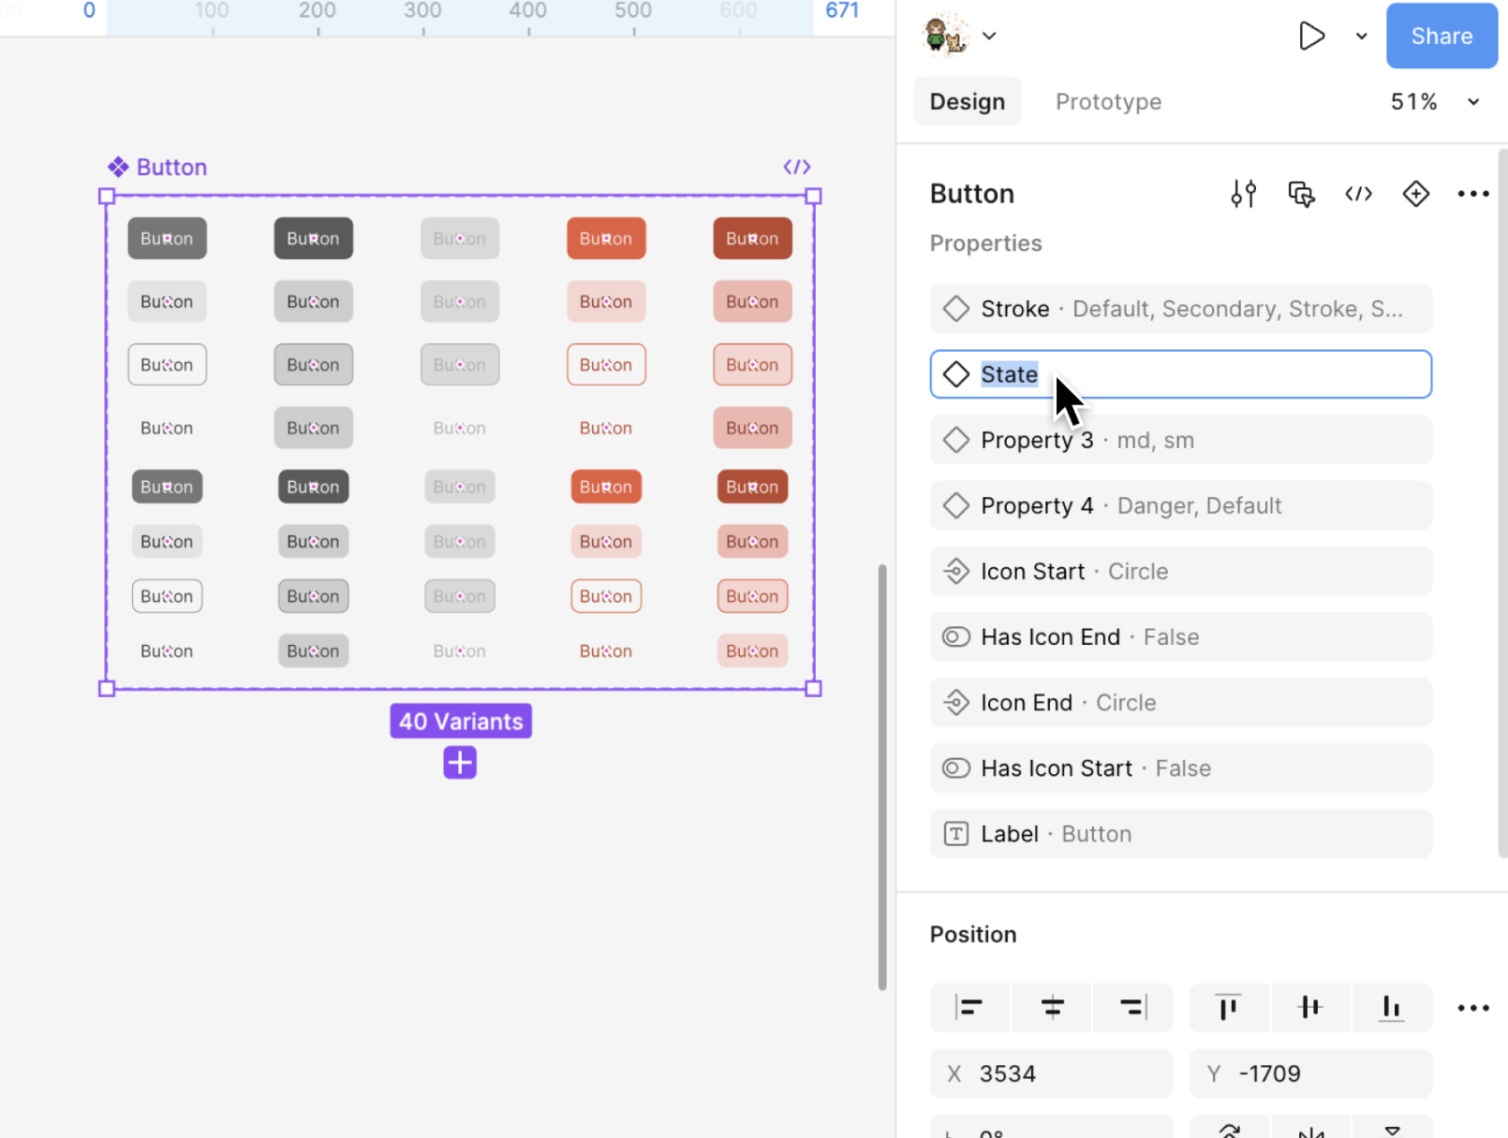
Renaming properties for variants

Method 3
Select a main component and do one of the following:
- Right click on the component and select ‘Main component’, then select ‘Add variant’.
- Click ‘Add variant’ in the sidebar.
- Click ‘+’ next to ‘Add property’ in the sidebar, then select Variant from the dropdown. This creates a new variant and turns the main component into a component set. Then click ‘+’ below the component set to add a variant.

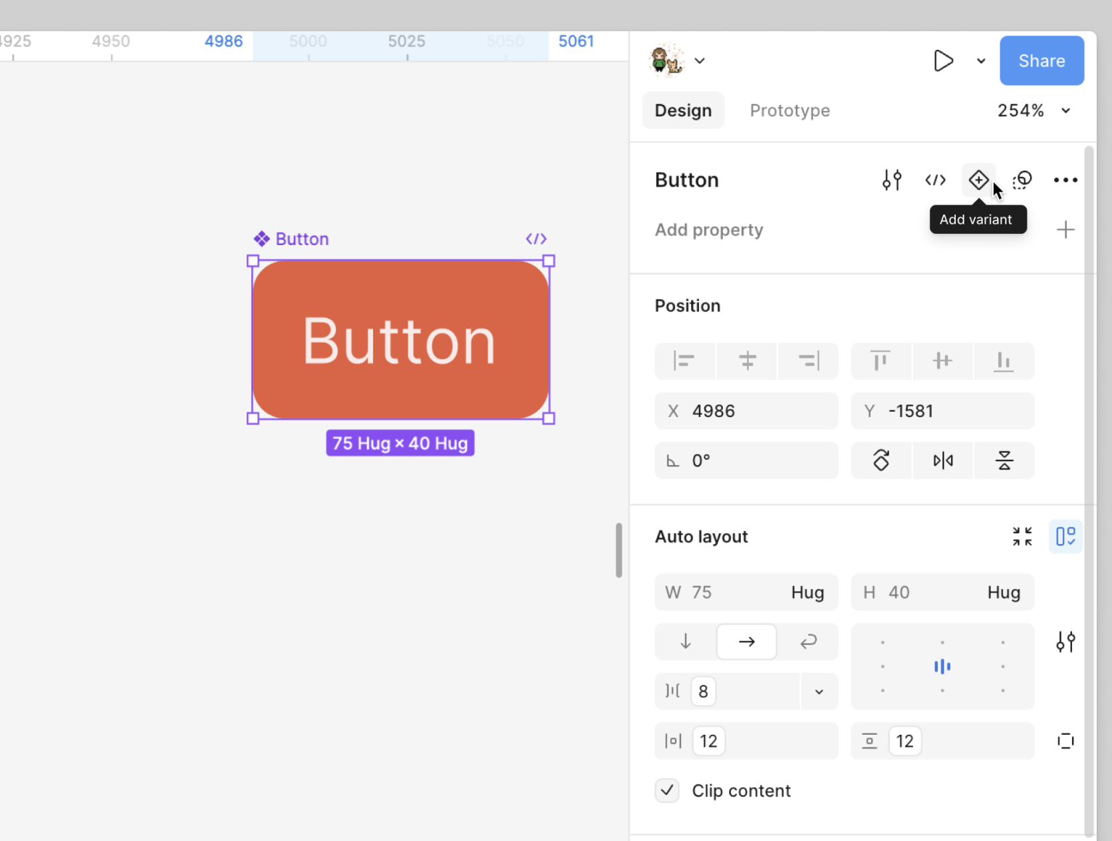
‘Add variant’ option for a main component

Using Variants

Select component sets:
- Click on the ‘Assets’ tab in the left sidebar.
- Select the component set and drag it onto the canvas. Figma will create an instance of the default variant of that component set.

Configure variants:
- Select the instance.
- View the component’s name in the side bar. Use the dropdowns next to the property to select combinations of values. Turn specific properties on and off using toggles.

Visual Test Cases
A visual test case is a component instance that has been configured and overridden in particular ways so that you can verify the component works as expected.

Having test cases allows teams to verify that the component works as expected in terms of style, properties, layout, content, and more. Test cases can be retained over time to be updated as the design system evolves.

Types of Cases:
- Properties
Testing includes validating that every property combination works as expected. This process can reveal missing values, unexpected property toggles, and wrongly tagged options.

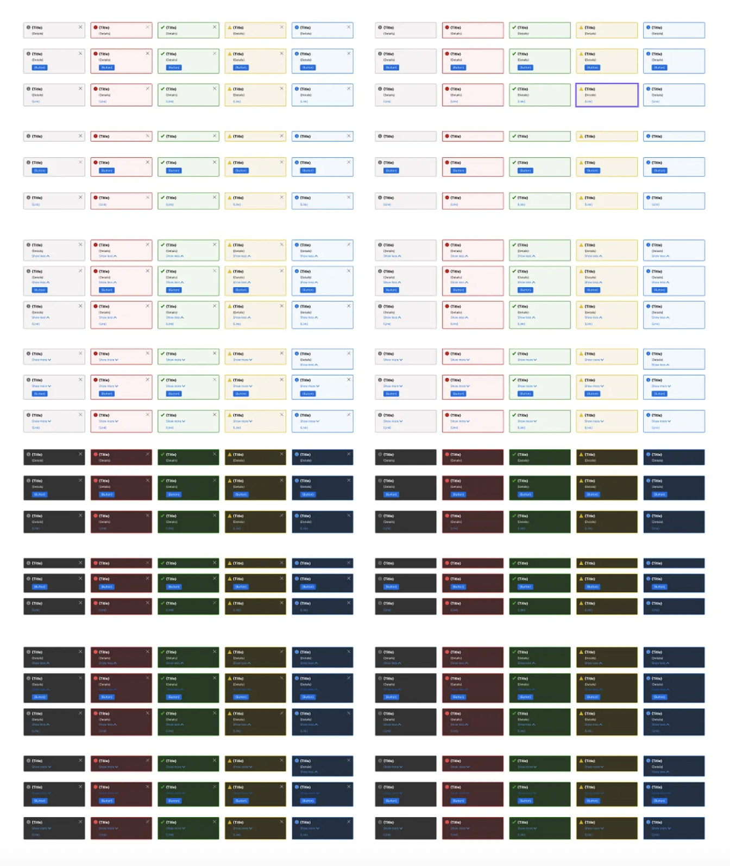
Visual test cases for each property combination

- Content
For elements that contain text, image fills or swapped component instances, test the display’s resilience with realistic and unrealistic content. Start with text and images with length or size that’s just right, long and short. Test how the component responds when the content might be wrong, may collide with other elements, or when it’s missing (and should collapse).

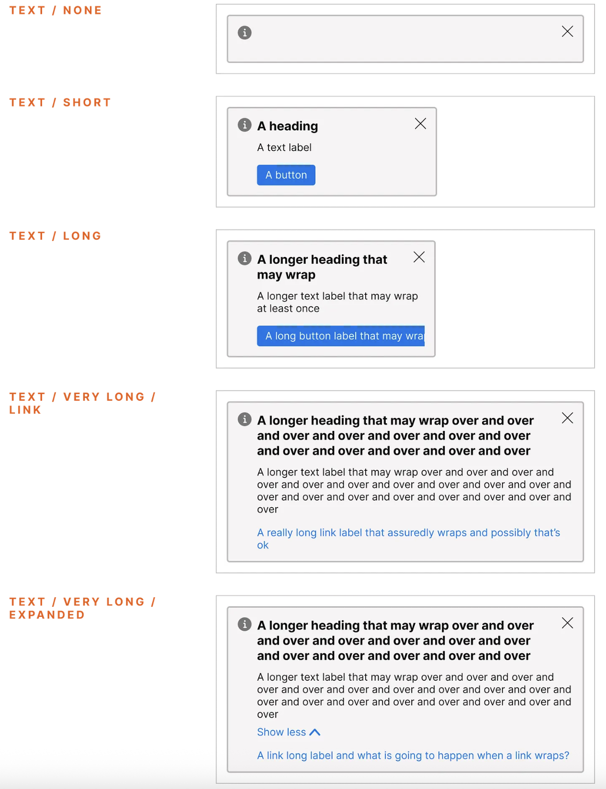
Visual test cases of different text lengths

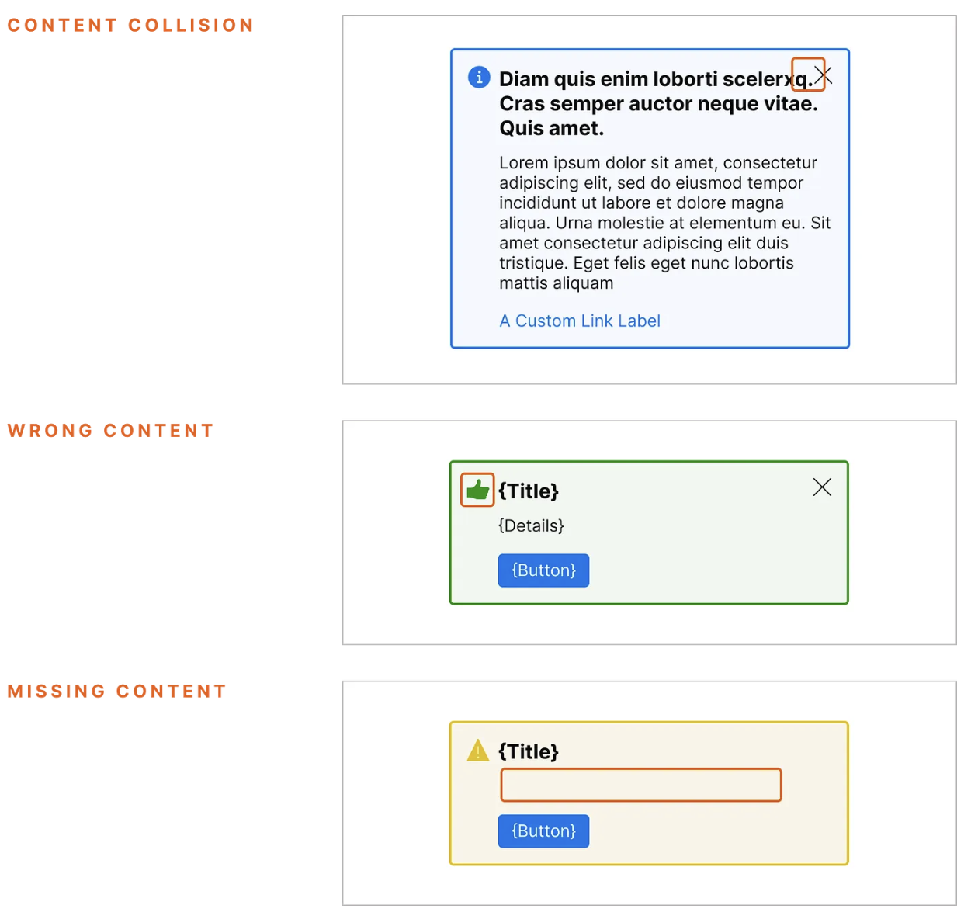
Visual test cases for how component responds to other contexts

- Layout
Test the layout with varying combinations of displayed elements, and then alter the component width to be ‘Fixed Width’ both narrower and wider than the default.

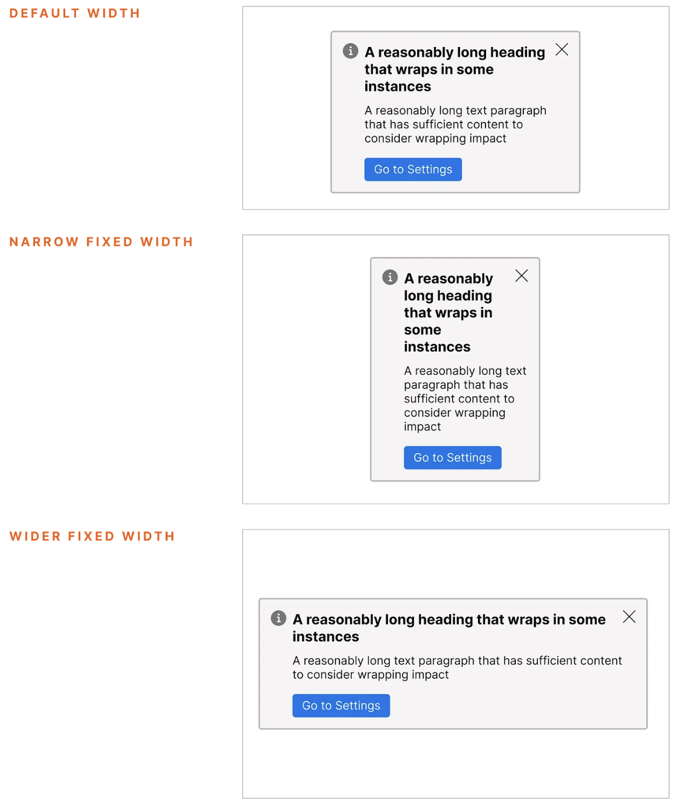
Visual test cases for different layouts

MCP Servers

Using MCP, AI applications can connect to:
- Data sources (e.g. local files, databases)
- Tools (e.g. search engines, calculators)
- Workflows (e.g. specialized prompts)

This allows them to access information and perform tasks.


How MCP connect AI applications to external systems

Figma MCP Server
**subject to change



List all component props based on number of options for each prop (in descending order). Exclude other nested VDS components
Add the first prop to the default state of component and duplicate based on number of options for that prop
Add the next prop and repeat process till all the props are added
Bugs found?
yes
no
Resolved in the variant by designer
No changes to be made
Start component variant testing
Add component to variant display template in Figma
Duplicate the base set to create min width and max width sets
Create more sets for different viewports
Manually check test case responsiveness to different contexts
Update the placeholder text that is slightly longer than the ideal scenario

Additional Resources

Signal (future: "Guardian Angel")

Signal

https://gitlab.verizon.com/cx-platforms/vds/vds-experimental/vds-ig-signal

Signal is a modular Figma plugin framework developed by Verizon Design System (VDS) to consolidate disparate design tooling into a single, extensible platform. It serves design teams, design system maintainers, and product engineers who use Figma as their source of truth for UI components and design specifications.

Core Value Proposition: Rather than managing dozens of individual Figma plugins with separate auth, analytics, and UI frameworks, Signal provides a unified architecture where new design automation tools can be developed as lightweight modules that share infrastructure. This reduces development overhead, improves maintainability, and delivers a consistent user experience across all VDS tooling.

Strategic Position: Signal sits at the nexus of design governance, component lifecycle management, and design-to-code workflows. It connects Figma (design source of truth) to backend APIs for component tracking, AI-powered validation, usage analytics, and potentially GitLab integration for design system versioning.

Architecture Overview

System Architecture
Signal employs a dual-context architecture typical of Figma plugins:

- Plugin Sandbox (Node.js context) - src/plugin/code.ts
  - Runs in Figma's restricted sandbox with access to the Figma Document API
  - Manages all document manipulation and node queries
  - Handles message routing via the SetupManager
  - Cannot directly access network APIs or external libraries
- UI Layer (Browser context) - src/app/
  - React 18 + TypeScript SPA rendered in an embedded iframe
  - Uses modern UI stack: Tailwind CSS, ShadCN components, Recoil for state
  - Communicates with plugin sandbox via postMessage API
  - Can make HTTP requests to external services
- Message Bus Architecture - src/lib/messaging.ts
  - Namespaced messaging system: Each module gets its own message namespace to prevent collisions
  - Type-safe bidirectional communication: TypeScript interfaces ensure payload contracts between UI and plugin
  - Registry pattern: Each module registers message handlers on initialization
  - Lifecycle management: Modules can be activated/deactivated with cleanup guarantees

Data Flow Pattern
User Action (UI)

→ createUIMessageSender posts namespaced message
→ MessageRegistry routes to active module handler
→ Plugin code manipulates Figma document
→ createPluginMessageSender sends response
→ UI hook receives and updates React state

Core Modules and Their Functions

Component Manager (component-manager/)
Purpose: Analyze breaking changes to design system components and determine appropriate semantic versioningKey Capabilities:

- Usage scope analysis: Queries backend API to determine how many Figma files and teams use a selected component
- AI-powered change analysis: Sends serialized component data to backend LLM service that recommends version bump (major/minor/patch) based on structural changes
- Risk signaling: Uses a 0-3 icon system to indicate blast radius (0 = minimal usage, 3 = >40% of files affected)
- Version publishing: Captures component thumbnails and posts version metadata to component tracking API

External Dependencies:

- API: https://vds-ig-mapping-api.ebiz.verizon.com/api/v1
- Endpoints: /components-usage, /components/breaking-changes/analyze, /components

LayerMatch (LayerMatch/)
Purpose: Advanced batch selection and modification system based on reference nodes and customizable filtersKey Capabilities:

- Filter-based selection: Select a reference node, apply filters (size, color, effects, layout properties), find matching nodes across the page
- Similarity slider: Fuzzy matching with configurable tolerance (e.g., "find all nodes within 20% of this size")
- Batch actions: Apply transformations (position, scale, rotation, fills, strokes) to selected nodes
- History tracking: Maintains selection history within session for reproducibility
- Scope controls: Search entire page, within parent, or siblings only

Architecture Highlights:

- Highly modular with separate filter functions per property type (fills.ts, stroke.ts, text.ts, etc.)
- Extensible filter system with configuration files for node-type visibility and UI behavior
- State management using class-based managers to avoid scattered globals

AI Chatbot (ai-chatbot/)
Purpose: Context-aware design system assistantKey Capabilities:

- Conversational interface for design system questions
- Session-based chat history with thread management
- Feedback mechanism for response quality
- Integration with VDS knowledge base via backend API

External Dependencies:

- API: https://vds-ig-mapping-api.ebiz.verizon.com/api/v1/signal/chat/message

Theme Creator (theme-creator/)
Purpose: Rapidly generate component variants by cloning from VDS libraryKey Capabilities:

- Clone components and variables from master VDS library
- Generate variants from minimal input
- Add component annotations for variant changes

Planned Enhancements:

- Migrate from REST API component fetching to internal API
- Improved layout organization for component sets
- Existing theme detection and editing workflows

Time Tracker (TimeTracker/)
Purpose: Track time spent in Figma sessions for productivity analyticsTelemetry Integration:

- Mixpanel events: "Time Tracking Started", "Time Tracking Ended"
- Tracks module context, duration, and user information

Patterns, Frameworks, and Abstractions

Plugin SDK Pattern
Signal implements a module SDK abstraction inspired by Discord's Spellbook system. The framework provides:

- createModuleMessageHandler<T>(namespace): Factory for type-safe message handlers
- createUIMessageSender<T>(namespace): Sends messages from UI to plugin
- createPluginMessageSender<T>(namespace): Sends messages from plugin to UI
- createMessageHandlerHook<T>(namespace): React hook for receiving messages

Benefits:

- Module developers only define message interfaces and handlers
- No need to manage message routing, cleanup, or namespace collisions
- TypeScript ensures compile-time safety across the message boundary

Lifecycle Management
The SetupManager class (src/plugin/setup-manager.ts) orchestrates module activation:

- Single-active-module pattern: Only one module's Figma event handlers active at a time
- Automatic cleanup: Deactivating a module removes event listeners and message handlers
- Hot registration: Modules can be registered/deregistered dynamically

Code Generation System
Signal uses Plop.js (plopfile.ts) for scaffolding new modules:

yarn create-module

This generates:

- Module directory structure
- TypeScript message type definitions
- UI panel component with hooks
- Plugin code with message handlers
- Config file with metadata
- Auto-injection into module registry

Filter Rule Engine (LayerMatch)
LayerMatch implements a sophisticated rule-based selection engine:

- Filter configuration DSL: JSON-based filter definitions with visibility rules
- Callback mapping: Filters map to pure functions that return boolean match results
- Composable filters: Multiple filters can be combined with similarity thresholds
- Node-type awareness: Filters automatically show/hide based on selected node type

Shared Infrastructure
All modules inherit:

- Logging: Centralized logger (lib/logger.ts) with module attribution
- Analytics: Mixpanel integration for event tracking
- Storage: Figma clientStorage and pluginData wrappers for persistence
- Styling: Pre-configured Tailwind + ShadCN component library

Validation, Scoring, and Guidance Logic

Component Manager - AI Change Analysis
Location: component-manager/api/BCApiService.ts → /components/breaking-changes/analyzeProcess:

- User selects a component instance in Figma
- Plugin serializes the entire component tree (nodes, properties, styles)
- Data POSTed to backend LLM service with component structure
- Backend analyzes structural differences against previous version
- Returns:
- Recommended version bump: Major/Minor/Patch
- Confidence scores: Numerical scores for each version type
- Primary factors: Array of reasoning strings explaining the recommendation

UI Feedback:

- Visual display of confidence scores
- Reasoning bullets for transparency
- Ability to override AI recommendation before publishing

Component Manager - Scope Scoring
Location: component-manager/ui/Panel.tsx lines 52-61Scoring Algorithm:

if (fileUsageRatio > 0.4) → Icon Level 3 (Critical Impact)
else if (ratio > 0.2) → Icon Level 2 (High Impact)
else if (ratio > 0.05) → Icon Level 1 (Moderate Impact)
else if (ratio > 0.001) → Icon Level 0 (Low Impact)

Metrics Displayed:

- Figma files using component / Total files in organization
- Teams using component / Total teams
- Total instance count across all files
- List of specific team names using the component

LayerMatch - Similarity Scoring
Location: LayerMatch/lib/utils/utils.ts → calculateSimilarity functionApplication:

- Size filters: Match nodes within X% of reference dimensions
- Color filters: Color distance calculations (likely RGB/HSL delta)
- Effect filters: Compare blur radius, opacity with tolerance

External Dependencies and Integrations

Backend API: VDS IG Mapping API
Base URL: https://vds-ig-mapping-api.ebiz.verizon.com/api/v1Authentication: Bearer token (txNbg8fkbWub) hardcoded in sourceEndpoints Used:

GET /components-usage?figma_node_id={id}
- Returns usage statistics for a component
- Response includes: file counts, team usage, instance counts

POST /components/breaking-changes/analyze
- Accepts serialized component node data
- Returns AI-generated version recommendation with reasoning

POST /components
- Publishes new component version
- Accepts FormData with image thumbnail, raw node data, increment type

POST /signal/chat/message
- AI chatbot conversation endpoint
- Manages session-based chat threads

Figma REST API
Usage: Theme Creator module needs Figma personal access tokensUser Flow:

- User generates PAT in Figma settings
- Stores in Signal settings panel (SettingsPanel.tsx)
- Saved to Figma pluginData on current page
- Used for programmatic component fetching from VDS master file

Mixpanel Analytics
Project Token: aa940caa2461d056425542403a386442Implementation: mixpanel-figma npm packageTracked Events:

- "Module Selected" - When user switches to a module
- "Shape Created" - Demo event from example module
- "Time Tracking Started" / "Time Tracking Ended" - Time tracking feature

User Identification:

mixpanel.identify(figma.currentUser.id);
mixpanel.people.set({ $name, $email });

External Resources
- VDS Master File Key: tb11zGciYOsYGZ1Bx8uscF (hardcoded in figma-store.ts)
- Network Access: Manifest allows all domains ("*") with reasoning "because debugging"
- Permissions: currentuser, teamlibrary, inspect capabilities

Data Telemetry, Analytics, and Privacy

Data Collection
User Information Collected:

- Figma user ID (for Mixpanel identification)
- User name and photo URL
- Figma team membership (inferred from component usage queries)
- File access patterns (which files use which components)

Event Telemetry:

- Module switching behavior
- Time spent per module (when Time Tracker active)
- Component version change actions
- AI chatbot query patterns (session IDs tracked server-side)

Storage Mechanisms:

- Figma clientStorage (Browser localStorage-like, per-user)
  - Favorite modules list
  - Sidebar open/close state
- Figma pluginData (Stored in Figma document, shared)
  - User API keys (base design system file key, Figma PAT)
  - Per-page settings
- In-Memory Logs (lib/logger.ts)
  - Module-attributed log events with timestamps
  - Retrievable via Logs Panel
  - Not persisted - cleared on plugin close

Privacy Concerns
🚨 Critical Issues:

Hardcoded API Token in Source Code
- Bearer token txNbg8fkbWub is committed to repository
- Provides backend API access to anyone with source code
- Should be moved to environment variables or OAuth flow

Overly Permissive Network Access
- Manifest allows "*" for all domains
- Reasoning states "because debugging"
- Should be restricted to specific domains in production

User API Tokens in Plugin Data
- Figma personal access tokens stored in document pluginData
- PluginData is accessible to all plugin code (potential exfiltration risk)
- Should use more secure storage or OAuth delegation

No Data Anonymization
- Mixpanel receives real Figma user IDs and names
- Component usage data ties users to specific teams/files
- No apparent consent mechanism or data retention policy

Data Flows
Outbound to Mixpanel:

figma.currentUser → mixpanel.identify() → Mixpanel servers

User actions → mixpanel.track() → Mixpanel event ingestion

Outbound to VDS API:

Component node data → Serialized JSON → Backend LLM analysis

Usage queries → Node IDs → Backend returns file/team usage stats

Chat messages → Backend RAG system → Persistent session storage (server-side)

Technical Risks and Architectural Bottlenecks

Monolithic Plugin Size
Issue: All modules are bundled into a single plugin artifactImpact:

- Large initial download for users who only need one module
- Increased load time as module count grows
- Limited ability to version modules independently

Evidence: Build process compiles all modules regardless of dev flags (line 339 of README: "all code in main is built into production plugin")

Single-Threaded Plugin Sandbox
Issue: Figma's plugin sandbox is single-threadedImpact:

- LayerMatch's page-wide node scanning can freeze UI on large documents
- No apparent pagination or chunking strategy for large selection sets
- Batch actions on hundreds of nodes could cause timeout

Recommendation: Implement async chunking with progress indicators

Hardcoded Dependencies
Critical Items:

- API base URL
- Auth token
- VDS file key
- Mixpanel token

Risk:

- Cannot easily switch environments (dev/staging/prod)
- Rotating credentials requires code changes
- Multi-tenant deployment not possible

Message Bus Scalability
Current Design: Global message registry with string-based routingBottlenecks:

- All messages processed through single registry per namespace
- No message prioritization or queuing
- Potential for message storms if modules emit frequent updates

Observed in Code: figma.ui.on("message", messageListener) registers a single listener that filters by namespace

State Management Fragmentation
Three State Systems:

- React useState/useEffect per component
- Recoil atoms for cross-module state
- Class-based StateManager (LayerMatch)

Issues:

- No consistent state management pattern
- Difficult to debug state flow across modules
- Recoil marked as "TODO: Replace with Jotai" (line 474 of README)

API Error Handling
Observed Pattern:

catch (error) {
console.error("Error fetching...", error);
throw error; // Re-throw without handling
}

Gaps:

- No retry logic for transient failures
- No user-facing error messages for API failures
- No offline mode or graceful degradation

Build System Complexity
Build Pipeline:

- Separate Vite configs for UI and plugin
- Concurrent watch processes
- Manual CSS injection via Vite plugin
- File touch hack to trigger Figma reload

Risks:

- Build process fragile on different platforms
- Hot reload can fail silently
- No build artifact caching

Testing Infrastructure
Absence of:

- No test files in project structure
- No CI/CD validation mentioned
- Manual testing via Loom videos (line 594 of README)

Impact:

- High risk of regression when modules interact
- Message contract changes can break multiple modules
- No automated validation of Figma API usage

Module Isolation
Current Reality: Modules can access each other's Recoil atomsExample from README:

// OtherModule can read ExampleModule's state

const exampleModuleSelectedTab = useRecoilValue(exampleModuleSelectedTabAtom);

Risk:

- Implicit coupling between modules
- No enforced boundaries
- Refactoring one module can break others

Documentation Drift
Observed:

- Commented-out code in Component Manager (lines 129-158)
- TODO items in code and documentation
- Example modules marked as dev: true but still shipped

Long-term Risk:

- New developers struggle to understand current vs. aspirational architecture
- Dead code accumulates
- Uncertainty about which patterns to follow

Maintainability Concerns

Positive Patterns
✅ Clear module boundaries with dedicated directories
✅ Type-safe message contracts prevent runtime errors
✅ Code generation reduces boilerplate
✅ Comprehensive documentation (README, module-specific docs
)✅ Consistent naming conventions enforced

Areas for Improvement
1. Code Review Process

- Minimum 1 approval, preferred 2 (line 39 of README)
- No automated checks mentioned
- No linting in CI

2. Dependency Management

- yarn.lock is 4,718 lines
- Mix of development and runtime dependencies
- Some dependencies like mixpanel-figma appear to be Verizon-specific forks

3. Branch Protection

- Branch naming convention defined but not enforced
- No mention of protected branches
- Main branch can potentially receive direct commits

4. Environment Configuration

- References to .env file in Theme Creator README
- But no .env.example in project root
- Environment variables prefixed with SIGNAL_ (vite.config.ts line 20)

Strategic Recommendations

Immediate Priorities (Security & Stability)

Externalize Secrets
- Move API tokens to environment variables
- Implement OAuth flow for Figma API access
- Rotate exposed backend token

Restrict Network Access
- Update manifest to whitelist specific domains
- Remove "because debugging" reasoning

Add Error Boundaries
- Wrap modules in React error boundaries
- Implement user-facing error messages
- Add retry logic for API calls

Medium-Term (Scalability)
Implement Module Chunking
- Explore dynamic imports for modules
- Lazy-load module code when selected
- Reduce initial bundle size

Add Automated Testing
- Unit tests for message handlers
- Integration tests for module interactions
- Snapshot tests for UI components

Standardize State Management
- Migrate to single state library (Zustand or Jotai)
- Document state management patterns
- Enforce module isolation

Long-Term (Architecture)
Federated Module System
- Allow modules to be developed/deployed independently
- Implement module marketplace concept
- Enable team-specific module visibility

Offline-First Design
- Cache component metadata locally
- Queue operations when API unavailable
- Sync when connection restored

Analytics Pipeline Improvements
- Implement consent mechanism
- Add data anonymization layer
- Document data retention policies

Conclusion
Signal represents a consolidation play that solves real organizational pain around fragmented tooling. The modular framework pattern is sound and the message bus abstraction successfully isolates modules from each other.

Key Strengths:

- Strong developer experience via code generation and type safety
- Extensible architecture that can absorb new tools easily
- Unified UI/UX across all design automation tools
- Active integration with backend intelligence (AI analysis, usage tracking)

Key Risks:

- Security posture requires immediate attention (hardcoded secrets, overly permissive network access)
- Scalability concerns as module count and usage grow (bundle size, single-threaded operations)
- Maintainability could degrade without stronger testing and module isolation

Strategic Fit: Signal is production-ready for internal use with security fixes but would require architectural hardening for external distribution or enterprise multi-tenant deployment. The framework provides a solid foundation for long-term design system governance and could be extended to support broader design-to-development workflows.

Similarity Engine

Similarity Engine

vds-ig-similarty-main is a computer vision-based similarity detection service that helps design system teams identify visually similar UI components within Figma design libraries. It serves as a quality assurance and deduplication tool in a larger design system governance ecosystem, enabling teams to detect redundant components, enforce design consistency, and prevent component proliferation across large-scale Figma projects (~5,000+ components).

Demo: similarity_service_Gerardo.mov

Similarity Aggregation Report Consolidation:
Perceptual Hashing to detect image similarity
Color Hashing and Invariant Moments for Image Similarity
IGVCG-215: Similarity Match Implementation - Attribute Compare
IGVCG-217 Similarity Match Implementation Image Compare
IGVCG-499 Similarity Aggregation

Value Proposition: This tool addresses a critical pain point in enterprise design systems — component sprawl. By using perceptual hashing and color-based invariant moment algorithms, it automatically surfaces components that are visually similar but not yet consolidated, helping design teams make informed decisions about component consolidation, variant creation, or deprecation.

Ecosystem Position: This appears to be part of a broader VDS (Visual Design System) Intelligence/Governance suite (indicated by the "vds-ig-" prefix and sibling projects like vds-ig-mapping, vds-ig-contribution, vds-ig-signal). It acts as a backend analytical engine that likely feeds results to other tools in the ecosystem for decision-making, reporting, or automated suggestions.

Architecture Overview

System Type
Hybrid client-side research tool + backend API consumer

Core Architecture Pattern
Configurable Pipeline Architecture — The system implements a modular, sequential data processing pipeline where nodes can be enabled/disabled via YAML configuration. Data flows through a series of transformations, with each node enriching the payload dictionary.

Component Map
┌─────────────────────────────────────────────────────────────┐

│ Entry Point │

│ similarity_pipeline.py │

│ (CLI with YAML configuration loader) │

└───────────────────────┬─────────────────────────────────────┘



┌─────────────────────────────────────────────────────────────┐

│ Pipeline Orchestrator │

│ similarity_algorithms/pipeline.py │

│ (Abstract pipeline runner with pluggable PipelineNode) │

└───────────────────────┬─────────────────────────────────────┘

 │

┌─────────────┴────────────┬─────────────┐

▼ ▼ ▼

┌──────────────────┐ ┌──────────────────┐ ┌──────────────┐

│ ReadCandidates │ ───│ PerceptualHash │───│ ColorHash │

│ │ │ │ │ │

│ • Calls backend │ │ • dHash algo │ │ • Hu moments │

│ similarity API │ │ • 17x16 resize │ │ • YCbCr/HSI │

│ • Gets top N │ │ • Returns 256bit │ │ • 42-element │

│ candidates │ │ hash string │ │ vector │

└──────────────────┘ └──────────────────┘ └──────────────┘

 │ │ │

└──────────────┬───────────┴──────────────────┘

▼

┌──────────────────────────────┐

│ SimilarityAggregation │

│ │

│ • Hamming distance calc │

│ • Fuzzy logic scoring │

│ • scikit-fuzzy controller │

└──────────────┬───────────────┘

▼

┌──────────────────────────────┐

│ SaveImageResults │

│ │

│ • Copies thumbnails to │

│ result\_images/ folder │

└──────────────────────────────┘

External System Integration
The tool connects to a backend similarity service hosted at https://155.138.192.178:

- POST /api/similar-components — Receives target image, returns top N candidates (already pre-processed with perceptual hashing)
- GET /api/components_variants/{node_id} — Retrieves component metadata including thumbnail URLs

Authentication: Bearer token (SIMILAR_BACKEND_TOKEN environment variable)

Core Modules & Components

1. Pipeline Framework (pipeline.py)
Purpose: Abstract orchestration layerPattern: Strategy pattern with sequential executionKey Characteristic: Each PipelineNode receives a dictionary, enriches it, and passes it forward

2. ReadCandidates (read_candidates.py)
Purpose: API client for backend similarity serviceResponsibilities:

- Loads target image from data/target_image/
- Posts image to backend API with configurable candidate count
- Enriches response with thumbnail URLs via secondary API calls
- Critical Note: This is the data source node — disabling it breaks the pipeline

Configuration: readCandidates.NumCandidates in YAML (default: 3-50)

3. PerceptualHash (perceptual_hash.py)
Purpose: Difference hashing (dHash) implementationAlgorithm:

- Convert to grayscale (with special handling for contrast-only images)
- Resize to 17x16 pixels
- Compute horizontal gradient (differential: image[:, 1:] > image[:, :-1])
- Flatten to 256-bit binary hash string

Use Case: Structural similarity detection (invariant to color changes, lighting)

4. ColorHash (color_hash.py)
Purpose: Advanced color-based similarity using Hu invariant momentsAlgorithm (42-element feature vector):

- Normalization: Resize to 256x256, Gaussian blur
- YCbCr color space: Compute 7 Hu moments per channel (Y, Cb, Cr)
- HSI color space: Compute 7 Hu moments per channel (H, S, I)
- Concatenate: 6 channels × 7 moments = 42 features
- Stabilization: Log-transform: -sign(hu) * log10(|hu|)

Use Case: Detect color/style similarity in visually similar componentsStatus: Currently disabled by default in pipeline_configuration.yaml

5. SimilarityAggregation (similarity_aggregation.py)
Purpose: Scoring engine with fuzzy logicAlgorithm:

- Calculate Hamming distance between target and candidates
- Fuzzy Logic Controller:
- Input: Hamming distance [0, 60]
- Output: Similarity score [0, 1]
- Rules:
- Low distance → High similarity score
- Average distance → Average similarity score
- High distance → Low similarity score
- Uses Gaussian membership functions (σ₁=0.05, σ₂=0.17)

Value: Provides human-interpretable similarity scores instead of raw distances

6. SaveImageResults (save_image_results.py)
Purpose: Copies matching thumbnails to output directoryBehavior: Searches data/images/ for candidate filenames, copies to data/result_images/

7. CreateCsvFile (create_csv_file.py)
Purpose: Batch processing mode for offline analysisUse Case: Given a pre-computed CSV of all components with perceptual hashes:

- Select one component as target
- Calculate Hamming distance to all others
- Sort by similarity
- Export ranked results

Input: data/vds_components.csv (pre-processed component database)Output: data/sorted_vds_components.csv

Patterns, Frameworks & Abstractions

1. Configurable Pipeline Pattern
- YAML-driven node composition (pipeline_configuration.yaml)
- Enable/disable nodes without code changes
- Two operating modes via separate YAML files:
- Real-time mode: pipeline_configuration.yaml (API-driven)
- Batch mode: csv_file_pipeline.yaml (CSV processing)

2. Node Factory Pattern
Maps string identifiers to classes:

node_factory = {

"ReadCandidates": ReadCandidates,

"PerceptualHash": PerceptualHash,

...

}

3. Dictionary-Based Data Flow
All pipeline state flows through a single enriched dictionary:

{

'api_similar_components_token': str,

'candidates': List[Dict], # Enriched by each node

'target_image': str,

'perceptual_hash': ImageHash,

'color_hash': np.ndarray,

...

}

4. Research-Oriented Structure
- Jupyter notebooks in notebooks/ for algorithm experimentation
- Separation of algorithm development (notebooks) from production pipeline (src)
- Indicates iterative refinement of similarity algorithms

Validation, Scoring & Guidance Logic

Perceptual Hash Validation (utilities.py)

validate_image(image_path):

✓ File size < 4MB

✓ Extension in [jpg, jpeg, png]

✓ Returns boolean pass/fail

Similarity Scoring
Primary Metric: Hamming distance (bit differences in perceptual hashes)Interpretation:

- Distance = 0 → Near identical
- Distance < 10 → Very similar
- Distance > 60 → Dissimilar (capped at 60)

Fuzzy Logic Scoring:

- Converts raw Hamming distances to normalized similarity scores [0, 1]
- Uses scikit-fuzzy with Gaussian membership functions
- Three categories: low/average/high distance mapped to high/average/low similarity

Color Distance (when enabled)
- L2 Euclidean distance between 42-element color hash vectors
- Smaller distance = higher color/style similarity

External Dependencies

Backend API (Critical)
- Host: https://155.138.192.178 (hardcoded IP — likely internal/staging)
- Endpoints:
- /api/similar-components — Pre-processed similarity search
- /api/components_variants/{node_id} — Component metadata
- Authentication: Bearer token
- Data Format: JSON responses with node IDs, perceptual hashes, thumbnails
- Network Requirements: Must disable VPN (documented requirement)

Python Libraries (Key Dependencies)
Library | Purpose
ImageHash | Perceptual hashing utilities
opencv-python | Image processing (resize, color conversion)
scikit-fuzzy | Fuzzy logic control system
pandas | CSV processing for batch mode
requests | HTTP client for backend API
scikit-image | Advanced image algorithms
numpy | Numerical operations

Data Dependencies
- Thumbnail Cache: data/images/ (~4,891 PNG files)
- Likely synced from S3 or backend to avoid runtime downloads
- Used for visual result inspection and CSV processing
- Pre-computed Component Database: data/vds_components.csv
- Pre-processed perceptual hashes for bulk comparison

Data, Telemetry & Privacy

Logging
- Standard Python logging module
- Output to app.log (file-based)
- Log level: INFO
- Captures:
- Pipeline execution flow (enter/exit nodes)
- Candidate results (node IDs, Hamming distances, similarity scores)
- API errors and validation failures
- Performance metrics (ColorHash processing time)

No Telemetry or Analytics
- No external tracking or phone-home behavior
- No usage metrics collection
- No crash reporting to external services

Data Handling
- Local-only processing: All image analysis happens client-side
- API calls: Target image sent to backend for candidate retrieval
- No PII: Works with Figma component IDs and image thumbnails (no user data)

Privacy Posture
- Secure: Bearer token authentication for API
- Insecure: SSL verification disabled (verify=False) — RED FLAG
- Isolated: No cross-component data sharing beyond local filesystem

Technical Risks & Bottlenecks

🔴 CRITICAL RISKS

1. Hardcoded IP Address + SSL Verification Disabled

r = requests.post('https://155.138.192.178//api/similar-components',

verify=False) # ← Security vulnerability
- Risk: Man-in-the-middle attacks, certificate warnings
- Impact: Exposes API tokens and image data to network interception
- Recommendation: Use DNS-based endpoints, enable SSL verification, handle certificates properly

2. Single Point of Failure: Backend API
- Risk: Entire pipeline depends on ReadCandidates node
- Impact: If API is down/slow/deprecated, tool is non-functional
- Mitigation: None detected (no fallback, retry logic, or circuit breaker)
- Recommendation: Add local-only mode using pre-computed hashes

3. VPN Configuration Requirement

4.- Disable your VPN, otherwise the api calls won't be able to be reached.
- Risk: Enterprise/security policy violation
- Impact: Tool unusable in compliant environments
- Root Cause: Backend likely on internal network without proper routing
- Recommendation: Fix network infrastructure, not developer workflow

⚠️ ARCHITECTURAL CONCERNS

4. No Versioning of Algorithms or Data
- Risk: Results not reproducible across pipeline changes
- Impact: Can't compare similarity scores from different runs
- Missing: Model versioning, hash algorithm versioning, data lineage tracking

5. Synchronous, Single-Threaded Processing
- Bottleneck: ColorHash node processes candidates sequentially
- Impact: O(n) processing time where n = number of candidates
- Evidence:
- for candidate in self.data["candidates"]:

hash2 \= self.compute\_color\_hash(image\_2) *\# No parallelization*

- Recommendation: Use multiprocessing/threading for independent candidate analysis

6. Tight Coupling to Local Filesystem

IMAGES_PATH = '../data/images/' # Relative paths everywhere
- Risk: Breaks when running from different directories
- Impact: Deployment complexity, container unfriendly
- Recommendation: Use pathlib absolute paths or environment variables

7. No Error Handling for Missing Data
- Example: If backend returns candidates without thumbnail_path or thumbnail keys, crashes occur
- Impact: Pipeline fails silently or with unclear errors
- Missing: Graceful degradation, validation of API response schemas

⚡ MAINTAINABILITY ISSUES

8. Mixed Concerns: Research + Production Code
- Observation: Notebooks in notebooks/, but unclear which algorithms are "production ready"
- Risk: Code drift between experimental and deployed logic
- Recommendation: Clear boundary between research (notebooks) and production (src)

9. Configuration Scattered Across Files
- YAML config files for pipeline
- Hardcoded constants in individual nodes (IMAGES_PATH, PREPROCESSED_CSV_FILE)
- Environment variables for secrets
- Impact: No single source of truth, difficult to deploy to different environments

10. Limited Test Coverage
- Found: tests/ directory exists but not examined
- Missing: No CI/CD configuration, no linting, no type checking (despite using type hints)

11. Fuzzy Logic Controller Complexity

self.sim_controller = ctrl.ControlSystemSimulation(controller)
- Risk: Non-obvious behavior, difficult to debug when scores seem wrong
- Impact: Users can't easily understand why two similar images get different scores
- Missing: Explainability, documentation of fuzzy membership functions

Strategic Recommendations

For Integration
- API Gateway Pattern: Abstract backend calls behind interface to enable:
- Local-only mode (using CSV)
- Mock mode for testing
- Multiple backend versions
- Result Caching: Cache perceptual/color hashes to avoid re-computation
- Webhook Support: Allow pipeline results to POST to downstream systems (e.g., Figma plugin, dashboard)

For Scalability
- Batch Processing at Scale: Use CreateCsvFile mode for bulk analysis, real-time mode only for interactive use
- Distributed Processing: Extract algorithm nodes into microservices for parallel execution
- Pre-computation Pipeline: Run perceptual hashing on component updates, not on-demand

For Long-Term Maintainability
- Configuration Management: Consolidate all config into single YAML + environment variables
- Schema Validation: Use Pydantic for API response validation
- Observability: Add structured logging (JSON), metrics (Prometheus), tracing (OpenTelemetry)
- Containerization: Dockerize with mounted data volumes

For Governance
- Algorithm Versioning: Track which similarity algorithm version produced each result
- Audit Trail: Log all similarity searches with timestamps, users, parameters
- Threshold Configuration: Make similarity score thresholds configurable per use case

Positioning in Broader Ecosystem
Based on the project structure, this appears to be part of a Design System Intelligence Platform:

- vds-ig-similarty ← You are here (Similarity detection engine)
- vds-ig-mapping (Likely maps components to taxonomy/standards)
- vds-ig-contribution (Likely handles component submissions/proposals)
- vds-ig-signal (Likely Figma plugin for real-time feedback)
- vds-grand-central (Likely admin dashboard/control plane)

This tool's role: Serves as the analytical engine that powers component deduplication recommendations, quality checks, and potentially automated refactoring suggestions across the design system governance workflow.

Bottom Line: This is a mature research prototype with production aspirations. The algorithm work is sophisticated (dual hashing approaches, fuzzy logic), but the infrastructure is brittle. For strategic use, invest in hardening the API integration, parallelizing processing, and adding observability before scaling adoption.

Scratchpad

Project Slides

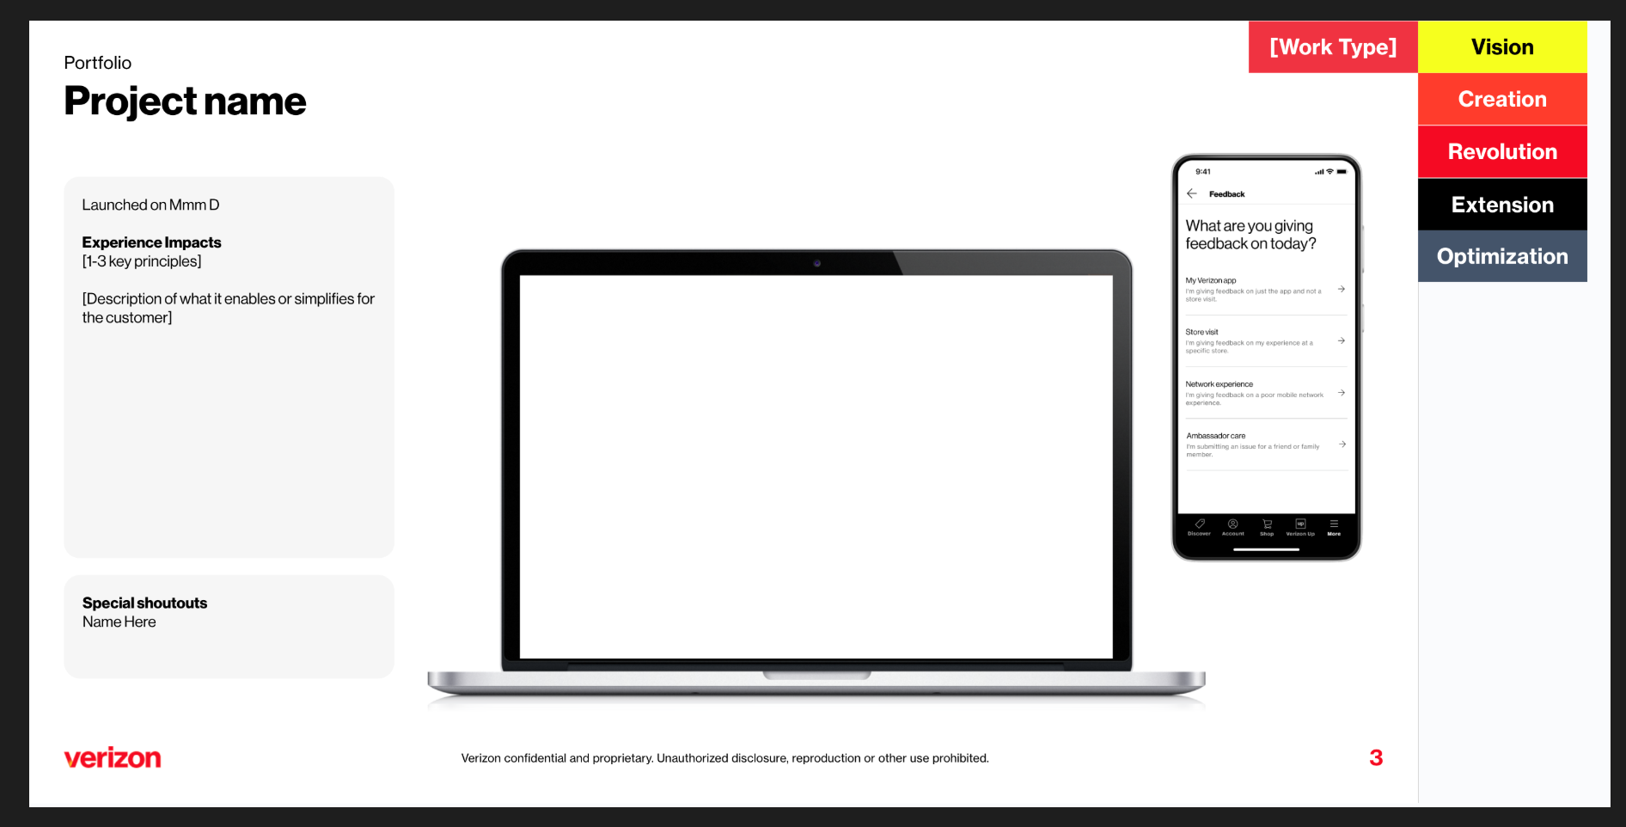

VEGAS Setup
These instructions assume you have already received experimental VEGAS portal access.

We confirmed that anyone who is doing either Content Generation, or RAG (pretty much all of us), will need to request a non-funded API Key in Jira to be able to access the endpoint.
If you have not done that yet, let me know and I can walk you through it. It takes 3-5 business days for approval.

GenAI Use Cases
This is where we construct our deployable GenAI use cases. We must use this system to receive an automatically generated API endpoint, and more importantly, it is the ticketing process for enterprise use case approval. Nathan described it as the "Jira ticket process", we need to have it in there to both deploy, and apply for funding. [Video tutorial]

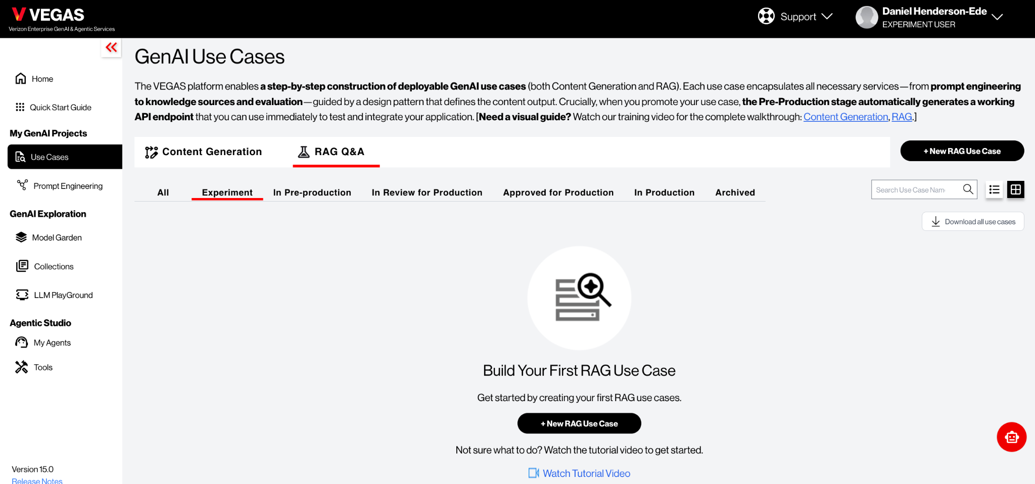

Collections
This is where we upload our context files that are made available to the agents we create. It is worth noting at this time it does not accept JSON. Nathan has tested the file types and generally found the most effective formats, in order from best to worst:
- TXT
- HTML
- PDF
Worth noting there is a 10MB limit per file uploaded. You can upload many files however.

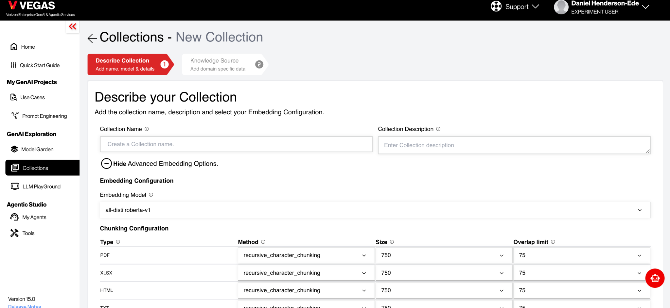

Model Garden
This is where we can experiment with the different models and prompts. It opens up an LLM PlayGround where you are able to run up to 2 models at the same time to compare, as well as include collections you have uploaded already.



Final point, you can create GenAI Use Cases, upload Collections, and experiment with the Model Garden, without an API Key. So we're able to continue to work on our VEGAS agents whilst we wait for the API Key to deploy it into our applications.

📢 Component Scaffolding

Component Scaffolding
Lead Dev: Harrison Gerstenlauer

New project alert: Tool that accelerates the VDS component design and discovery process. This tool will ingest "emerging need" patterns (i.e., multiple team-built examples of a single component), public design system contexts, DU guidelines. Then it will synthesize that against VDS guardrails, and generate a single, VDS-compliant component directly in Figma.
Traditional process for VDS: manual audits , competitive research , synthesis, and many debates just to create a V1 design.
New process for VDS: Receive a high-fidelity, VDS-compliant component (like the Bottom Sheet) generated by AI. Job shifts from "creator" to "editor," focusing on pressure-testing and refining a high-quality "starting point".

Tool Inputs
- Outputs from Tobias
- Verizon examples
- Industry examples

Tool Outputs
- Design discovery doc
- Component file in VDS Figma Component Library experimental/test branch

Resources
- VDS - Design Discovery - Ways of Working doc
- VDS Button (Figma Component Library

Google Workspace (Docs, Slides, Sheets), Atlassian (JIRA, Confluence), Slack, Figma, Gitlab. However, we do own and operate our documentation website: https://beta.designsystem.verizon.com.
Not because of their quality–they’re good. There just isn’t enough of them to be super influential.
https://www.browserstack.com/screenshots/api
https://medium.com/p/8875be702363
https://modelcontextprotocol.io/docs/getting-started/intro
https://help.figma.com/hc/en-us/articles/31304412302231-Explore-Figma-Make#h_01JTEHMXV40EAX57KXX54CH431
https://help.figma.com/hc/en-us/articles/360056440594-Create-and-use-variants#h_01G2SX8RVSXK0JCQBF8RDWT1MM
https://modelcontextprotocol.io/docs/getting-started/intro

